

User Manual

Appeal – Dealer Portal

Appeal – Dealer Portal
MGSTD
(MAHARASHTRA GOODS AND SERVICES TAX DEPARTMENT)

0

MGSTD
(MAHARASHTRA GOODS AND SERVICES TAX DEPARTMENT)

0

MGSTD
(MAHARASHTRA GOODS AND SERVICES TAX DEPARTMENT)

0

MGSTD
(MAHARASHTRA GOODS AND SERVICES TAX DEPARTMENT)

0



Contents

Appeal – Dealer Portal
Appeal – Dealer Portal
1. INTRODUCTION: 4
2. STEP WISE USER MANUAL FOR FILING OF APPEAL APPLICATIONS AND PAYMENT: 18
A. FILING OF APPEAL APPLICATION AGAINST ASSESSMENT ORDER PASSED ON SAP SYSTEM UNDER MVAT ACT: 18
B. FILING OF APPEAL APPLICATION AGAINST ASSESSMENT ORDER PASSED ON SAP SYSTEM UNDER CST ACT: 30
3. FILING OF APPEAL APPLICATION AGAINST ASSESSMENT ORDER ISSUED UNDER MVAT OR CST ACT FOR ASSESSMENT ORDERS NOT AVAILABLE ON SAP SYSTEM AND ORDER HAS RESULTED INTO DEMAND:……….. 42
4.FILING OF MISCELLENEOUS APPEAL APPLICATION 55
5. A. FILING OF DEALAY CONDONATION APPLICATION: 65
B. FILING OF FORM 311 APPLICATION FOR STAY OF RECOVERY: 68
C. FILING OF APPEAL WITHDRAWAL APPLICATION: 70
D. APPLICATION FOR RESTORATION OF APPEAL AGAINST SUMMARILY REJECTION 78
E. FILING OF APPEAL RESTORATION AGAINST APPEAL DISMISSAL ORDER: 88
F. PAYMENT AGAINST ADDITIONAL PART PAYMENT ORDER: 97

INTRODUCTION:

- The facility for filing of the Appeals Applications has been made available online on SAP Platform.
- As of now the Appeal Module is confined to the DC and JC Appeal only. Also, the scope of Appeal Module is with respect to Assessment Orders passed under VAT and CST only. As and when other functionalities will be made available including Appeal to Tribunal and other Appeals, Trade will be communicated accordingly.
- The Appeal Applications will be auto allocated based on the desk of Assessing Officer as provided in Appeal Application.
- Following are the Applications that are available to be filed online and the User Manual covers the step by step procedure of the same;
- Appeal Application Form 310 under VAT
- Appeal Application Form IX(B) under CST
- Application for Stay Form 311
- Delay Condo Nation Application
- Appeal Withdrawal Application
- Restoration Application against Summary Rejection of Appeal
- Restoration Application against Appeal Dismissal
- Following are the various Orders the Appellate Officer can issue online;
- Interim Stay cum Part Payment Order
- Final Stay Order Form 312
- System Generated Final Stay Order
- Delay Condo Nation Order
- Summary Rejection of Appeal
- Appeal Dismissal Order
- Restoration of Appeal Order
- Appeal Remand Back Order
- Appeal Withdrawal Order
- Additional Part Payment Order
- Stay Continuation Order Form 319
- Stay Vacation Order Form 319
- Form 311 Rejection/ No Stay Order
- Appeal Order
All these orders issued by the Appellate Authorities are available to the dealer on Dealer Portal for view and further actions and also will be sent to his registered mail ID as an attachment.

- Gateways to file the Appeal Application online: The departmental authorities have passed the Assessment and Other Orders on MAHAVIKAS as well as SAP System. The Appeal Application Module is designed to cater for filing the Appeals may the Order is passed on old MAHAVIKAS System or the SAP System. The dealer also can file the Appeal against some Miscellaneous Orders like Registration Cancellation Orders also. The Applicant first need to identify the nature of Order against which he requires to file the Appeal. Accordingly, he can choose the gateway to file the Appeal Application. Following are the gateways to file the Appeal depending on the nature of Order,
- Assessment Orders passed on SAP System- Any kind of Assessment Order passed on SAP System may resulted into Demand or Refund is covered under this category.
- Assessment Orders not passed on SAP System- Assessment Orders which are not passed on SAP System and resulted into some dues are covered under this category.
- Miscellaneous Appeals- All the Miscellaneous Appeals like Appeals against the Registration Cancellation Orders and also Assessment Orders not passed on SAP System but resulted into NIL dues or refund are covered under this category.
The detailed step by step procedure to file the Appeal Application under these categories are explained in respective sections.
- How the dealer will Log in and fill Appeal Application online: The dealer will log in to the dealer portal for the purpose of filing of Appeal Application. The dealer if knows the SAP Order ID against which Appeal is to be filed, can enter the same in a tab provided and can search the order. He can also enter various criteria like Assessment period, Act etc and then can search the order if he does not know the Order ID. In either case, if the Order is available in the system (If the Assessment Order is passed on SAP), the Assessment Order in PDF format will be displayed to the dealer against which the dealer can file the Appeal. In such cases, the Assessment Order data will auto populate in the “As per Order” of the Appeal Application against which applicant dealer can enter the data in “As per dealer” column. The system will then automatically calculate the Disputed and Undisputed Dues based on the information in Assessment Order and as filled up by the dealer. If the order is not available in the system, the line items of the Assessment Order dues if available in the recovery dues of the dealer will be displayed. The dealer then can identify the line item as per the Assessment Dues and click on the document number to open the Appeal Application. The dealer can then enter the information in the Application in both “As per Order” column and “As per dealer” column. The system will then automatically calculate the Disputed and Undisputed Dues The system will then automatically calculate the Disputed and Undisputed Dues based on the information in Assessment Order and as filled up by the dealer. There are some mandatory fields which the dealer needs to fill in order to save the Application. The system will then automatically calculate the disputed and undisputed amounts based on information filled by the dealer.
- Types of Stay offered and calculation of Payment: Before the issuance of Notification No XXXI dated 15TH April, 2017, there was no mandatory part payment for filing of Appeal Application. The dealer could be able to file the Appeal Application only by paying the requisite Appeal Fees. Subsequently, the Appellate Officer used to issue Ad-Interim Stay, Interim Stay cum Part Payment Order and then Final Stay Order. After the issuance of the above Notification, the applicant dealer has to pay mandatory part payment and then only can file the Appeal Application. Therefore, on receipt of the Appeal application, the Appellate Officer can directly issue the Final Stay Order on verification of Appeal Application and payment proofs.
In the Appeal Module, the stay offered to the dealer will also be based on the date of Assessment Order against which Appeal is preferred and Act under which Assessment Order is passed.
8.1 VAT: For the order which are passed under the VAT Act, the type of Stay available to the dealer depends on the date of Assessment Order for which Appeal is preferred. After the introduction of online filing of Appeal application on Appeal Module, apart from AD interim and Final Stay, the facility of System Generated Final Stay (Auto Stay) has been made available to the dealer. For the purpose of filing Appeal Application along with request for Final Stay, the applicant dealer needs to pay the 10% of the ‘’Disputed Amount’’ (Of only Tax) in addition to the fees applicable for such appeals application. For the purpose of filing Appeal Application and request of the System Generated Final Stay (Auto Stay), the applicant will have to pay all the undisputed amount (Including tax, interest, and penalty) and 10% of the ‘’Disputed Amount’’ (Of only Tax) in addition to the fees applicable for such appeals application. All these disputed and undisputed amounts will be system calculated based on the figures filled up by the applicant dealer and type of stay desired by the dealer. If the applicant does not pay the ‘’Undisputed Amount’’ (if any), then the facility to obtain ‘’ ’System Generated Final Stay’’ will not be afforded to the applicant and he will have to obtain the Final Stay from the appellate authority on merit by paying 10% of disputed amount of tax only which can also be issued online by respective Appellate Authority. Following Table shows the options of stay available to the dealer while filing online application based on date of Assessment Order passed;

Date of Assessment Order passed | Ad Interim Stay | Final stay | System generated Final Stay
On or After 15/4/2017 | N.A | Applicable | Applicable
Other than above | Applicable | N.A | N.A

For the purpose of obtaining various Stay from the Appellate Officer the dealer will have to pay following amount as Part payment/payment.
Final Stay: 10% of tax quantum of disputed amount+ Appeal fees
System Generated Final Stay: 10% of tax quantum of disputed amount + 100% of tax, interest, penalty or any other amount of undisputed amount+ Appeal fees
Ad- Interim Stay: Appeal fees.
8.2 CST: For the order which are passed under the CST Act, the type of Stay available to the dealer depends on the date of Assessment Order for which Appeal is preferred. The option of System Generated Final Stay (Auto Stay) is not available in the CST Appeals due to the fact that the fixation of part payment in CST Appeals involves verification of documents and reasons of tax liability in Assessment Order. This is because of the fact that in CST Appeals, the condition of Appeal against the orders wherein the dues are arisen due to non-submission of CST declarations has been incorporated. The dealer is supposed to give the figures of differential liability on account of pending declarations at the time of passing of Assessment Order and of the differential liability reduced due to declarations received after passing the Assessment Order till the date of filing of Appeal Application. The system will then automatically calculate the requisite amount of part payment and appeal fees based on the information submitted by the dealer. Hence, in CST Appeals the dealer can opt for Final Stay by paying the requisite amounts (including Appeal fees). The Appellate Authority on receiving of the said Appeal can verify the status of declarations as submitted by dealer in Appeal Application and can take proper decision on the said Application.
Following Table shows the options of stay available to the dealer while filing online application based on date of Assessment Order passed;

Date of Assessment Order passed | Ad Interim Stay | Final stay | System generated Final Stay
On or After 15/4/2017 | N.A | Applicable | N.A
Other than above | Applicable | N.A | N.A

For the purpose of obtaining various Stay from the Appellate Officer the dealer will have to pay following amount as Part payment/payment. The amount to be paid depends on the reason of dues raised in Assessment Order (Whether due to the pending declarations or other reasons or both)
Final Stay: 10% of tax quantum of disputed amount (For dues other than pending declarations) + 100% of tax quantum of differential disputed amount (For dues of pending declarations) + Appeal fees
Ad- Interim Stay: Appeal fees.
It is to be noted that whatever requisite payments calculated by system are based on the figures filled by the dealer in Appeal Application. The Appellate Officer can take the decision of Summary Rejection or Appeal Dismissal or as he may deem fit if any information is incorrectly or falsely given or for any other reasons.
- Integration of Payment gateway with Appeal Application: The Government of Maharashtra issued a Notification on 15TH April 2017 regarding Appeal filing procedure. In pursuance to the said Notification, MSTD also issued the Trade Circular No 11 T of 2017 dated 20th April 2017. The provision of remand back of Assessment case by the first Appellate Authority and mandatory part payment while filing the Appeal was introduced vide the said Notification. It mentions that for the Assessment Orders which are passed on or after 15/4/2017, the dealer can file the Appeal only after making the part payment of 10% of the disputed amount and if the disputed amount is pertains to pending declarations, then 100%-part payment of differential amount is to be paid as per the status of pending declarations on the date of filing of Appeal. To summarize, it means that for the Assessment Orders passed on or after 15/4/2017, the dealer cannot file the Appeal unless he pays the fixed percentage of part payment. The first Appellate Authority would not have any discretion for fixing the part payment amount for admission of Appeal in such cases. Therefore, as per the said provision, the dealer has to pay the requisite amount of payment and Appeal Fees while filing the Appeal Application only. Facility is provided to the dealer to pay the said amounts through the payment gateway immediately on saving the Appeal Application online. The system will automatically calculate the amount to be paid based on the date of Assessment Order, disputed and undisputed amount as filled by the dealer and type of stay desired by the dealer. The dealer can change the disputed amount and type of stay desired any time before going to the payment gateway. The required payment to be made will automatically change accordingly. Once dealer opts to pay the required payment and routed to the payment gateway, then he cannot alter the Appeal Application saved. Once Appeal Application is saved and payment is made accordingly, Appeal case is created which will then automatically allot by system to the concerned Appellate Officer for further verification. It is no be noted that submission of Appeal Application does not mean in any way acceptance of claims of the applicant dealer. Once the Appeal Application is allotted to the Appellate Officer, he will verify the correctness of information given by the applicant dealer and will further take decision regarding the processing of Appeal Application.
Any amount paid before filing of Appeal gets automatically adjusted as per Section 40 of the MVAT Act. It means the amount paid before filing of Appeal is adjusted automatically with interest first, then penalty, forfeiture amount, fine and then with tax. Therefore, facility of part payment along with Appeal Application is provided so that the amount paid along with Appeal Application directly gets adjusted with disputed tax. Department has issued Trade Circular 55T of 2019 prescribing the instructions to file the online Appeal filing and part payment. Dealers are therefore required to make part payment along with Appeal Application only with in the Appeal Module.

- Calculation of Part Payment under VAT and CST Appeals:
VAT:
The logic for calculation of part payment was developed in the following manner-
- Arriving at the Disputed and Undisputed dues.
- Calculating the total undisputed credit available to the dealer on the date of appeal. This total undisputed credit includes all credits (ITC and other credit) allowed as per Assessment Order.
- Appropriating the total undisputed credit available against undisputed dues first and then with disputed dues.
- Calculating the amount of part payment that needs to be paid.
This can better be explained in the form of following formula-
- Disputed Dues = Tax Dues as per Order less Tax Dues Accepted by Appellant.
- Undisputed Dues = Dues as per Order less Disputed Dues.
- Total undisputed Credit Available = All the credit available as per Order.
Appropriation of undisputed available Credit is done as per the following method –
- All the undisputed available Credit would first be appropriated against the undisputed dues.
- If any credit is left un-appropriated after adjusting undisputed dues, it would be appropriated against the disputed tax dues.

Scenario 1:

Scenario 2:

Scenario 3:
Scenario 4:
Scenario 5:

CST:
If output tax comprises the dues due to differential liability for orders issued after 15.04.2017, then the said amount of differential liability would have to be paid in full in addition to the amount arrived at by applying above mentioned formulae to the remaining amount of dues.
The dealer is requiring to pay the remaining undisputed or accepted dues. If no such dues are paid, the officer can initiate the recovery actions in such cases.

Scenario 1:
Scenario 2:

Scenario 3:

Scenario 4:

STEP WISE USER MANUAL FOR FILING OF APPEAL APPLICATIONS AND PAYMENT:

A. FILING OF APPEAL APPLICATION AGAINST ASSESSMENT ORDER PASSED ON SAP SYSTEM UNDER MVAT ACT:

Log In Screen
- Login in to the Dealer Application with your Login credentials.
- User:
- Password:
- Click on ‘’Log On’’

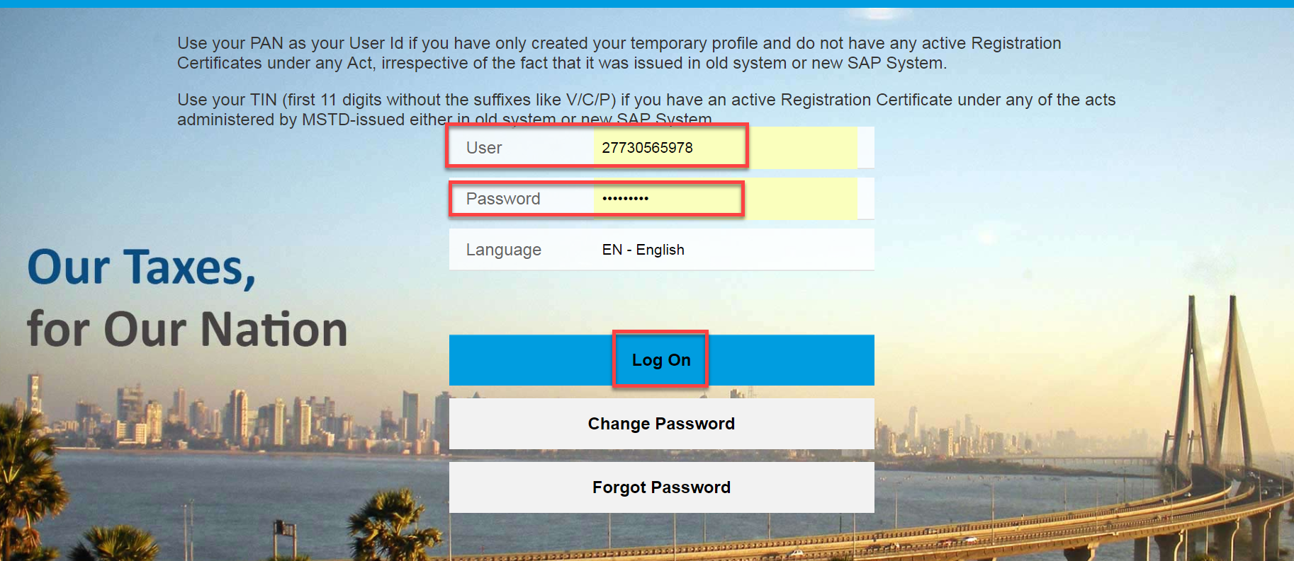
XXXXXXXX

ASSEMENT ORDER ID SEARCH
- Click on ‘’Other-E Services’’ option from L.H.S menu (Left Hand Side)

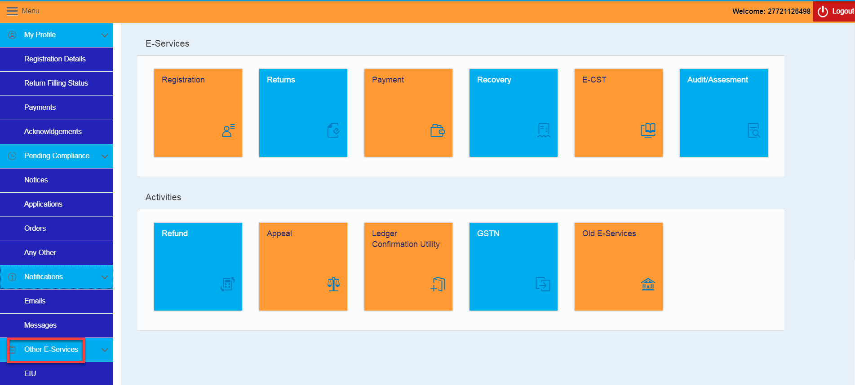

- Click on ‘’Appeal’’ Tile under Activities section

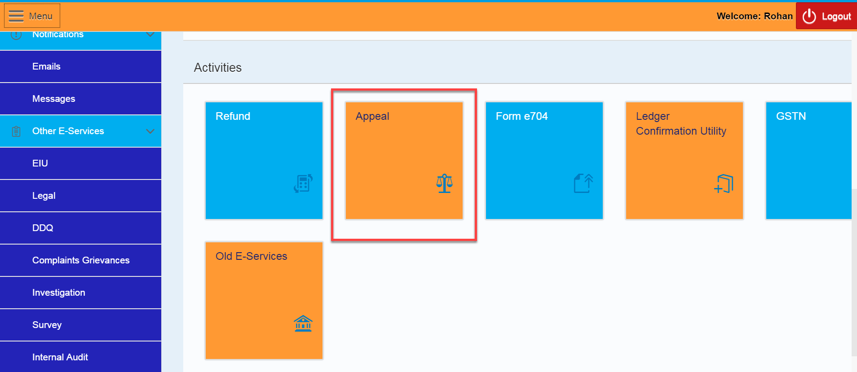

- Click on “Appeal” tile again under CRM APPEAL // APPEAL TO TRIBUNAL HOME PAGE



- Enter the VAT Assessment Order ID under “Search Document Number”
- Click on ‘Display’’ button

- Click on “Appeal” button

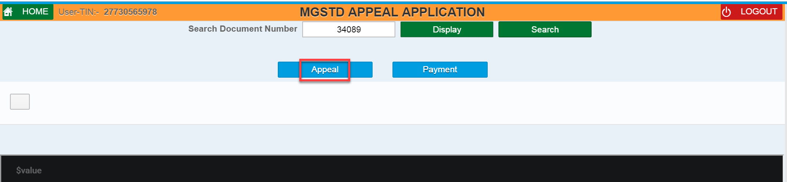

Dealer can also see the list of Orders through filling the following fields and clicks on “Submit” button– (Select an Act, Document Type, Period of Assessment from, and Period of Assessment to)
- Select an Act, and Document Type from drop down list

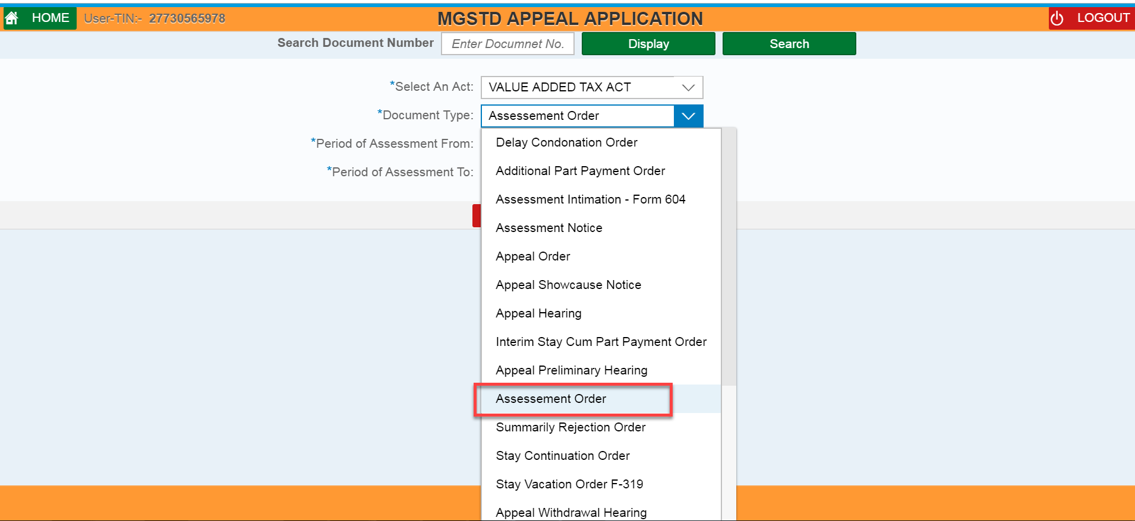

- Enter Period of Assessment From, and Period of Assessment To date
- Clicks on “Submit” button

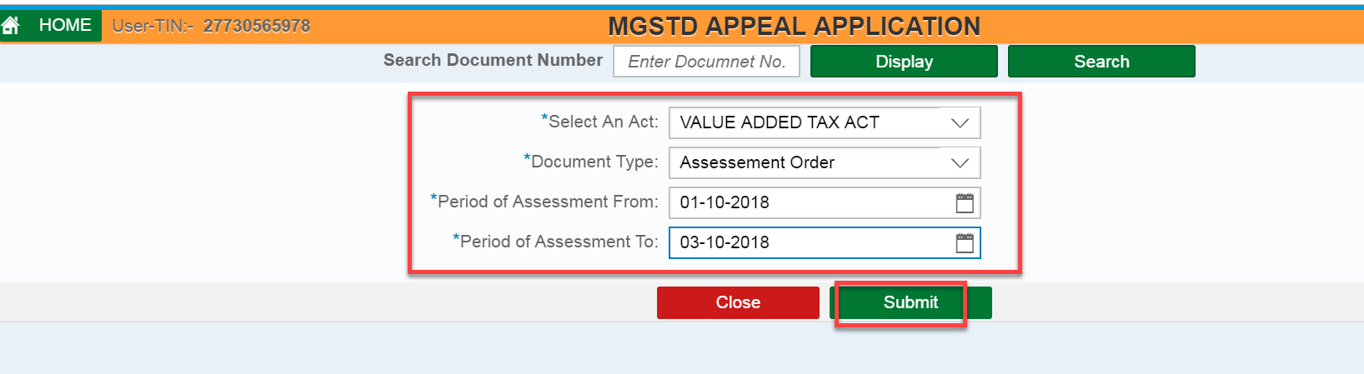

FILLING FORM 310 APPEAL APPLICATION
- Tick & Select the “Order Form 231” radio button

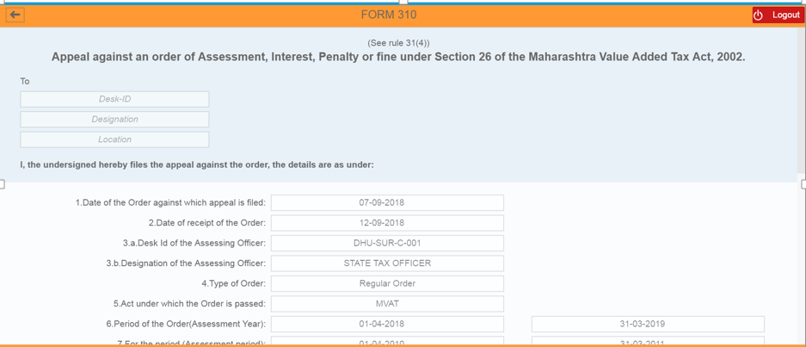

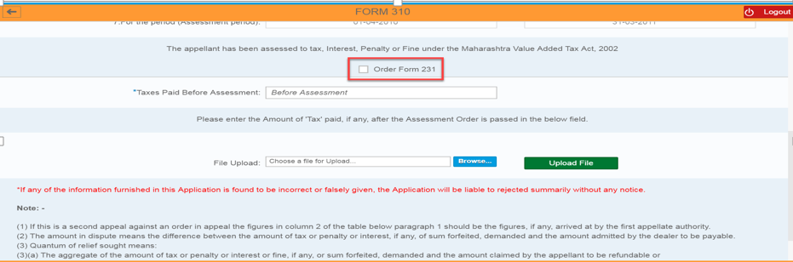
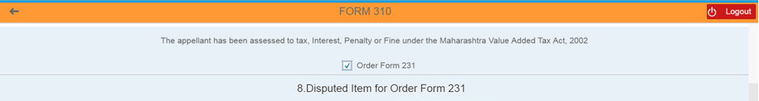

- Enter values under “As Per Applicant (Rs.)” section against “As Per Assessment (Rs.)” section for all mandatory fields wherever applicable.
e.g.. GTO of sales
GTO of Purchases

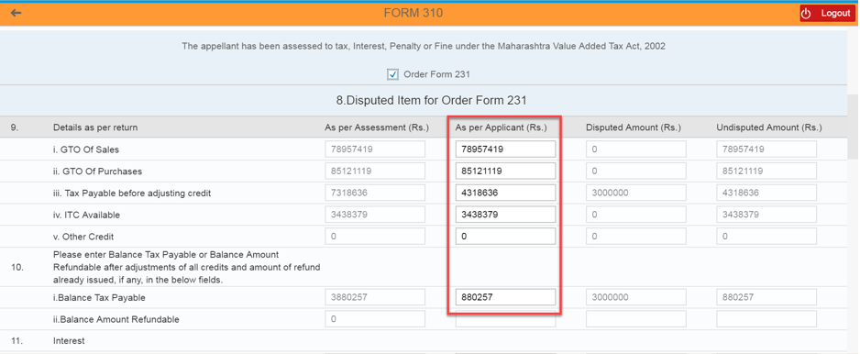

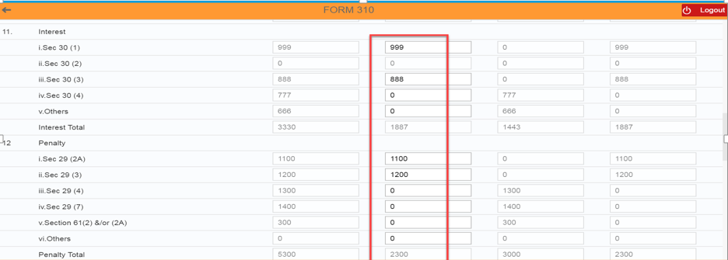

- Enter the value wherever required shown on the screen.
- Select “Yes” for “Whether Desire to file application for stay of recovery” field
- Select either of one stay (Final Stay/Auto Stay) from Drop-down list for “Type of Stay Desire” field. – Here if the Date of Assessment Order passed if on or after 15/4/2017, option of Final Stay and System Generated Final Stay (Auto Stay) will be displayed. If the Date of Assessment Order passed is before 15/4/2017, then option of only AD-Interim Stay will be displayed. The amount of Tax, Interest, Penalty, Appeal Fee and Total amount that is to be paid with Appeal Application should get auto populated once select the Type of Stay.

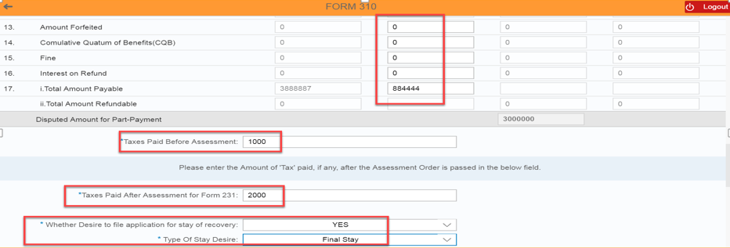

- Select Major issue involved in Appeal from the drop down menu.
- Enter Grounds of Appeal notes. In this section, applicant dealer can enter or copy paste maximum 500 characters. For any additional information to be submitted like Grounds of Appeal, certified copy of Assessment Orders or any other records, dealer can use the facility of File Upload.
- Upload the Files under “File Upload” section by Clicking on “Browse” button and then upload the file
- Clicks on “Delete” button if dealer wants to delete the uploaded file
- Dealer can save the details by clicking on “Save/Print Preview” button

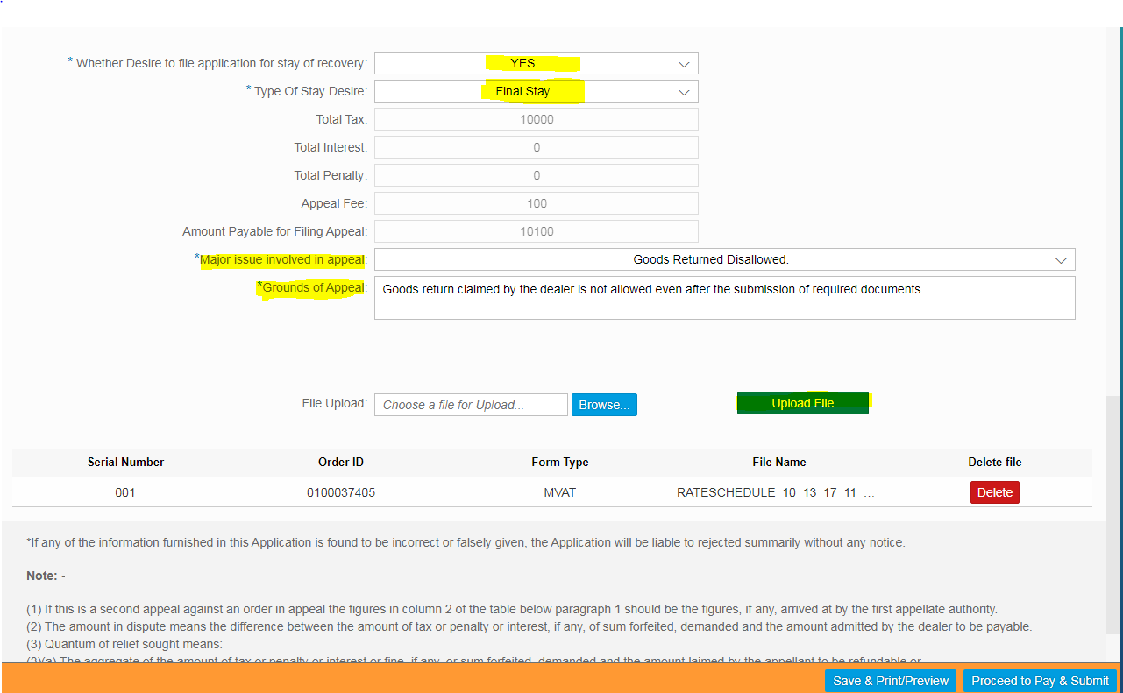

PAYMENT
- Clicks on “Proceed to Pay & Payment” button

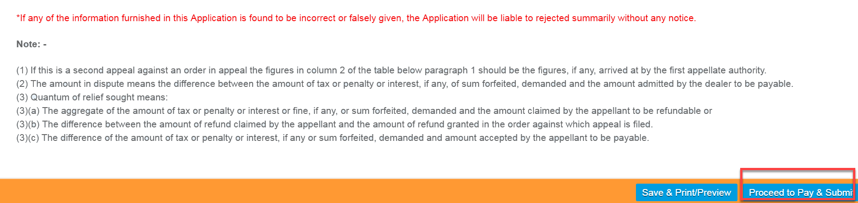

- A Pop Up message appears. If applicant dealer is confirmed of the correctness of data filled in Form 310, clicks on “Proceed” button to go towards Payment. Once the Proceed button is clicked, applicant/dealer cannot edit any data in Form 310.

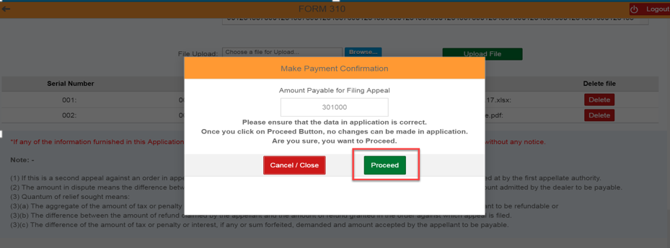

- Select the either of one Payment Gateway (1. “GRAS” – Banks Supported By GRAS; 2. “SBI ePay” - Banks Supported By SBIEPAY)
For e.g.… Here I selected “SBI ePay” radio button
- Select the proper “Location” and enter the valid “Mobile Number” with 10 digits
- Select the “Agree” radio button
- Again clicks on “Proceed For Payment” button

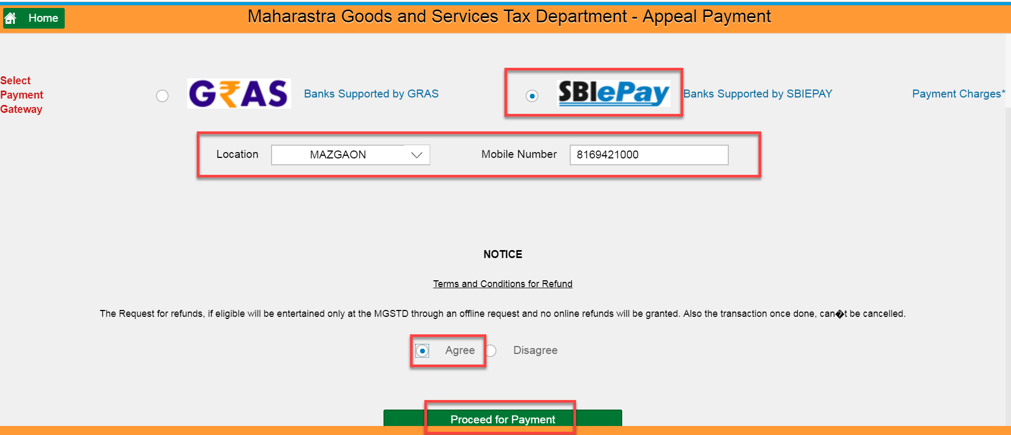

- Review the details and then Clicks on “Make Payment” button

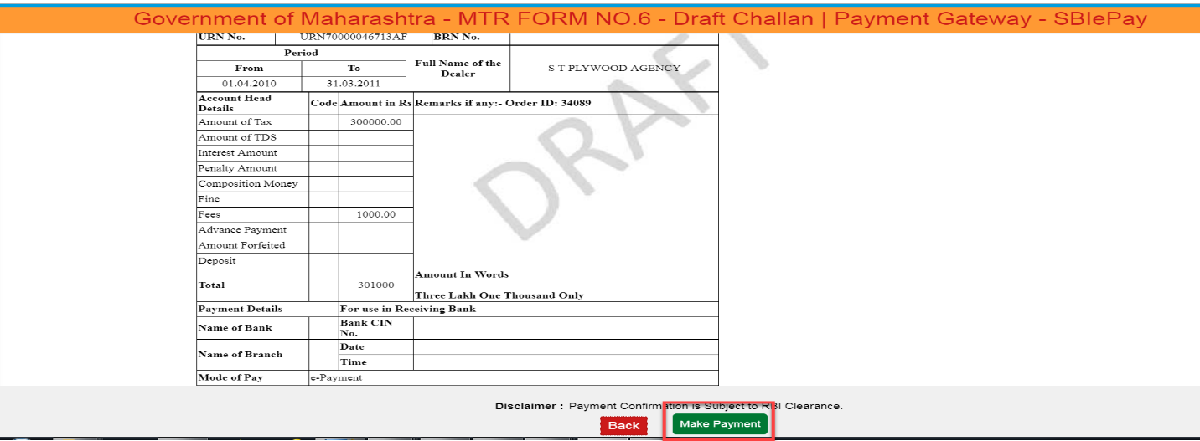

- Select either of one option (“Debit/Credit Card” OR “Internet Banking” OR “PayPal”),
For e.g... Here I have selected “Internet Banking” option
- Select the proper Bank from the list of Banks under “All Banks” section
- Clicks on “Pay Now” button

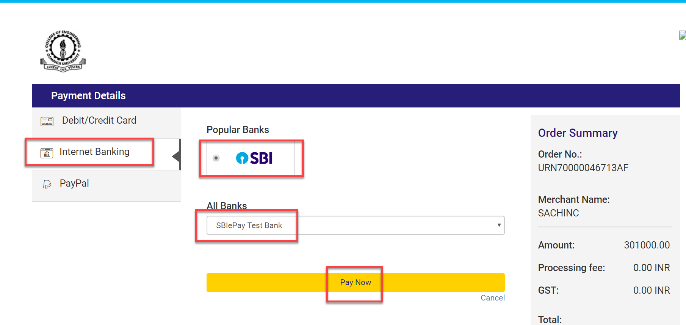

- Clicks on “Successful” button – 1) Payment Acknowledgement should get displayed
2) Appeal Id should get created in CRM automatically and it will be assigned to the concerned Tax Officer. This Appeal ID can be use by dealer for further reference during Appeal Hearings or for filing Appeal Withdrawal Application.
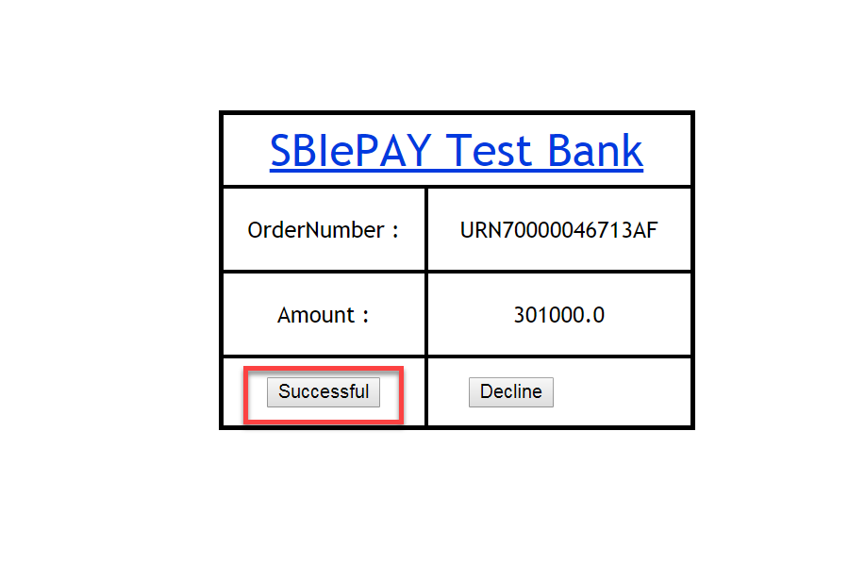
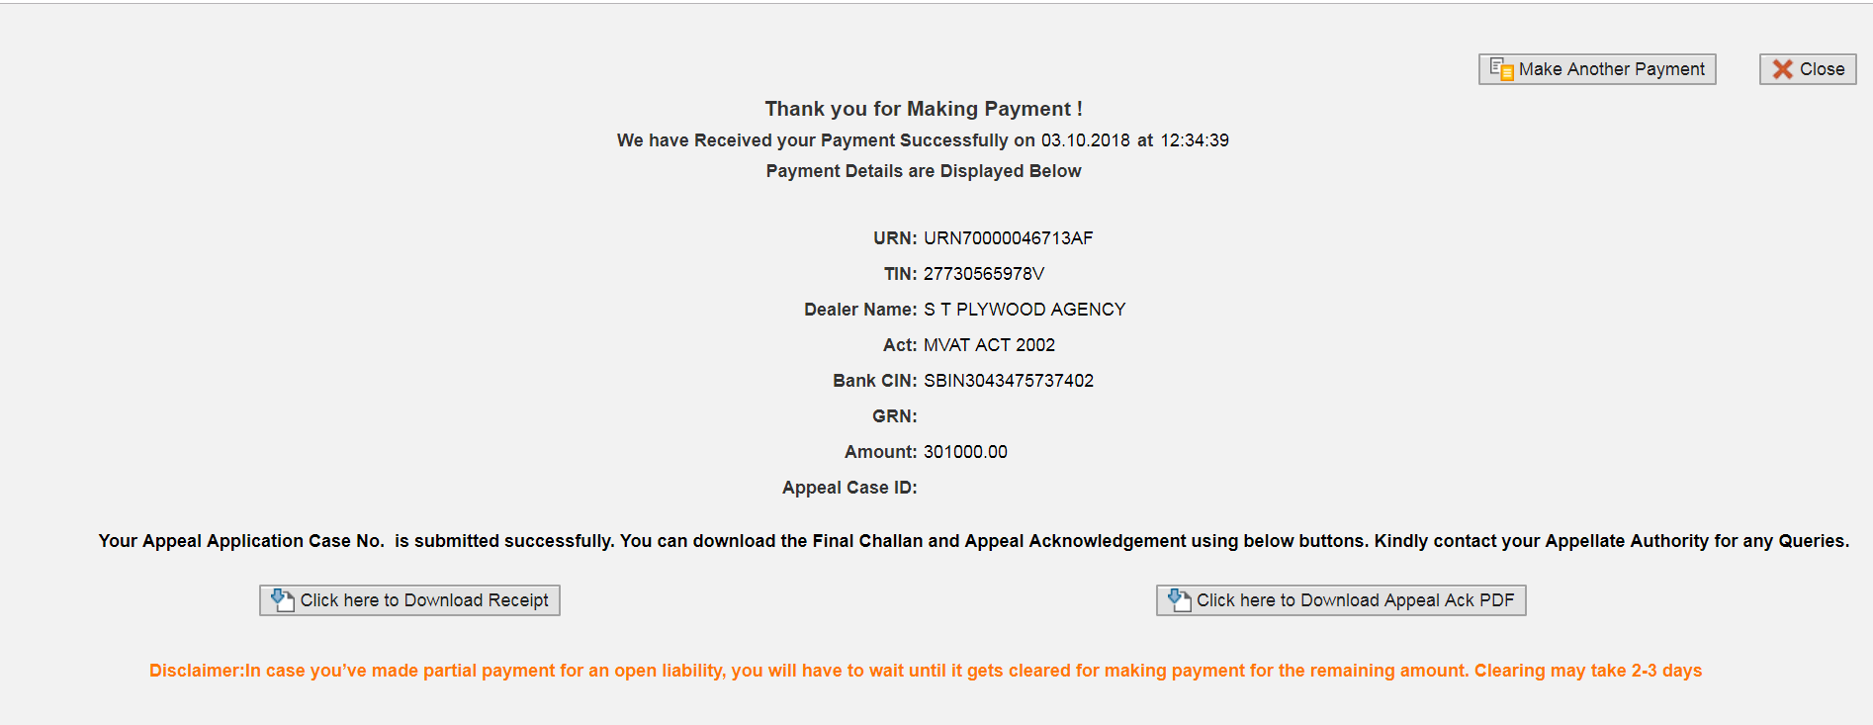
XXXXXXXX

How to send the payment link from one person to other person for Part Payment:
It needs to be mentioned first that it is always recommended to fill the Application form and make the part payment in a continuous process for security reasons. Prior necessary approvals from Authorized person for payments may be obtained for this. But, sometimes the person who is filling the Appeal Application is different than the person who is authorized to make the Part Payment. Many times the CA/Advocate/STP fill up the Appeal Application form and requires to forward the same to the dealer for part payment. Sometimes, the company accountant fills up the Application and requires to send it to the higher officer for part payment. In such scenarios, following process or procedure can be adopted.
After filling the Appeal Application, the person requires to click on “Save and Print Preview” tab. Then he shall click on “Proceed for Payment and Submit” button. The person will be directed to payment gateways as displayed in following screen. On reaching this screen, the person is required to copy the link shown in URL.

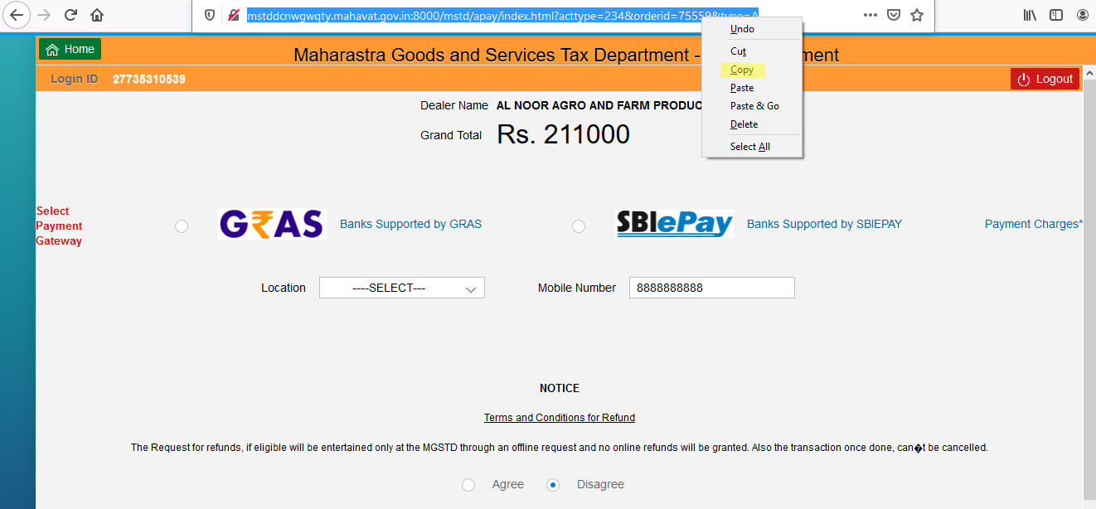

He then can send this link by mail or any other communication to the dealer or authorized person for further part payment. The person who has received this link can paste it in search toolbar of the browser and click Enter button.
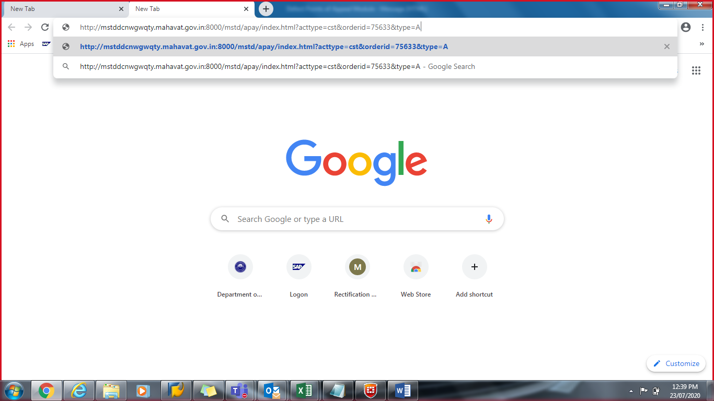

The system will ask the person to enter the log in details.
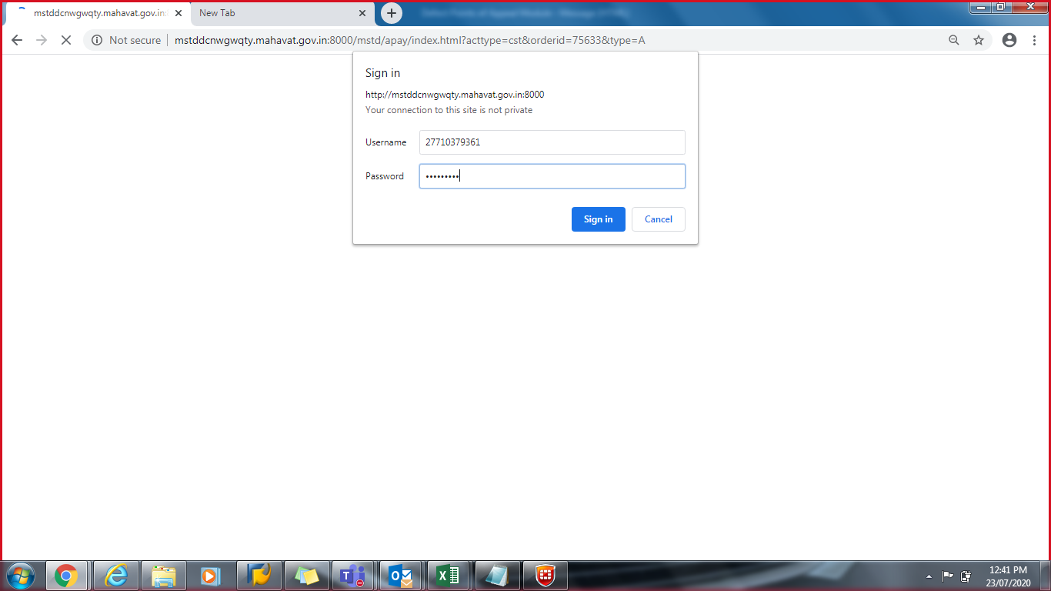

On entering the log in details, the system will land that person directly on the payment gateway screen of the same Appeal Application.

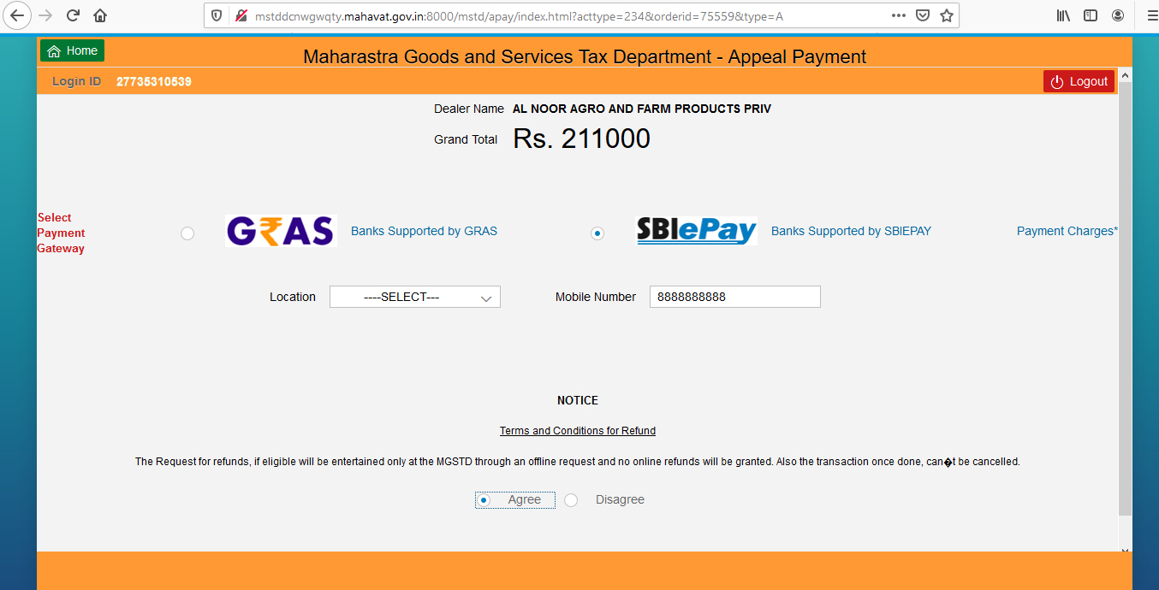

From this screen onwards, that person can follow the payment procedure already explained above. After the successful payment if the Appeal case is created on real time, following screen will appear. This facility of copy and sending the payment link to another person is applicable to all kinds of Appeal Applications.
It is needless to mentioned that the sending the link and payments thereof is the responsibility of the concerned persons and to be used cautiously for security reasons.

ACKNOWLEDGEMENT FORM
- Clicks on “Click here to Download Appeal Ack PDF” button

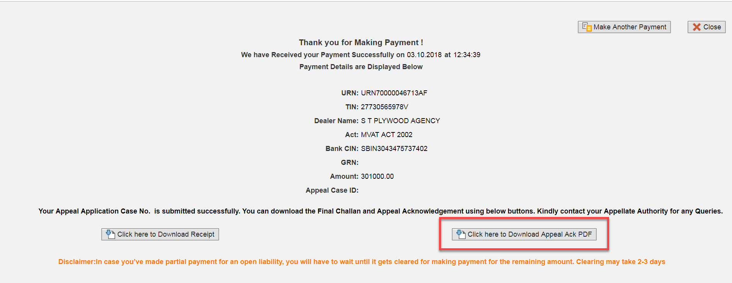
XXXXXXXX

- Clicks on “Download” icon under Acknowledgement Form
- The same Acknowledgement Form is also sent on Registered Mail ID of the dealer.

How to obtain the Acknowledgement Form:
There are three ways to obtain the Acknowledgement Form once the Appeal Case is created. This facility of downloading the Acknowledgement Form remains the same for all kinds of Appeal Applications.
- If the Appeal case is created on real time basis, the Applicant can obtain the PDF of Acknowledgement Form as shown in the above screen itself.
- The same PDF of Acknowledgement Form is also sent as an attachment to the Registered Mail ID of the Applicant. The PDF Acknowledgement Form can be viewed, downloaded and can be used for further reference.
- The dealer can also go the Order Search screen in the Appeal Tile as shown below and enter the necessary details. After that, if he clicks on Display button, the PDF of Acknowledgement Form can be seen. The same can be viewed, downloaded and can be used for further reference.

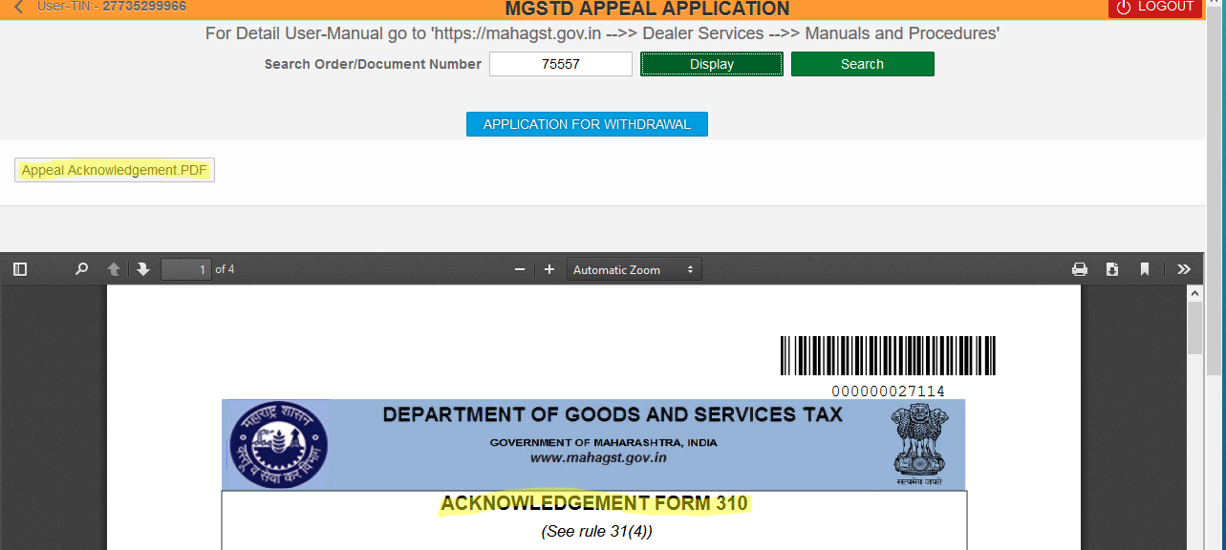

- The one thing that must be noted is that, Appeal case is created only after successful payment and updating of same in Government treasury. This sometimes happen on real time basis or may take 3-4 days. Once, the Appeal case is created, then only the above PDF of Appeal Acknowledgement form can be viewed and downloaded. If no Appeal Acknowledgement is received or generated by these method, it means that the Appeal case is not created yet as the payment must be in processed stage. Once, the payment becomes successful, Appeal case is automatically created and Acknowledgement can be seen.
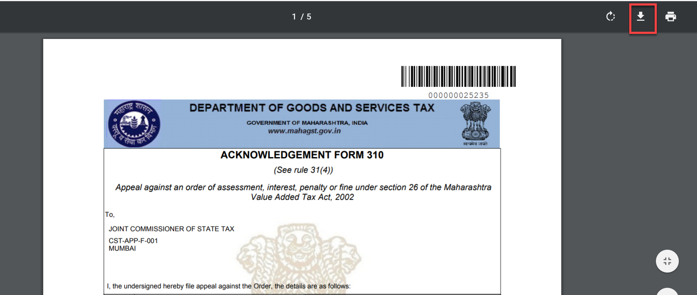

If the payment made is failed due to any reason, the amount gets recredited to the bank account from which payment is made. The dealer then can again file the Appeal Application and part payment.

B. FILING OF APPEAL APPLICATION AGAINST ASSESSMENT ORDER PASSED ON SAP SYSTEM UNDER CST ACT:

LOGIN SCREEN
- Login in to the Dealer Application with your Login credentials.
- User:
- Password:
- Click on ‘’Log On’’

XXXXXXXX

ASSEMENT ORDER ID SEARCH
- Click on ‘’Other-E Services’’ option from L.H.S menu (Left Hand Side)
XXXXXXXX

- Click on “Appeal” tile under Activities section
XXXXXXXX

- Click on “Appeal” tile again under CRM APPEAL // APPEAL TO TRIBUNAL HOME PAGE

- Enter the Assessment Order ID under “Search Document Number”
- Click on ‘Display’’ button

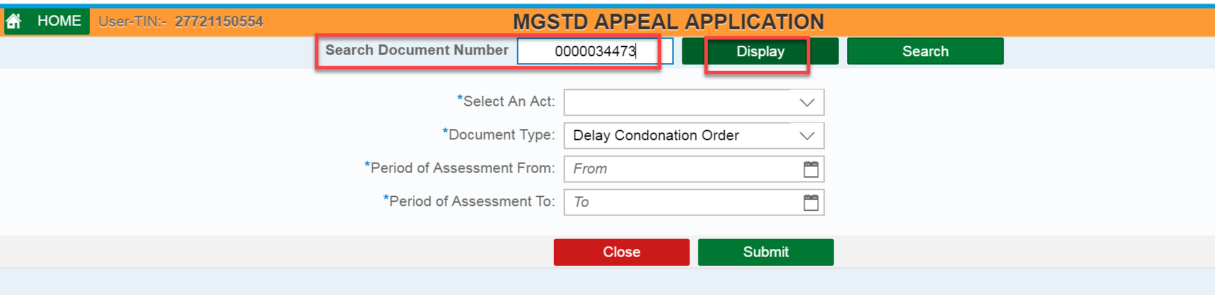
XXXXXXXX

- Click on “Appeal” button

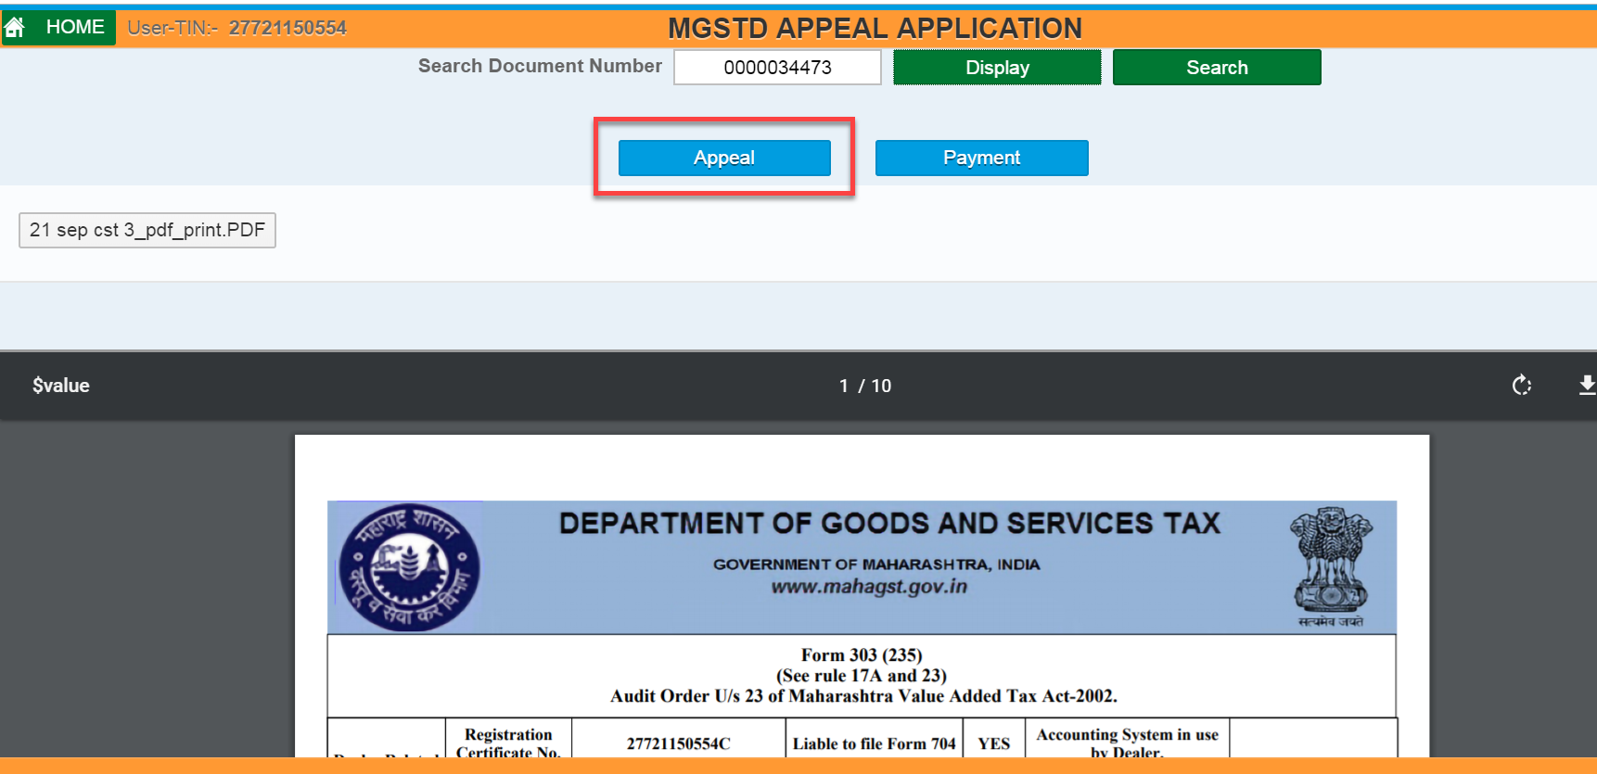
Dealer can also see the list of Orders through filling the following fields and clicks on “Submit” button – (Select An Act, Document Type, Period of Assessment From, and Period of Assessment To)
- Select An Act, and Document Type from drop down list

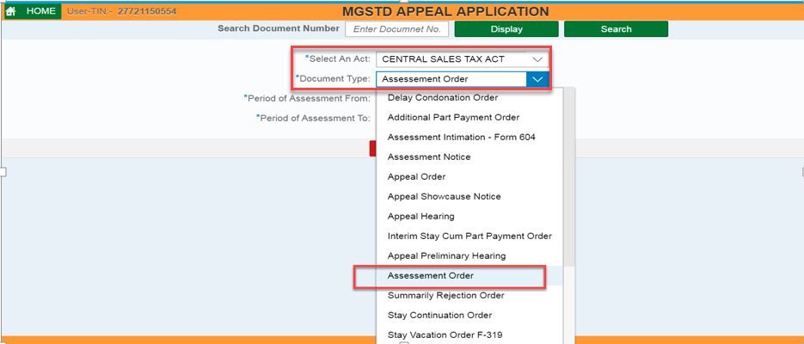

- Enter Period of Assessment From, and Period of Assessment To date
- Clicks on “Submit” button

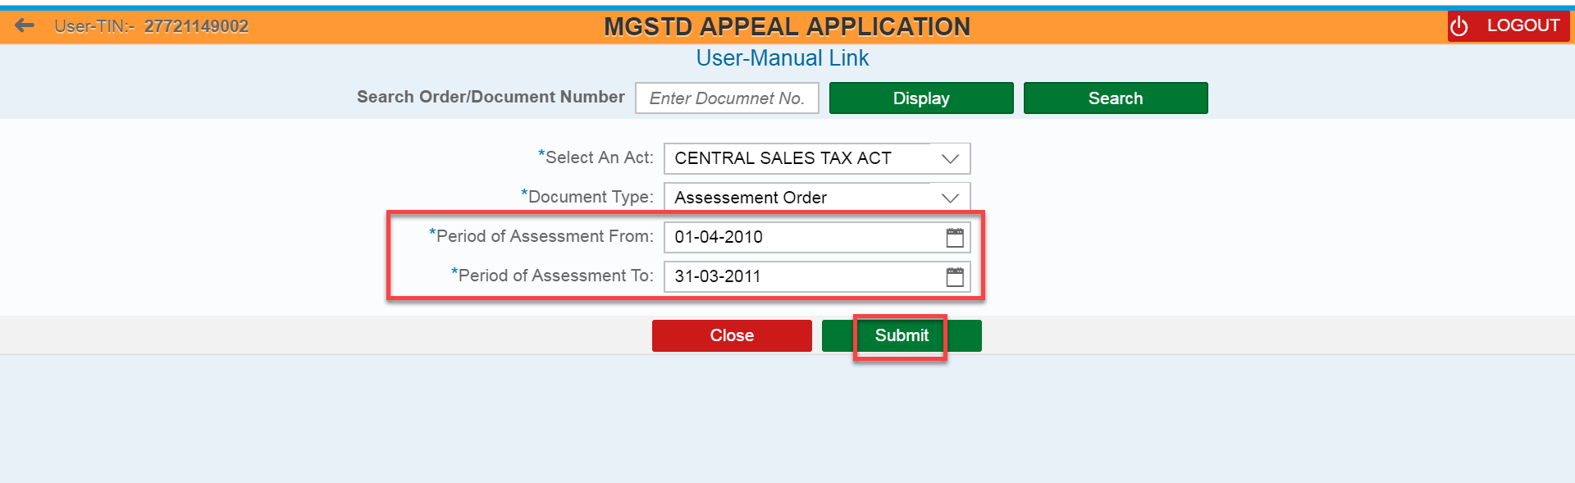
XXXXXXXX

FILLING APPEAL APPLICATION FORM IX (B)
- Tick & select the “Order Form CST” radio button
- Enter values under “As Per Applicant (Rs.)” section against “As Per Assessment (Rs.)” section for all mandatory fields
e.g.. GTO Of Inter state sales
Turn over of Taxable Interstate Sales

Scenario: Tax Payable before adjusting credit - As per Assessment (Rs.) filed value > Tax Payable before adjusting credit - As per Applicant (Rs.) filed value
The dealer will have to fill the values provided in the Appeal Application. Following validations are being provided in the application.
Sr No 16: Accepted Tax liability out of Balance Tax Payable as per Assessment Order (Sr No 10.i) cannot be more than the Balance tax payable as per the Assessment Order.
Sr No 17: Disputed Differential Tax for Pending Declaration for Which Appeal is Preferred in Tribunal cannot be more than the disputed tax liability calculated at Sr No 16.
Sr No 18: Disputed Differential Liability due to non-submission of certificate & declaration (Other than Form F for Branch Transfers) as per CST Act shall not be more than the disputed tax liability calculated at Sr No 16- Disputed Differential Tax for Pending Declaration for Which Appeal is Preferred in Tribunal at Sr No 17.
Sr No 19: Disputed Differential Liability reduced on account of Declarations received (Other than Form F for Branch Transfers) after the Assessment Order is passed till the date of filing of this Appeal cannot be more than the Disputed Differential Liability due to non-submission of certificate & declaration (Other than Form F for Branch Transfers) as per CST Act shown at Sr No 18.
*Kindly note that in Order to correctly calculate the amount of Part Payment, the Applicant is required to fill correct and mandatory details in Sr No 16,17,18 and 19
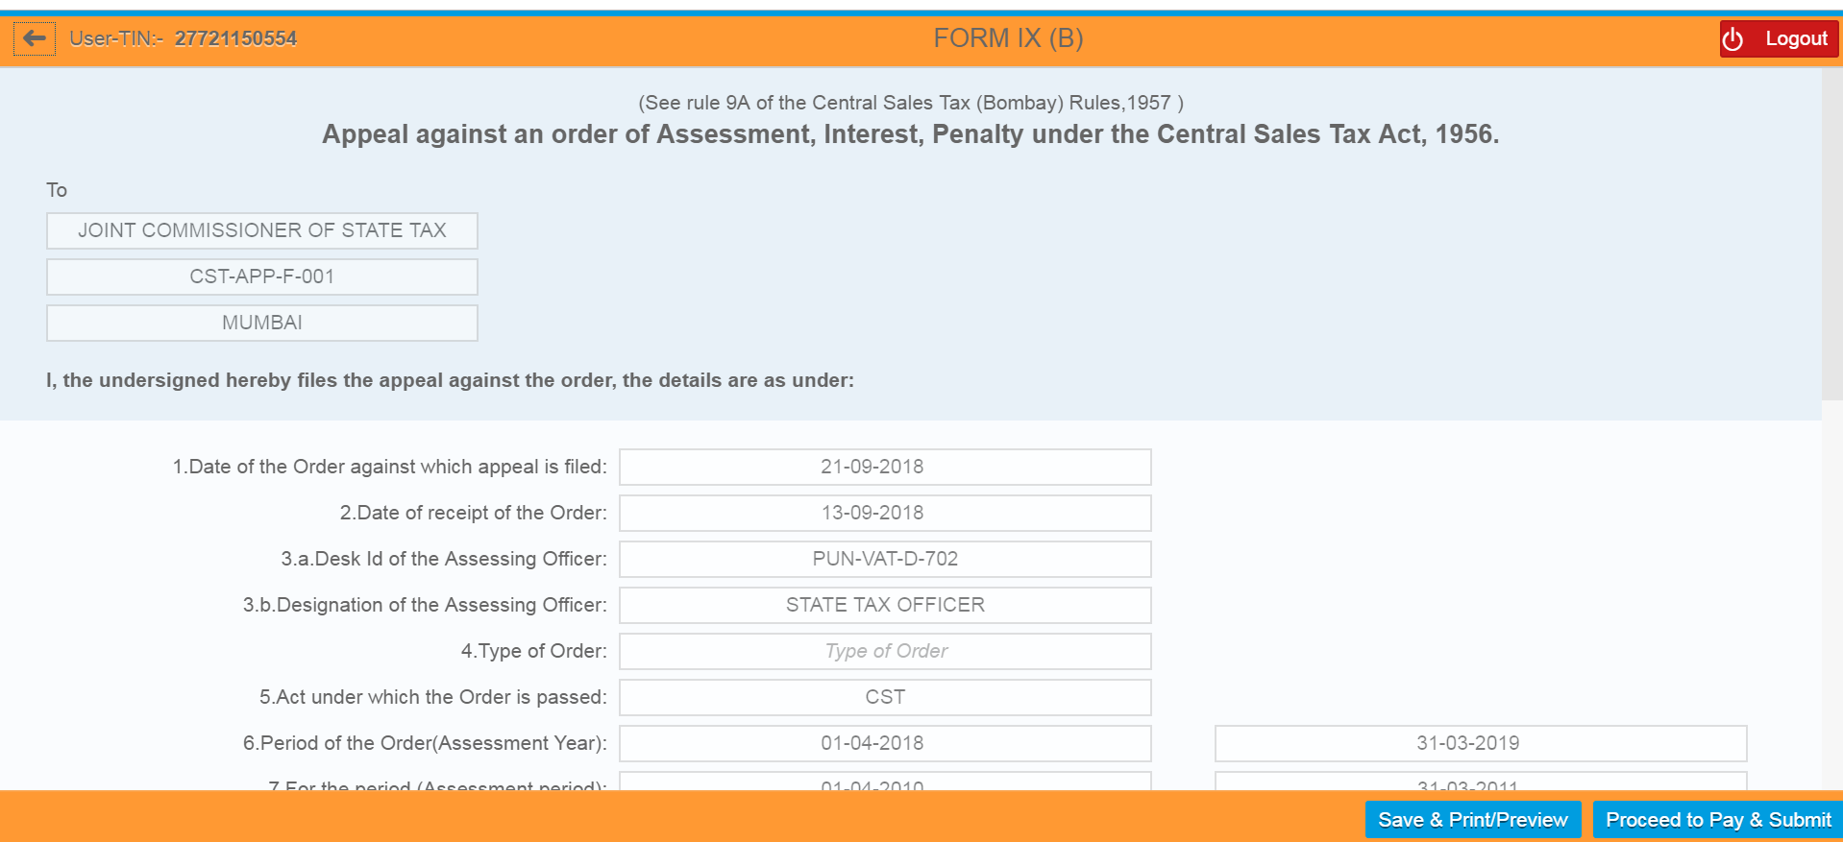

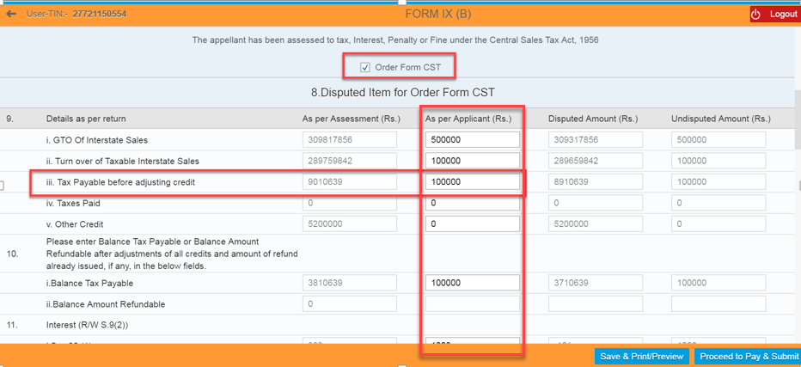

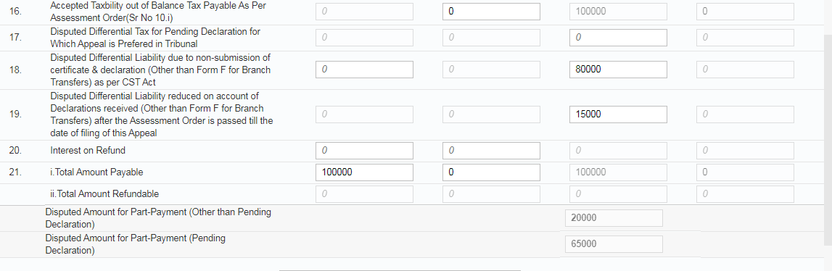

- Enter the value under “Taxes Paid Before Assessment”.
- Select “Yes” for “Whether Desire to file application for stay of recovery” field
- Select Final Stay from Drop-down list for “Type of Stay Desire” field. – Total tax, Total Interest, Total Penalty, Appeal Fee field values should get auto populated once select the Type of Stay Desire. Here if the Date of Assessment Order passed if on or after 15/4/2017, option of Final Stay will be displayed. If the Date of Assessment Order passed is before 15/4/2017, then option of only AD-Interim Stay will be displayed. The amount of Tax, Interest, Penalty, Appeal Fee and Total amount that is to be paid with Appeal Application should get auto populated once select the Type of Stay.
- Enter the Major issue involved in Appeal from the drop down list.
- Enter “Grounds of Appeal” notes. In this section, applicant dealer can enter or copy paste maximum 500 characters. For any additional information to be submitted like Grounds of Appeal, certified copy of Assessment Orders or any other records, dealer can use the facility of File Upload.

- Upload the Files under “File Upload” section by Clicking on “Browse” button and then upload the file
- Clicks on “Delete” button if dealer wants to delete the uploaded file
- Dealer can save the details by clicking on “Save/Print Preview” button

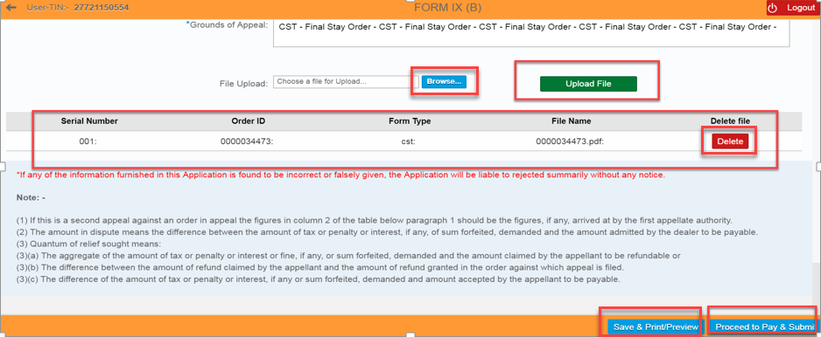

- Clicks on “Download” icon to save the file in local machine

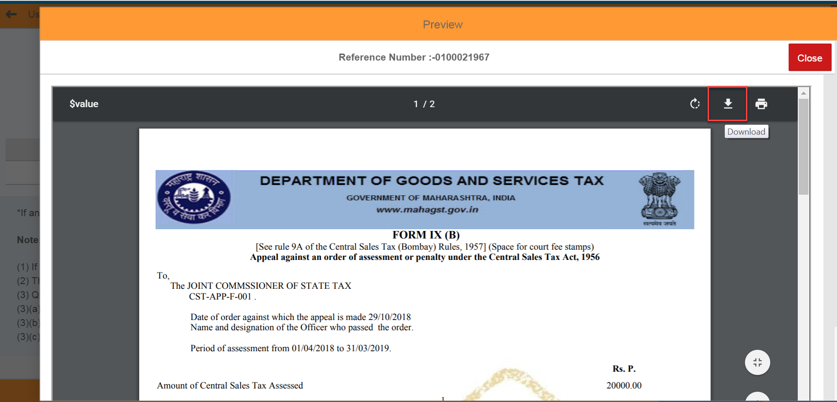

PAYMENT
- Clicks on “Proceed to Pay & Payment” button

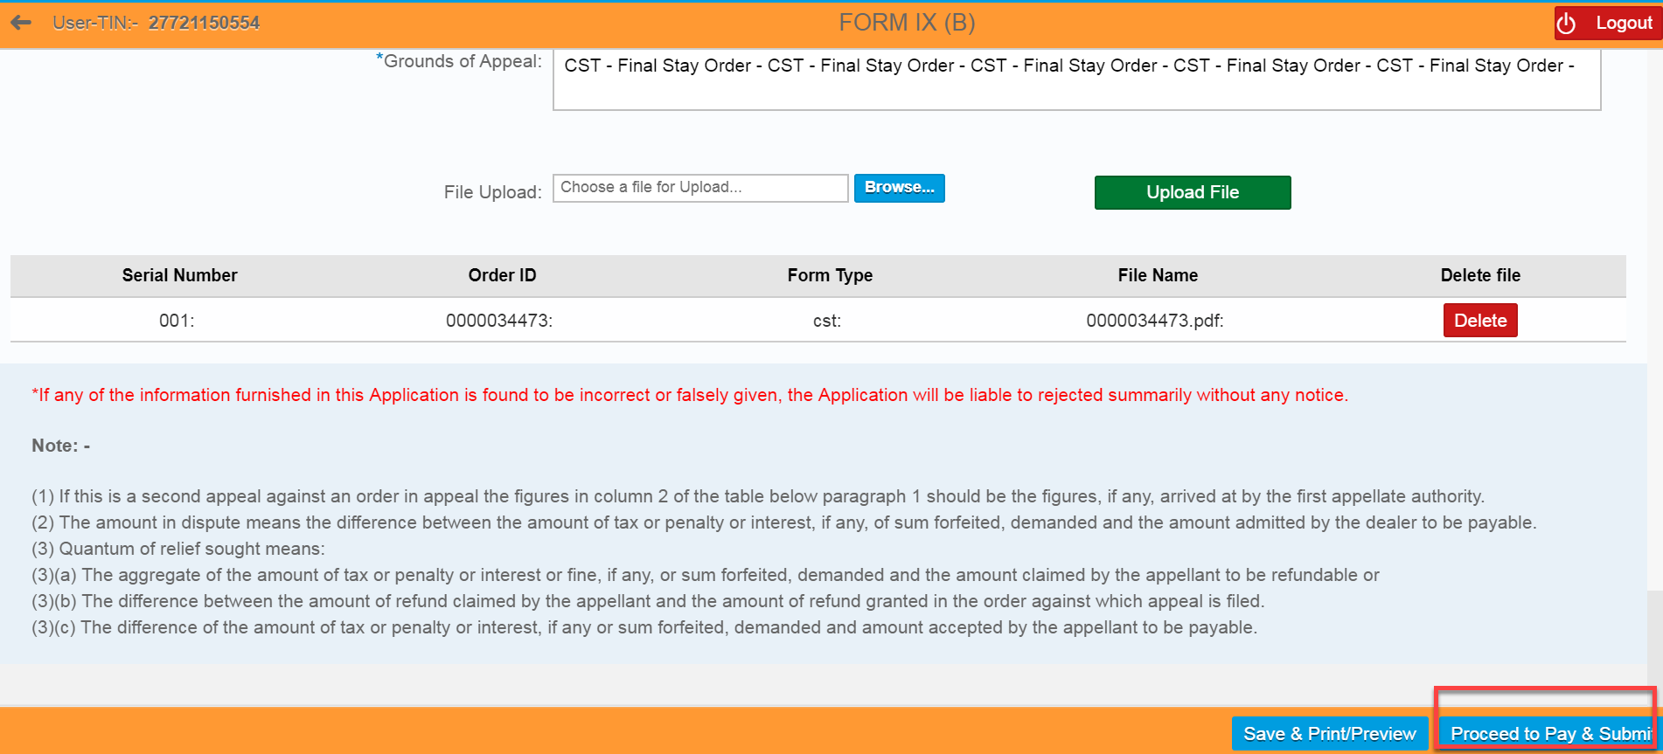

- A Pop Up message appears. If applicant dealer is confirmed of the correctness of data filled in Form IX(B), Clicks on “Proceed” button to go towards Payment. Once the Proceed button is clicked, applicant dealer cannot edit any data in Form IX(B).

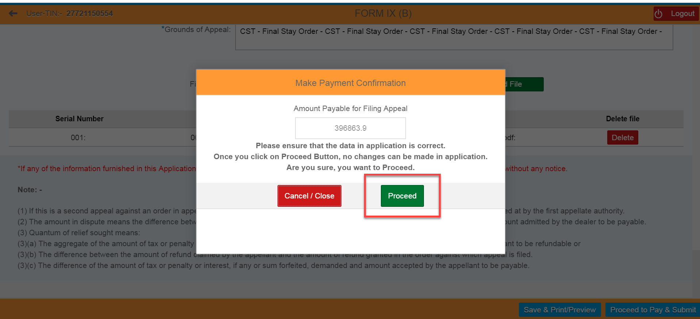

- Tick & select the either of one Payment Gateway (1. “GRAS” – Banks Supported By GRAS; 2. “SBI ePay” - Banks Supported By SBIEPAY)
For e.g.… Here I selected “SBI ePay” radio button
- Select the proper “Location” and enter the valid “Mobile Number” with 10 digits
- Select the “Agree” radio button
- Again clicks on “Proceed For Payment” button

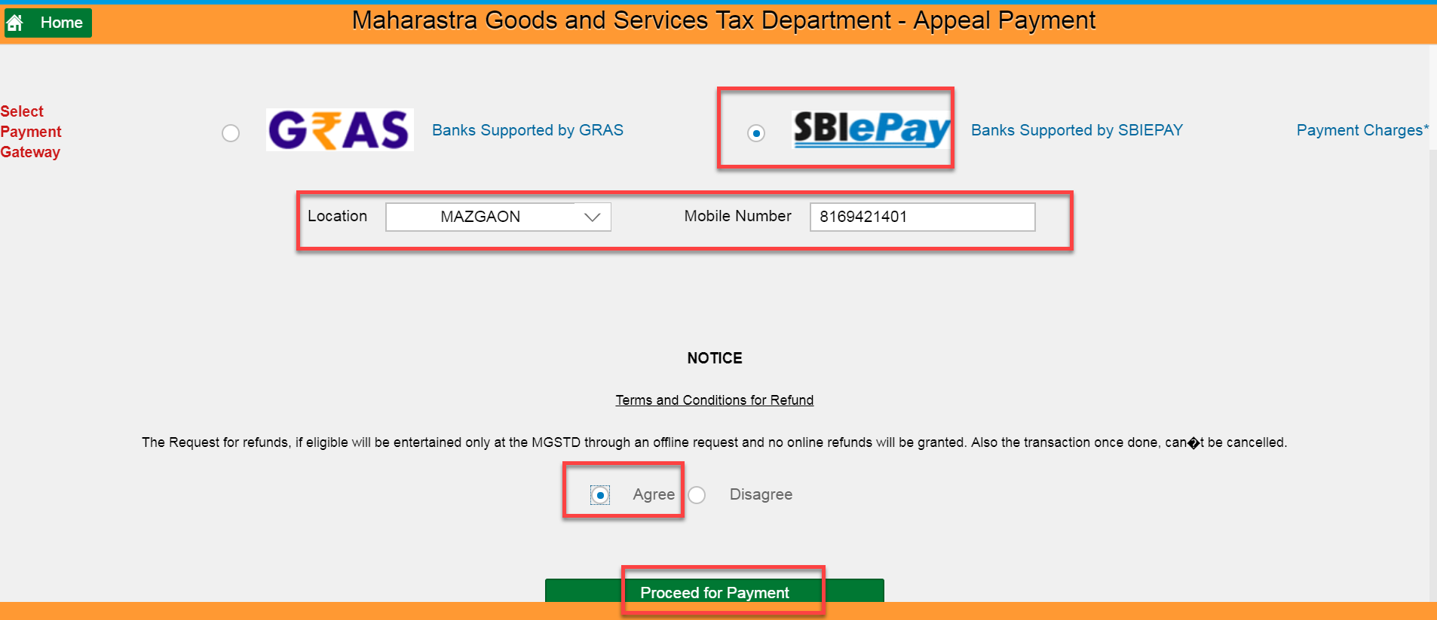

- Clicks on “Make Payment” button

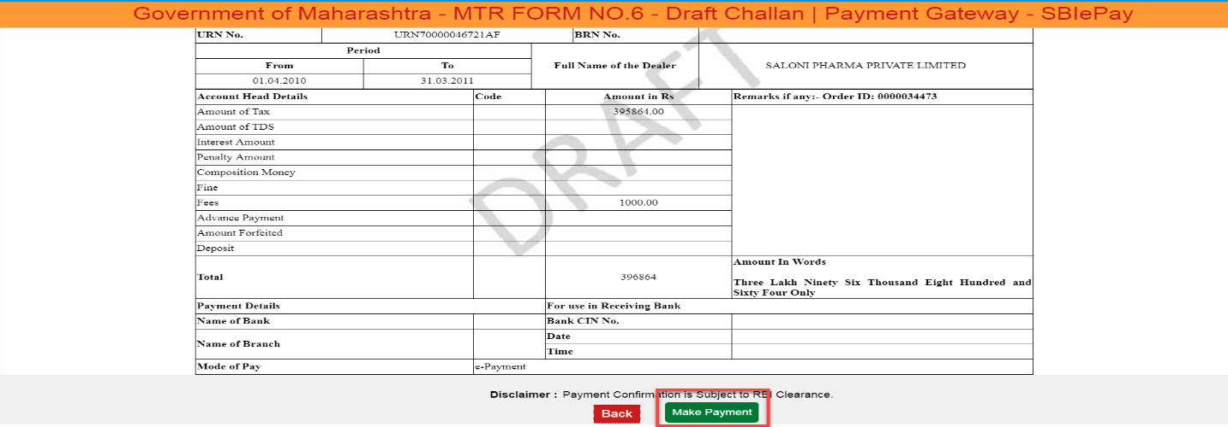

- Select either of one option (“Debit/Credit Card” OR “Internet Banking” OR “PayPal”), Here I have selected “Internet Banking” option
- Select one of the bank from list of banks under “All Banks” section
- Clicks on “Pay Now” button

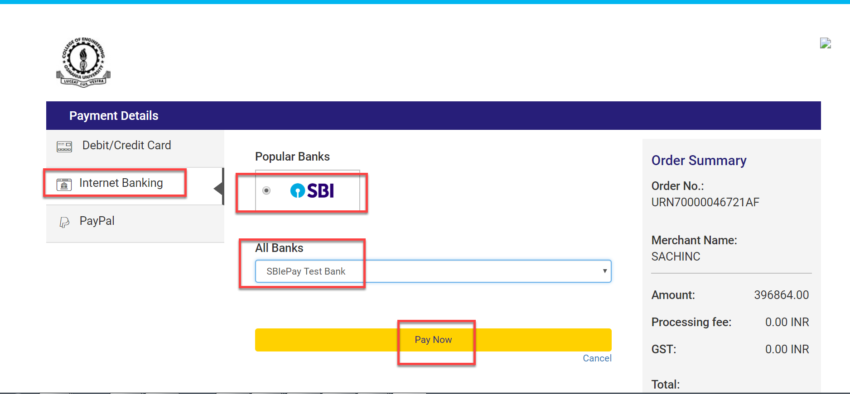

- Clicks on “Successful” button – 1) Payment Acknowledgement should get displayed
2) Appeal Id should get created in CRM automatically and it will be assigned to the concerned Tax Officer
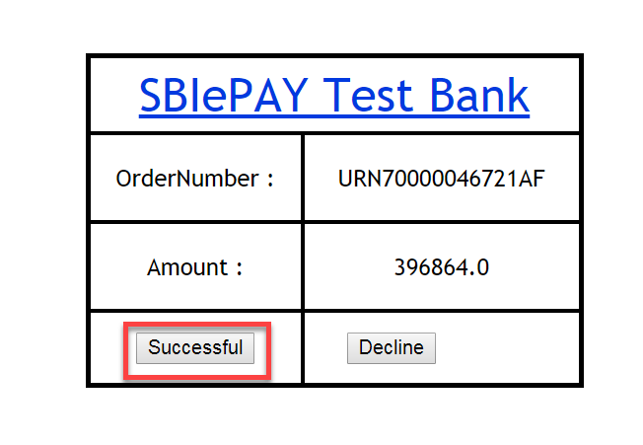
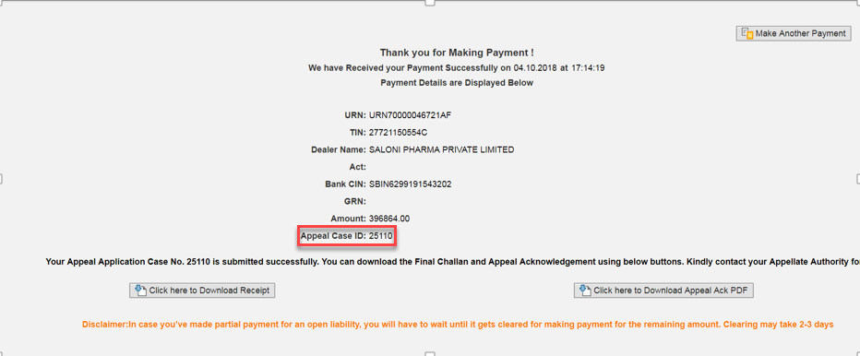

ACKNOWLEDGEMENT FORM
- Clicks on “Click here to Download Appeal Ack PDF” button
- Clicks on “Download” icon under Acknowledgement Form

- Clicks on “Click here to Download Appeal Ack PDF” button

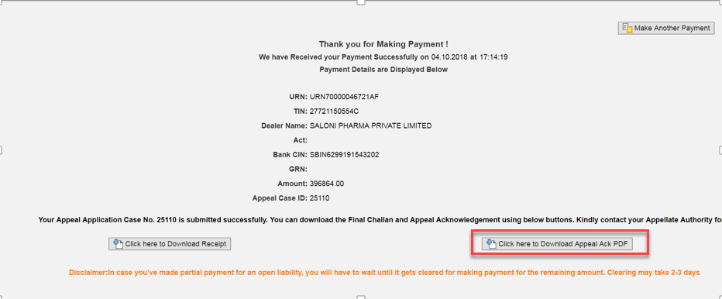

- Clicks on “Download” icon under Acknowledgement Form

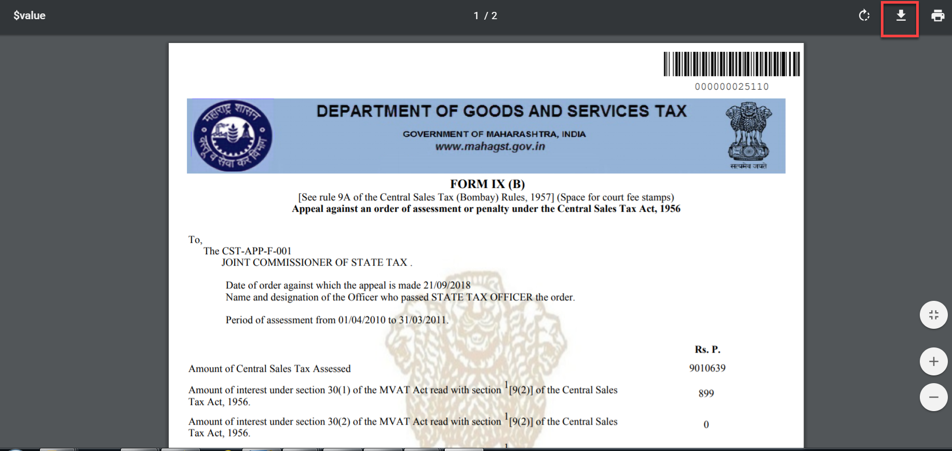

- Sending the payment link and downloading of Appeal Acknowledgement instructions as explained in “FILING OF APPEAL APPLICATION AGAINST ASSESSMENT ORDER PASSED ON SAP SYSTEM UNDER MVAT ACT “remains the same for this Applications also.

FILING OF APPEAL APPLICATION AGAINST ASSESSMENT ORDER ISSUED UNDER MVAT OR CST ACT FOR ASSESSMENT ORDERS NOT AVAILABLE ON SAP SYSTEM AND ORDER HAS RESULTED INTO DEMAND:

It is already mention in Para 7 above that the dealer if knows the Order ID of Assessment Order passed on SAP system against which Appeal is to be filed, can enter the same in a tab provided and can search the order. He can also enter various criteria like Assessment period, Act etc and then can search the order if he does not know the Order ID. In either case, if the Order is available in the system (If the Assessment Order is passed on SAP), the Assessment Order in PDF format will be displayed to the dealer against which the dealer can file the Appeal. In such cases, the Assessment Order data will auto populate in the “As per Order” of the Appeal Application against which applicant dealer can enter the data in “As per dealer” column. The system will then automatically calculate the Disputed and Undisputed Dues. If the order is not available in the system, the line items of the Assessment Order dues if available in the recovery dues of the dealer will be displayed. The dealer then can identify the line item as per the Assessment Dues and click on the document number to open the Appeal Application. The dealer can then enter the information in the Application in both “As per Order” column and “As per dealer” column. The system will then automatically calculate the Disputed and Undisputed Dues. There are some mandatory fields which the dealer needs to fill in order to save the Application. The system will then automatically calculate the disputed and undisputed amounts based on information filled by the dealer. Thus the only difference in filling of Appeal Application for the Orders available on SAP system and for orders not available on SAP system is that, dealer will have to enter the values in both “As per Order” and “As per dealer” column for Assessment Orders which are not available in SAP system. Further calculation of part payments and payment of the said amount is same for both types of Appeal Application. Following details explains the step by step procedure for filing of Appeal Application for Assessment Orders which are not available on SAP system. The procedure of VAT and CST remains the same except the type of stay available under the said Acts.

LOG IN SCREEN
- Login in to Dealer Application with your Login credentials.
- User:
- Password:
- Click on ‘’Log On’’ button

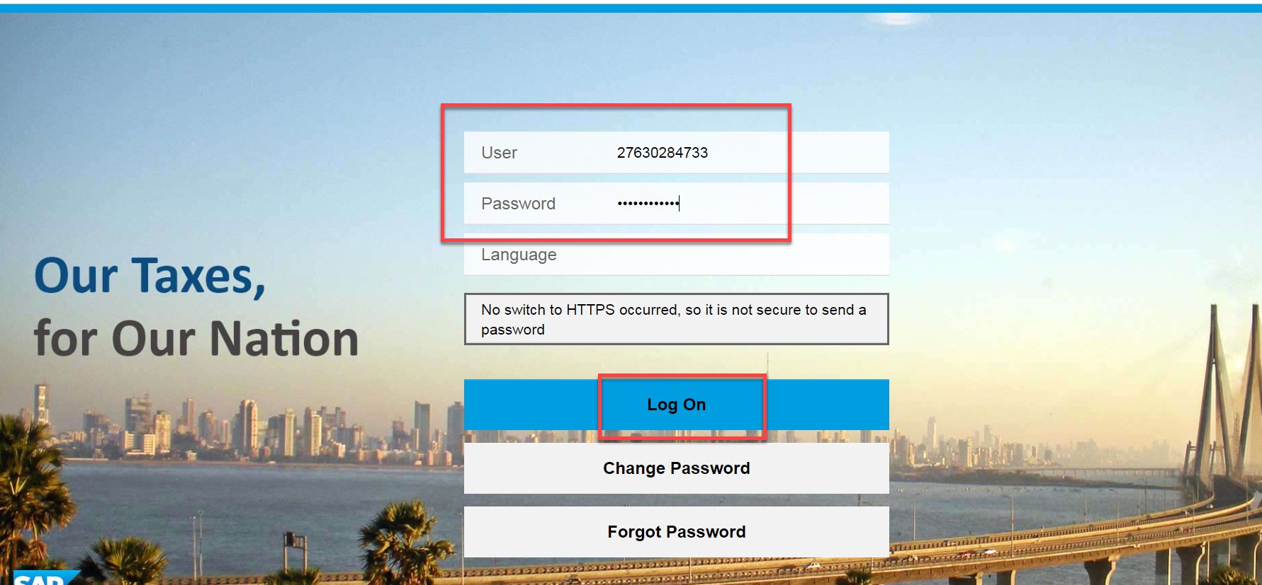
XXXXXXXX

OPEN APPEAL DOCUMENT NUMBER SEARCH
- Click on ‘’Other-E Services’’ option from L.H.S menu (Left Hand Side)
XXXXXXXX

- Click on “Appeal” tile under Activities section

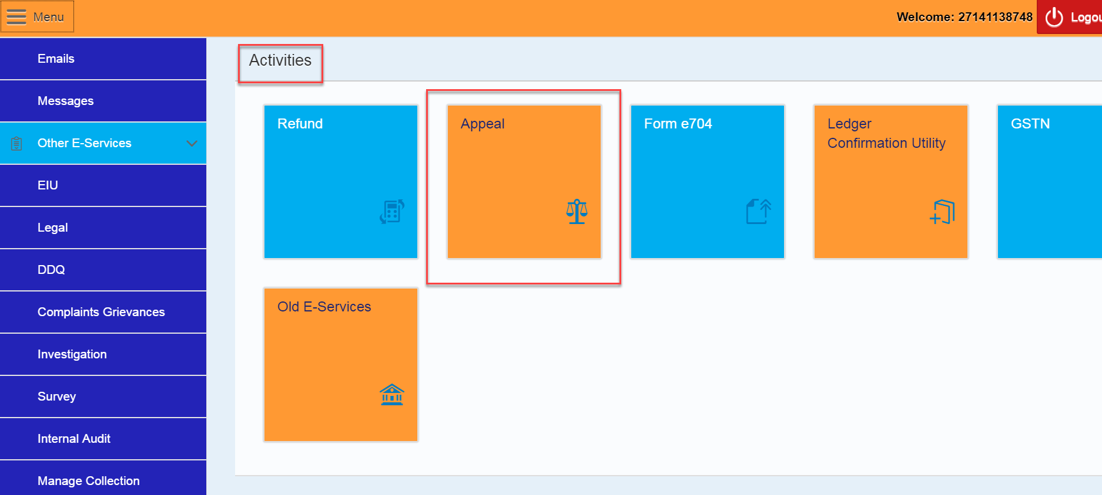
XXXXXXXX

- Click on “Appeal” tile again under CRM APPEAL // APPEAL TO TRIBUNAL HOME PAGE

- Select An Act, and Document Type from drop down list
- Enter Period of Assessment From, and Period of Assessment To date
- Clicks on “Submit” button

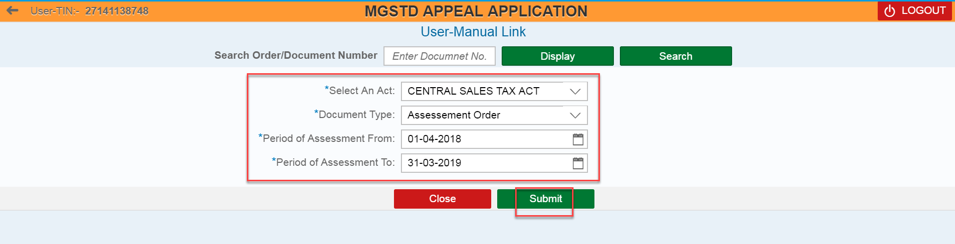

- Clicks on “Document Number” blue hyper link to open the Appeal Application.

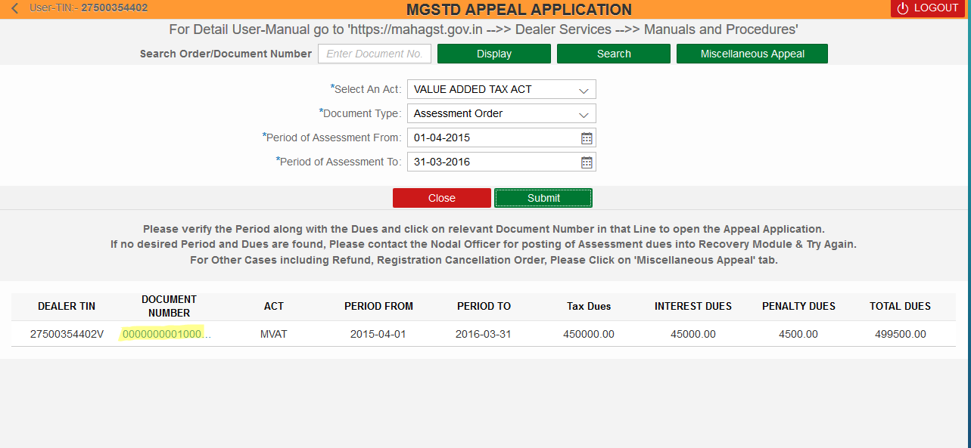

FORM 310/FORM IX (B)
- Enter the Date for “Date of the Order against which appeal is filed”
- Enter the Date for “Date of receipt of the Order”
- Enter the valid Desk Id of the Assessing Officer and then Click on Validate button
- Select the “Type of the Order” from drop-down list
- Select the Act for “Act under which the Order is passed” from drop-down list
- Select the Dates for For the period (Assessment period)

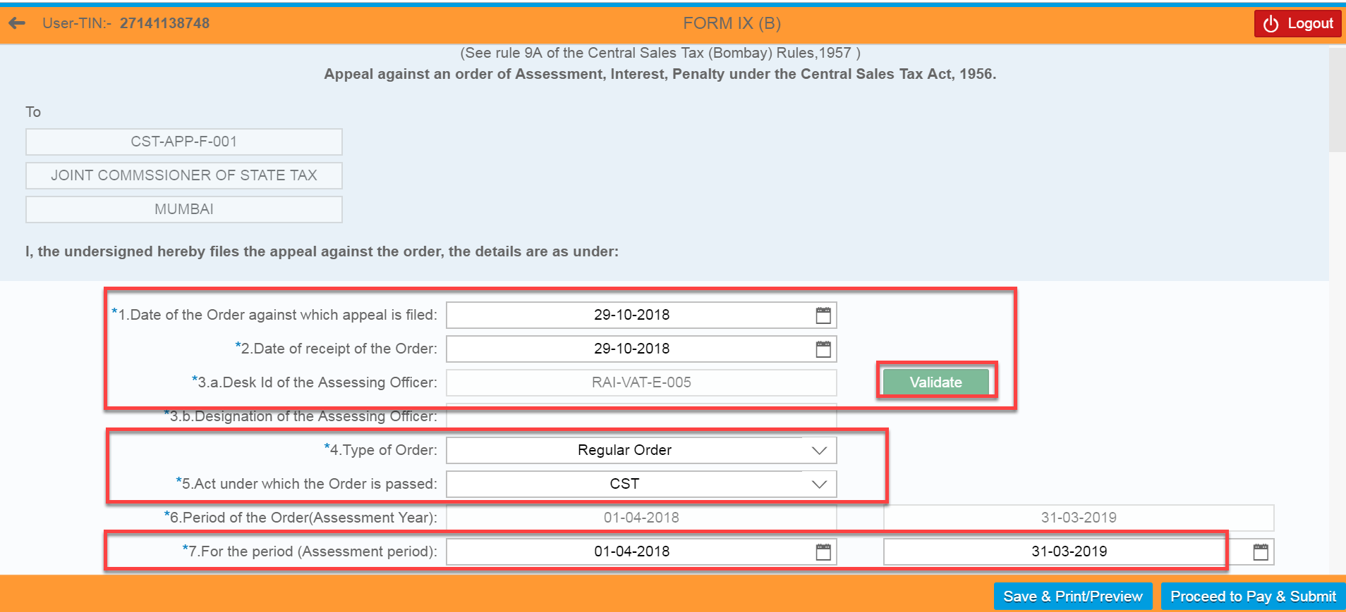

- Enter values under “As Per Assessment (Rs.)” and “As Per Applicant (Rs.)” sections for all mandatory fields. Kindly note that the amount of Disputed and undisputed dues is calculated based on the information furnished by dealer in first two columns. Hence, applicant dealer should take utmost care while entering the amounts in these columns.

e.g.. GTO Of Inter state sales
Turn over of Taxable Interstate Sales

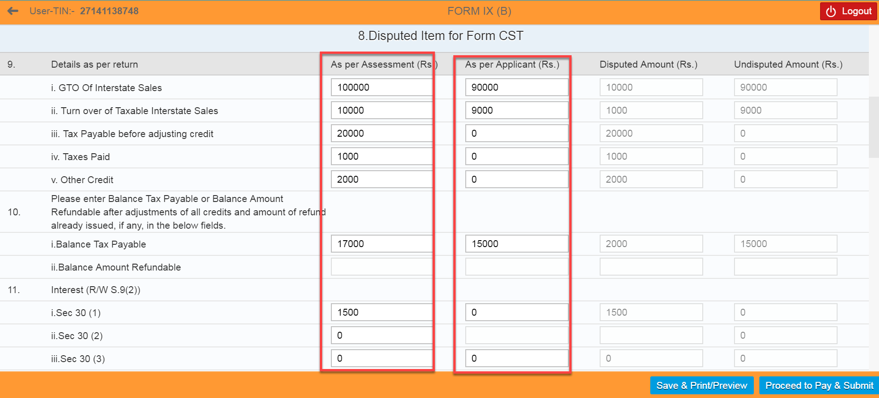

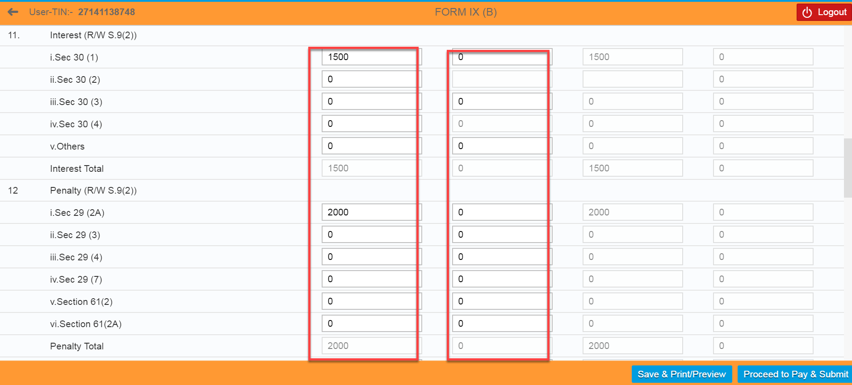

- Enter the value under “Taxes Paid before Assessment”.
- Select “Yes” for “Whether Desire to file application for stay of recovery” field
- Select desired Stay from Drop-down list for “Type of Stay Desire” field. – Total tax, Total Interest, Total Penalty, Appeal Fee and Amount Payable for Filing Appeal field values should get auto populated once select the Type Of Stay Desire.
- Select the Major issue involved in Appeal from the drop down list.
- Enter “Grounds of Appeal” notes.
- Kindly note that all the features of Appeal Application for Assessment Orders passed on SAP system and not passed on SAP system remains same with respect to calculation of disputed and undisputed amount, stay facility, payment of amounts etc. Only difference is that for SAP Appeal Application, dealer will have to enter the values in only “As per dealer” column and in Non-SAP Appeal Application, dealer will have to enter the values in both “As per Order” and “As per dealer” columns.

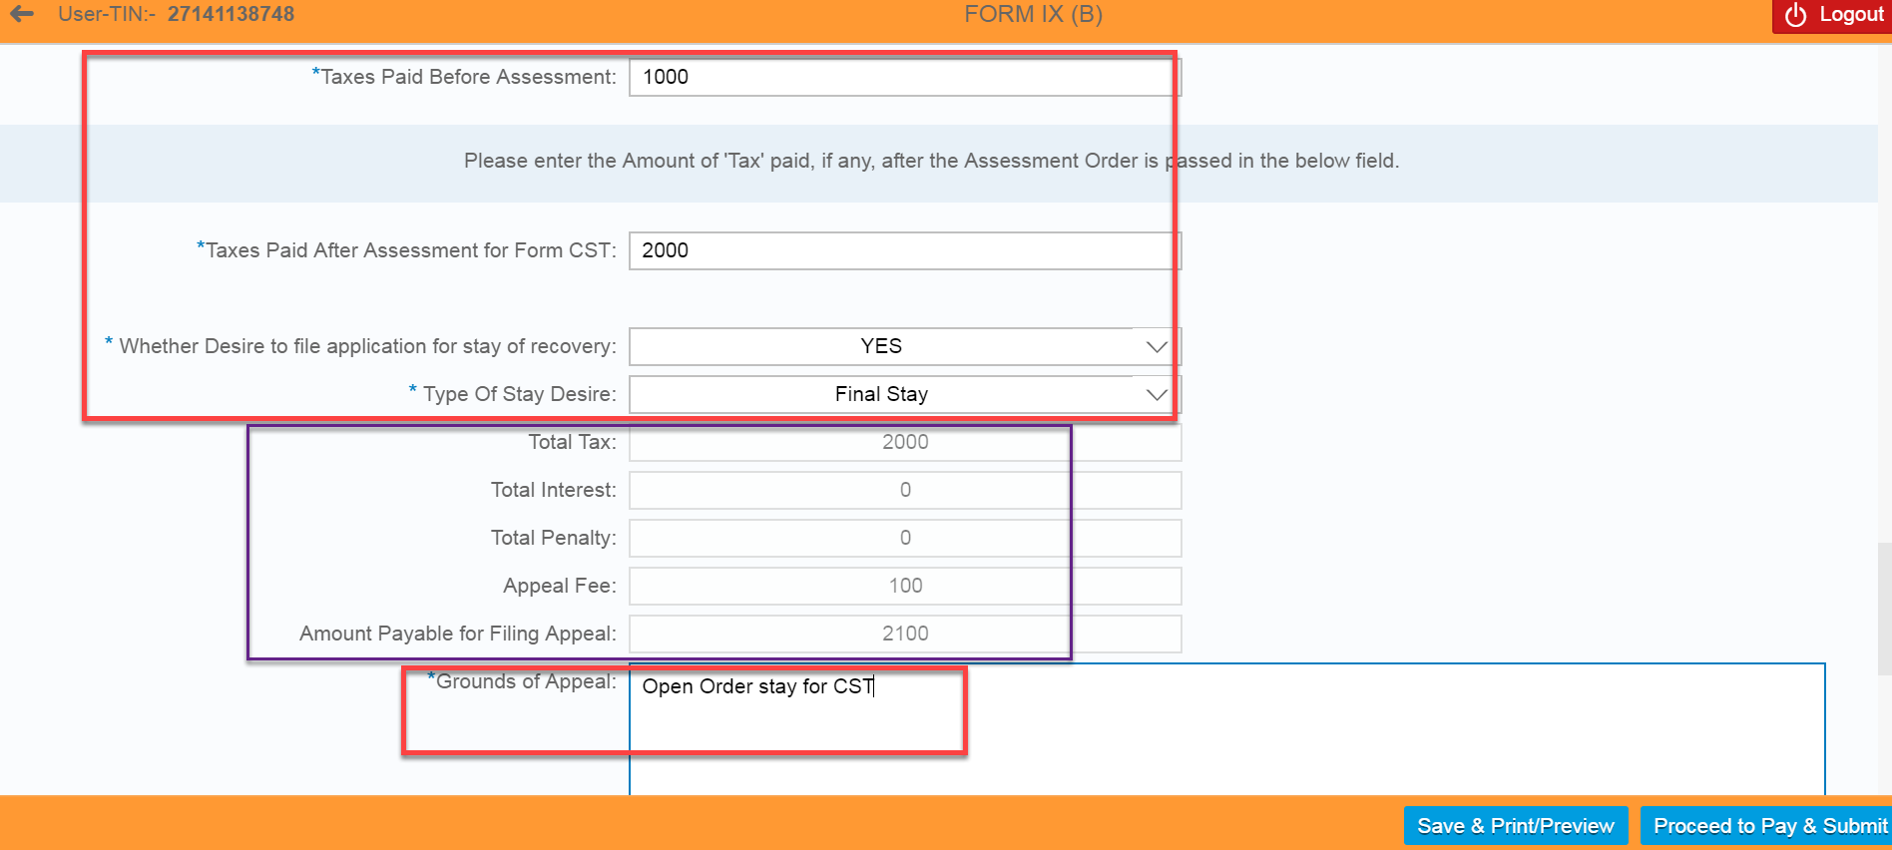

- Upload the Files under “File Upload” section by Clicking on “Browse” button and then upload the file
- Clicks on “Delete” button if dealer wants to delete the uploaded file
- Dealer can save the details by clicking on “Save/Print Preview” button

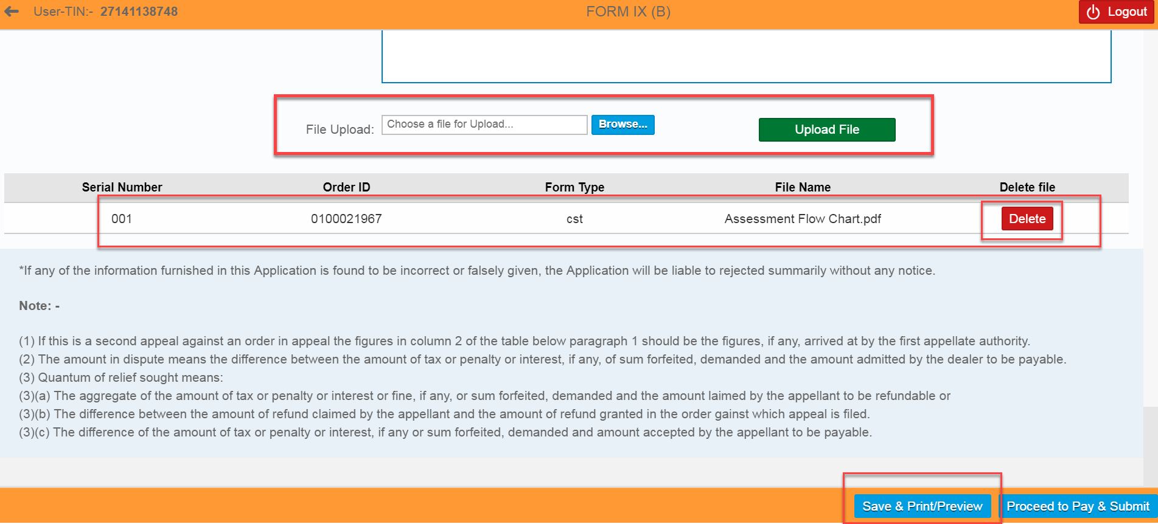

- Clicks on “Download” icon to save the file in local machine

PAYMENT
- Clicks on “Proceed to Pay & Submit” button

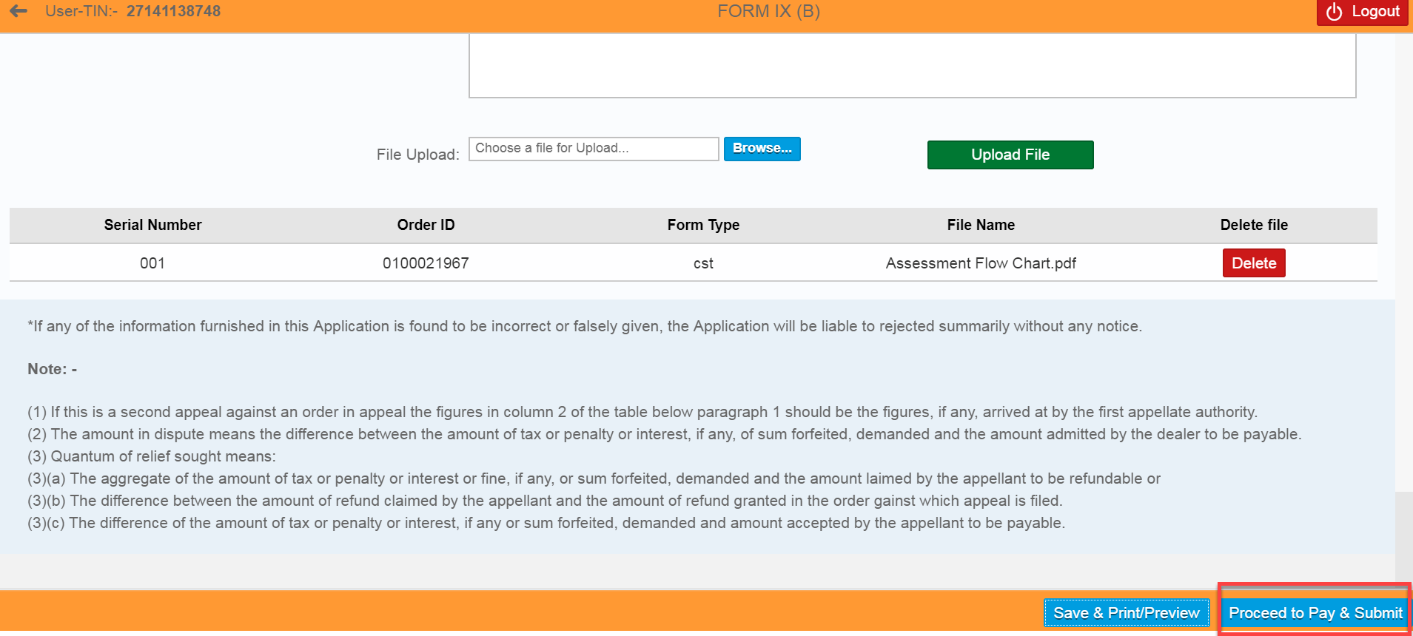

- Clicks on “Proceed” button
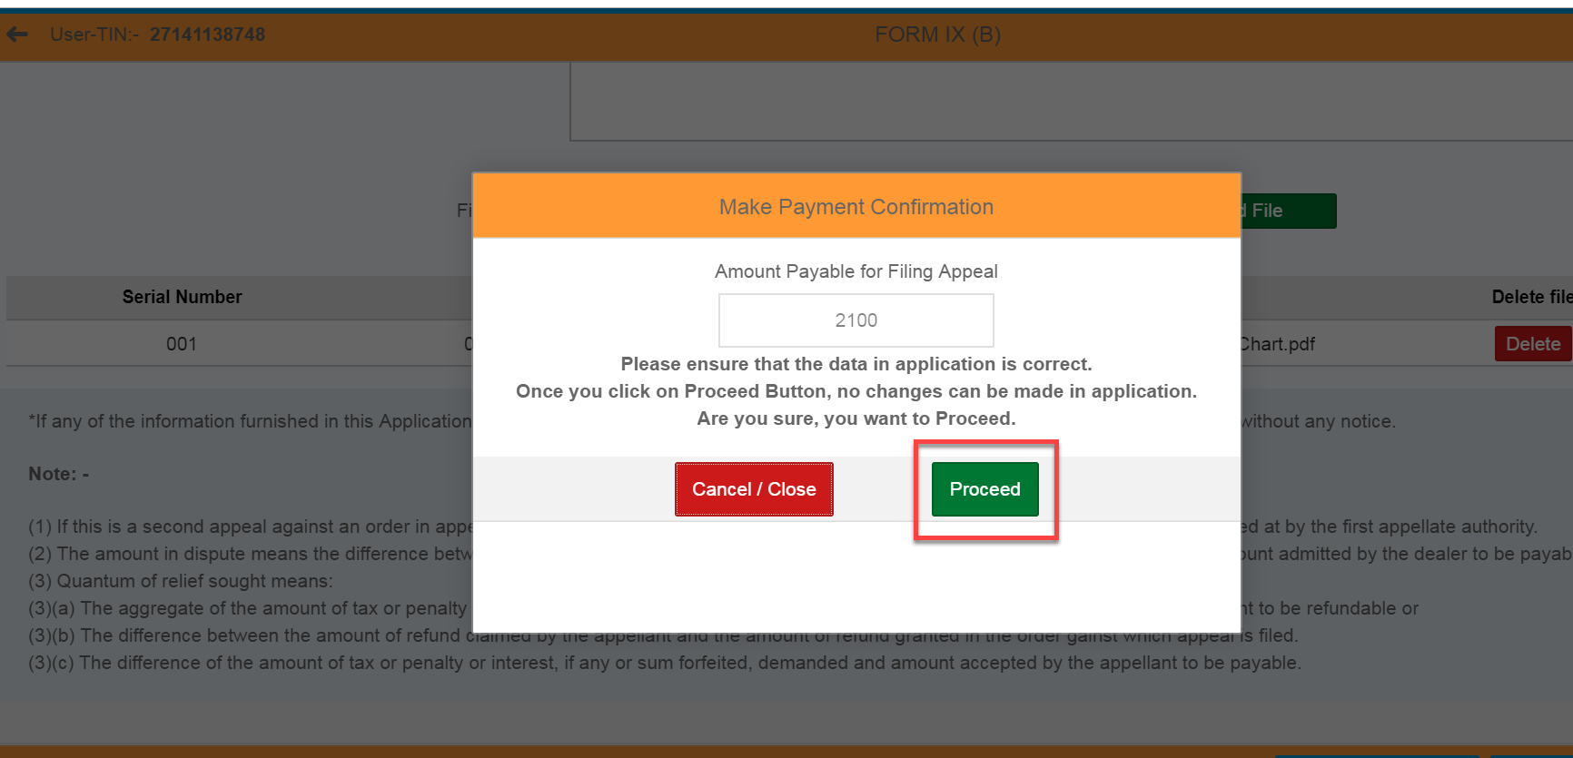

- Select the either of one Payment Gateway (1. “GRAS” – Banks Supported By GRAS; 2. “SBI ePay” - Banks Supported By SBIEPAY)
For e.g.… Here I selected “SBI ePay” radio button
- Select the proper “Location” and enter the valid “Mobile Number” with 10 digits
- Select the “Agree” radio button
- Again clicks on “Proceed For Payment” button

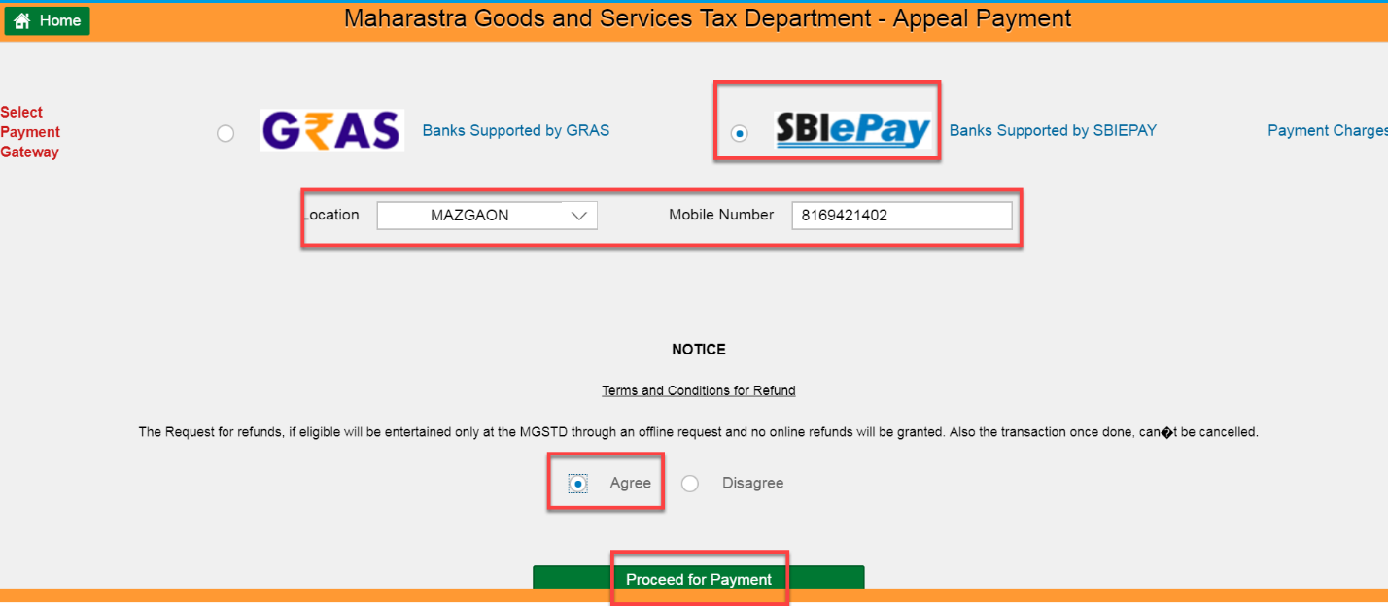

- Clicks on “Make Payment” button

- Select either of one option (“Debit/Credit Card” OR “Internet Banking” OR “PayPal”),
For e.g.… Here I have selected “Internet Banking” option
- Select one of the bank from the list of banks under “All Banks” section
- Clicks on “Pay Now” button
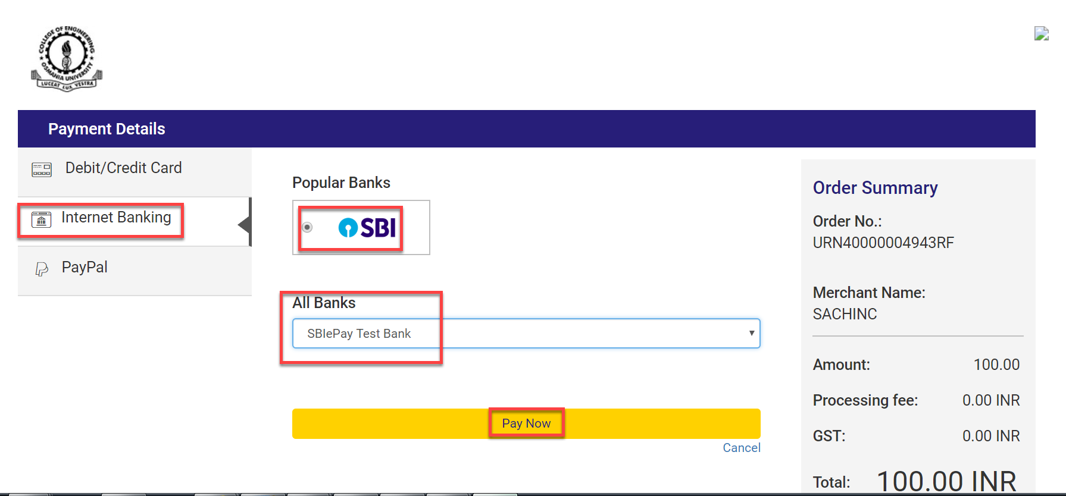

- Clicks on “Successful” button – 1) Payment Acknowledgement should get displayed
2) Appeal Id should get created in CRM automatically and it will be assigned to the concerned Tax Officer. The dealer can use this Appeal ID for subsequent Appeal proceedings.
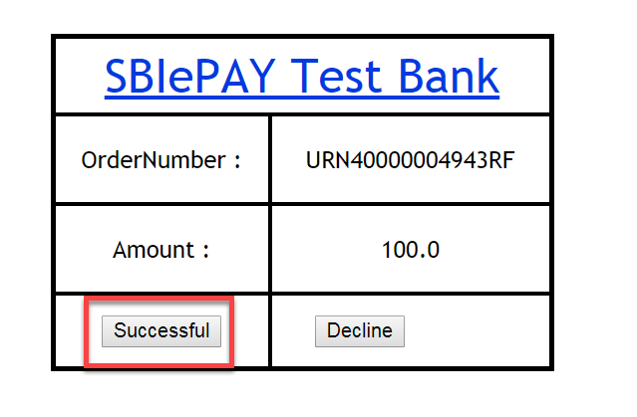
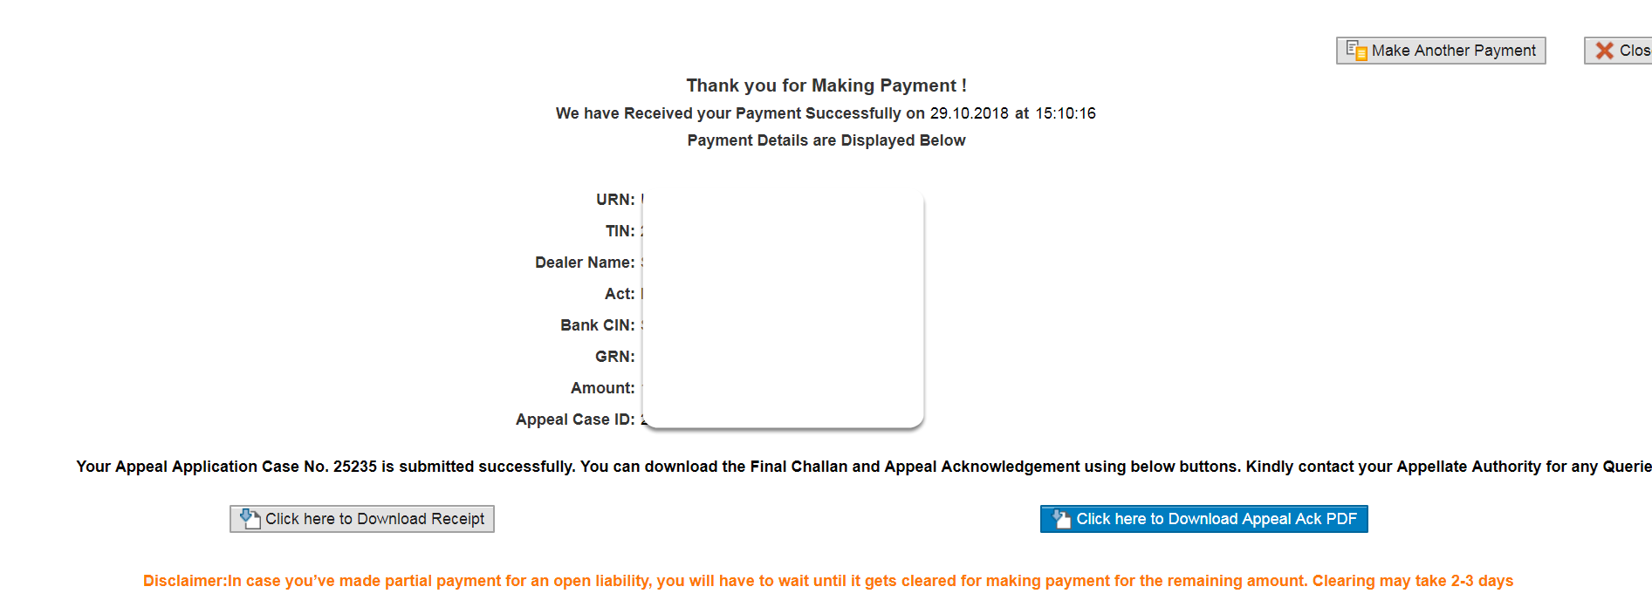
- Sending the payment link and downloading of Appeal Acknowledgement instructions as explained in “FILING OF APPEAL APPLICATION AGAINST ASSESSMENT ORDER PASSED ON SAP SYSTEM UNDER MVAT ACT “remains the same for this Applications also.
- the dealer can directly go to payment window by following above steps. sometimes, if the dealer does not wish to pay the amount immediately and wants to log out, On saving the application, a reference number is generated. this reference number can be used by the dealer if he wishes to log out and again log in for filing appeal. this referenec number can be entered in document search window and select type of document as “draft appeal application” so that the appeal application saved in earlier session will be opened and the dealer can further file the application by following above steps.

ACKNOWLEDGEMENT FORM
- Clicks on “Click here to Download Appeal Ack PDF” button
- Clicks on “Download” icon under Acknowledgement Form

- Clicks on “Click here to Download Appeal Ack PDF” button

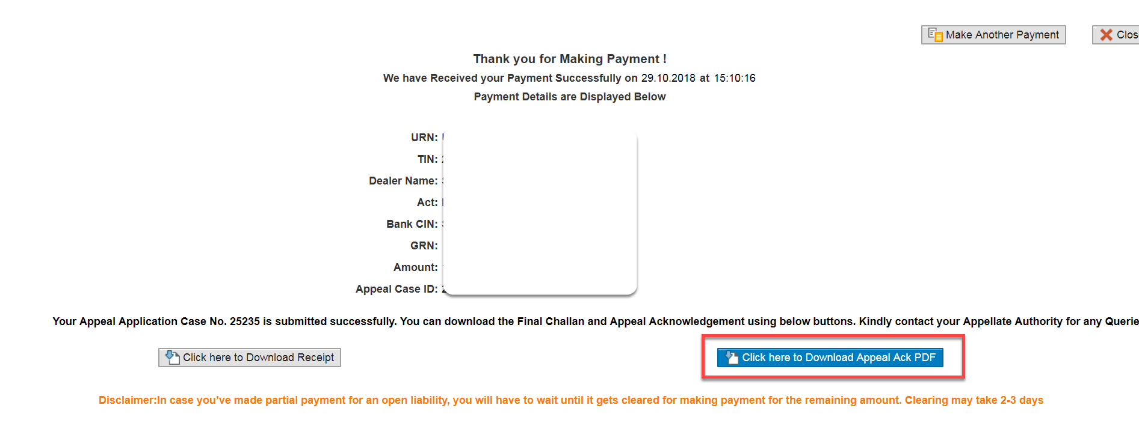

- Clicks on “Download” icon under Acknowledgement Form

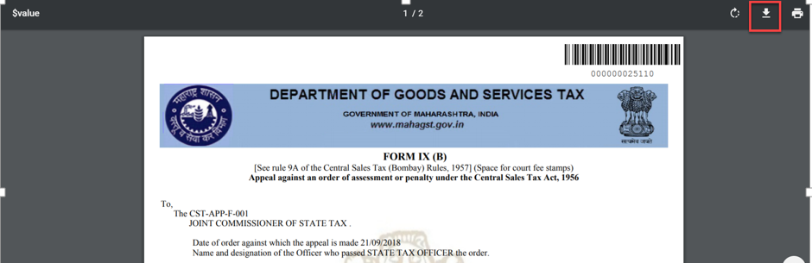

4.FILING OF MISCELLENEOUS APPEAL APPLICATION:

The dealer also can file the Miscellaneous Appeal by following the below mentioned steps. This gateway of Appeal Application filing can also be used for Appeal against the Assessment Orders not passed on SAP System and resulted into refund and also for Miscellaneous Appeal against the Registration Cancellation Orders.

- Login in to Dealer Application with your Login credentials.
- User:
- Password:
- Click on ‘’Log On’’ button

XXXXXXXX

OPEN APPEAL DOCUMENT NUMBER SEARCH
- Click on ‘’Other-E Services’’ option from L.H.S menu (Left Hand Side)
XXXXXXXX

- Click on “Appeal” tile under Activities section

XXXXXXXX

- Click on “Appeal” tile again under CRM APPEAL // APPEAL TO TRIBUNAL HOME PAGE

- Select the Act, and Document Type of Registration Cancellation Order from drop down list
- Enter Period of Assessment From, and Period of Assessment To date. Please enter the period of Financial Year of the date in which the Registration Cancellation Order is issued.
- Clicks on “Submit” button

- Following screen will appear. Click on Miscellaneous Appeals Tab provided on top right hand corner.
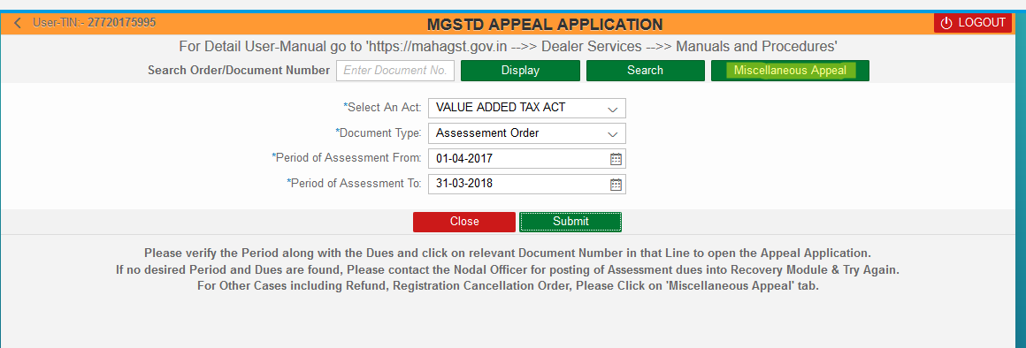
- On clicking the above tab, Miscellaneous Appeal Application screen will appear. Select the drop down of Registration Cancellation Order as provided in below screen.
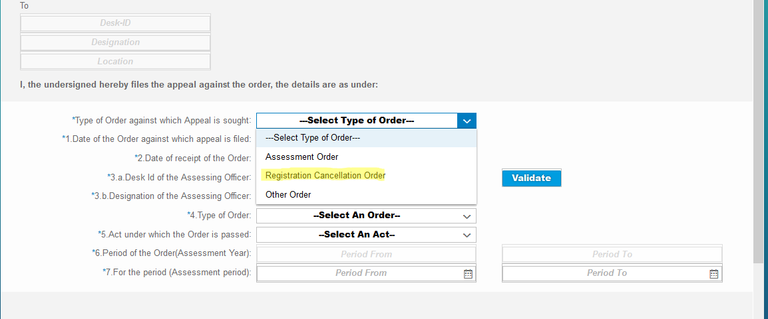

- The Applicant has to enter the remaining details. On entering the Desk ID of Assessing Officer click on Validate tab. If not validated, reenter the correct Desk ID. On entering the correct desk of Assessing Officer and on clicking Validate tab, system will automatically show the Appellate Officer Desk.
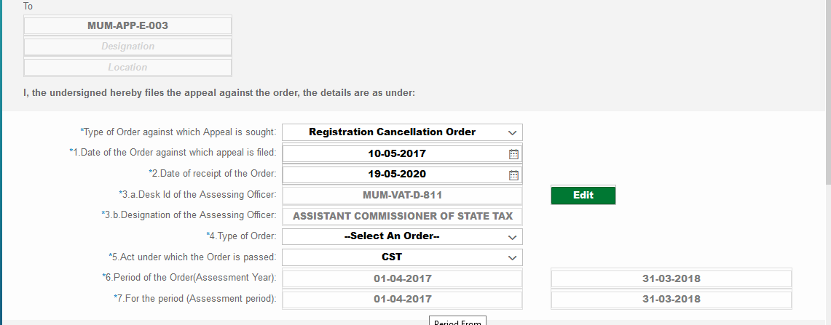

- Enter the remaining details. Applicant can attach the desired files along with the Appeal Application.

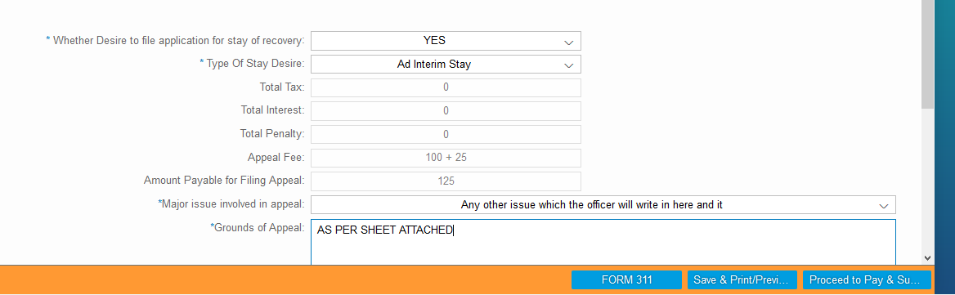

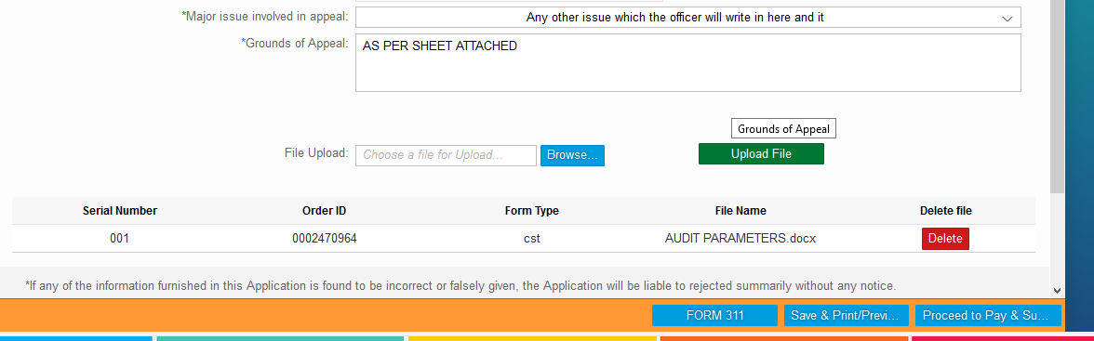

PAYMENT
- Clicks on “Proceed to Pay & Submit” button

- Clicks on “Proceed” button

- Select the either of one Payment Gateway (1. “GRAS” – Banks Supported By GRAS; 2. “SBI ePay” - Banks Supported By SBIEPAY)
For e.g.… Here I selected “SBI ePay” radio button
- Select the proper “Location” and enter the valid “Mobile Number” with 10 digits
- Select the “Agree” radio button
- Again clicks on “Proceed For Payment” button

- Clicks on “Make Payment” button

- Select either of one option (“Debit/Credit Card” OR “Internet Banking” OR “PayPal”),
For e.g.… Here I have selected “Internet Banking” option
- Select one of the bank from the list of banks under “All Banks” section
- Clicks on “Pay Now” button

- Clicks on “Successful” button – 1) Payment Acknowledgement should get displayed
2) Appeal Id should get created in CRM automatically and it will be assigned to the concerned Tax Officer. The dealer can use this Appeal ID for subsequent Appeal proceedings.
- Sending the payment link and downloading of Appeal Acknowledgement instructions as explained in “FILING OF APPEAL APPLICATION AGAINST ASSESSMENT ORDER PASSED ON SAP SYSTEM UNDER MVAT ACT “remains the same for this Applications also.
- the dealer can directly go to payment window by following above steps. sometimes, if the dealer does not wish to pay the amount immediately and wants to log out, On saving the application, a reference number is generated. this reference number can be used by the dealer if he wishes to log out and again log in for filing appeal. this referenec number can be entered in document search window and select type of document as “draft appeal application” so that the appeal application saved in earlier session will be opened and the dealer can further file the application by following above steps.

ACKNOWLEDGEMENT FORM
- Clicks on “Click here to Download Appeal Ack PDF” button
- Clicks on “Download” icon under Acknowledgement Form

- Clicks on “Click here to Download Appeal Ack PDF” button

- Clicks on “Download” icon under Acknowledgement Form
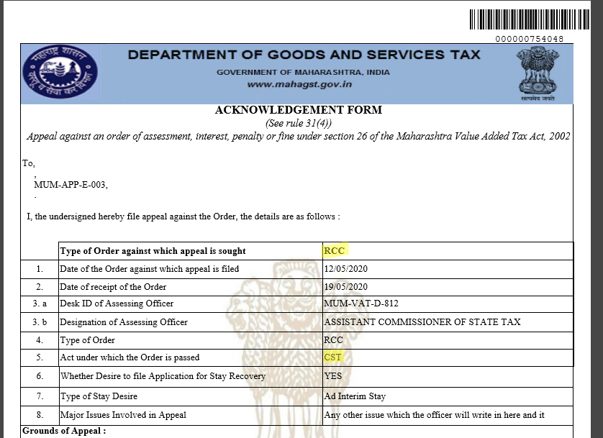
- Sending the payment link and downloading of Appeal Acknowledgement instructions as explained in “FILING OF APPEAL APPLICATION AGAINST ASSESSMENT ORDER PASSED ON SAP SYSTEM UNDER MVAT ACT “remains the same for this Applications also.

A. FILING OF DEALAY CONDONATION APPLICATION:

Delay Condonation Application is available to be filed online wherever there is a difference of more than 60 days in the date of service of Order against which Appeal is sought and date of Appeal application. The system automatically calculates the difference in these dates and displays the Tab of Delay Condo nation to the bottom of Appeal Application screen. Unless the Delay Condonation Application is filed, the applicant cannot proceed to submit the Appeal application.
If the applicant wishes to attach his detail say on Reasons for delay condonation, he can attach the said file in main Appeal Application screen.

DELAY CONDONATION APPLICATION
- Clicks on “Condonation Application” button

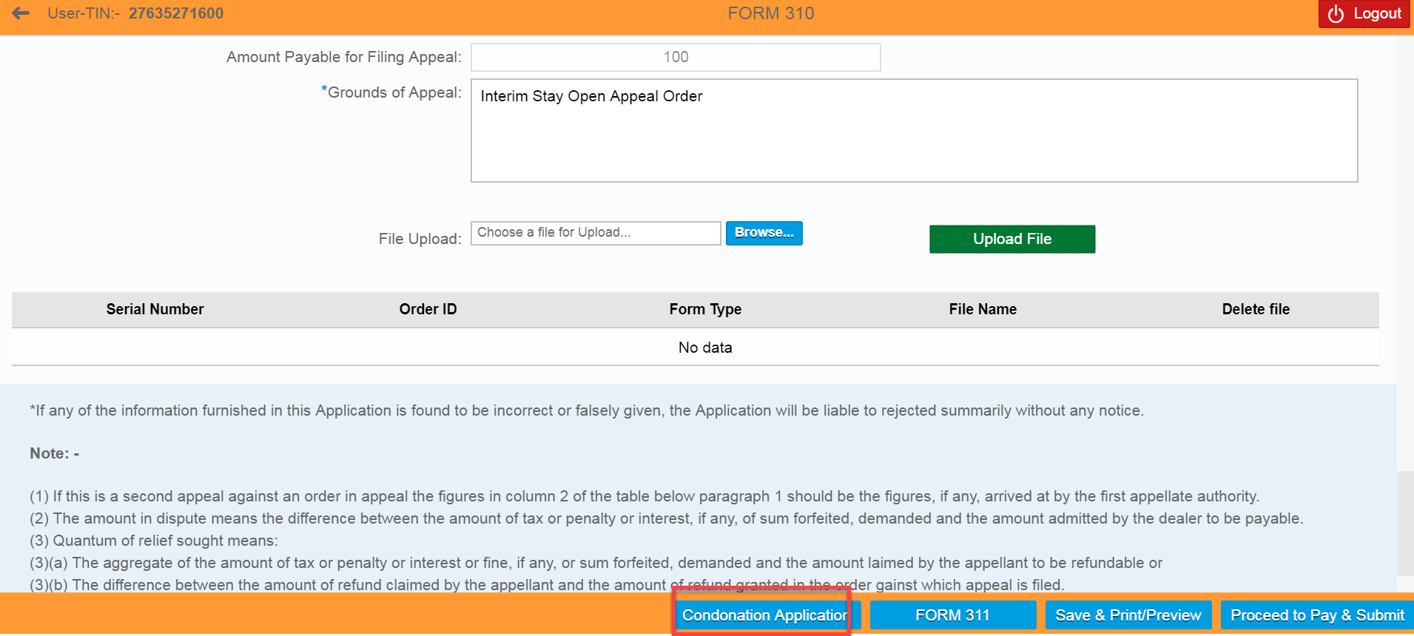

- Select “Condo nation Reason” from drop-down list
- Enter the “Reason for delay in filing the appeal” notes
- Dealer can save the details by clicking on “Save/Print Preview” button

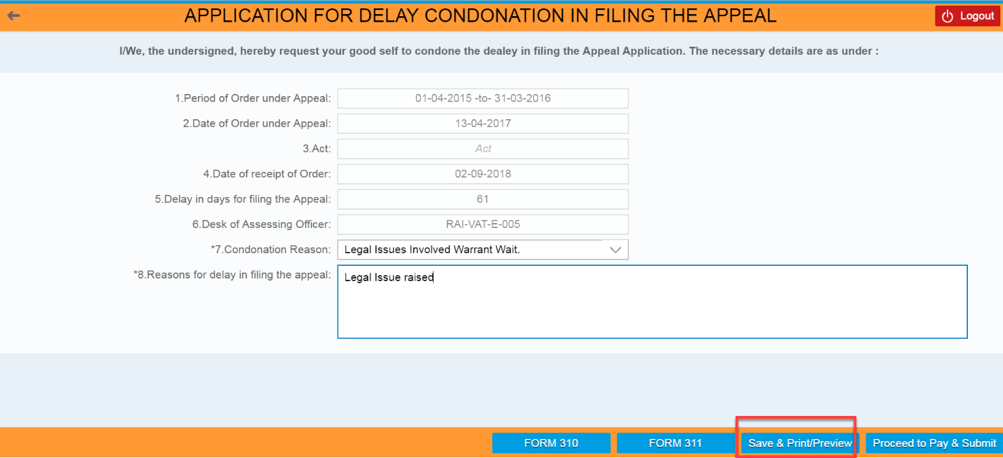

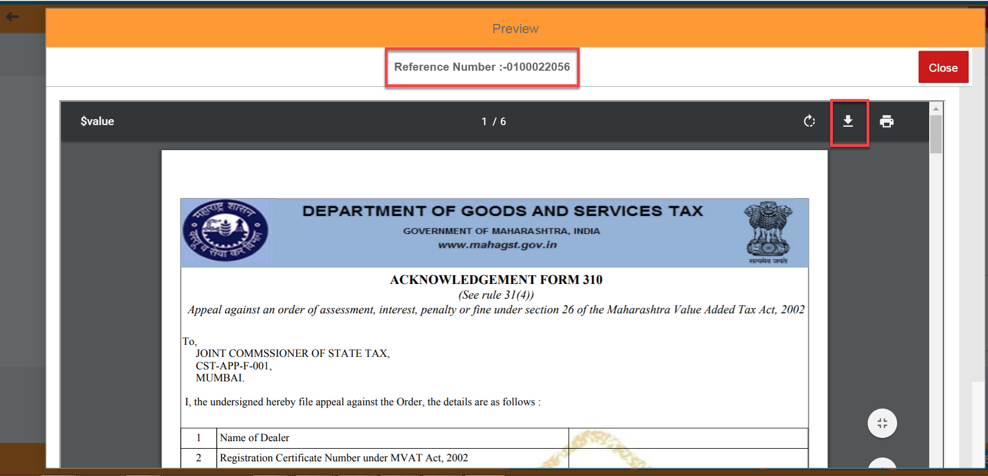

- Clicks on “Download” icon to save the file in local machine

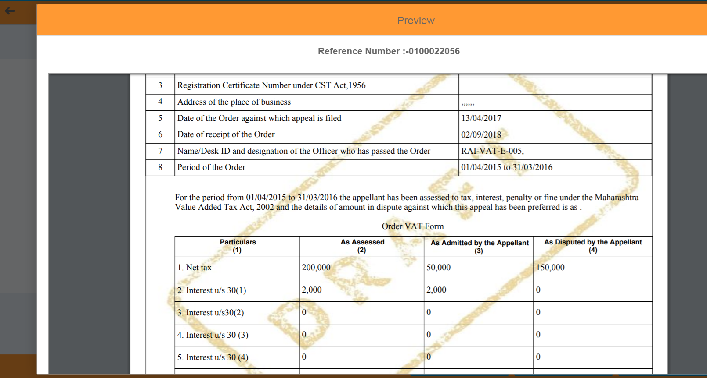

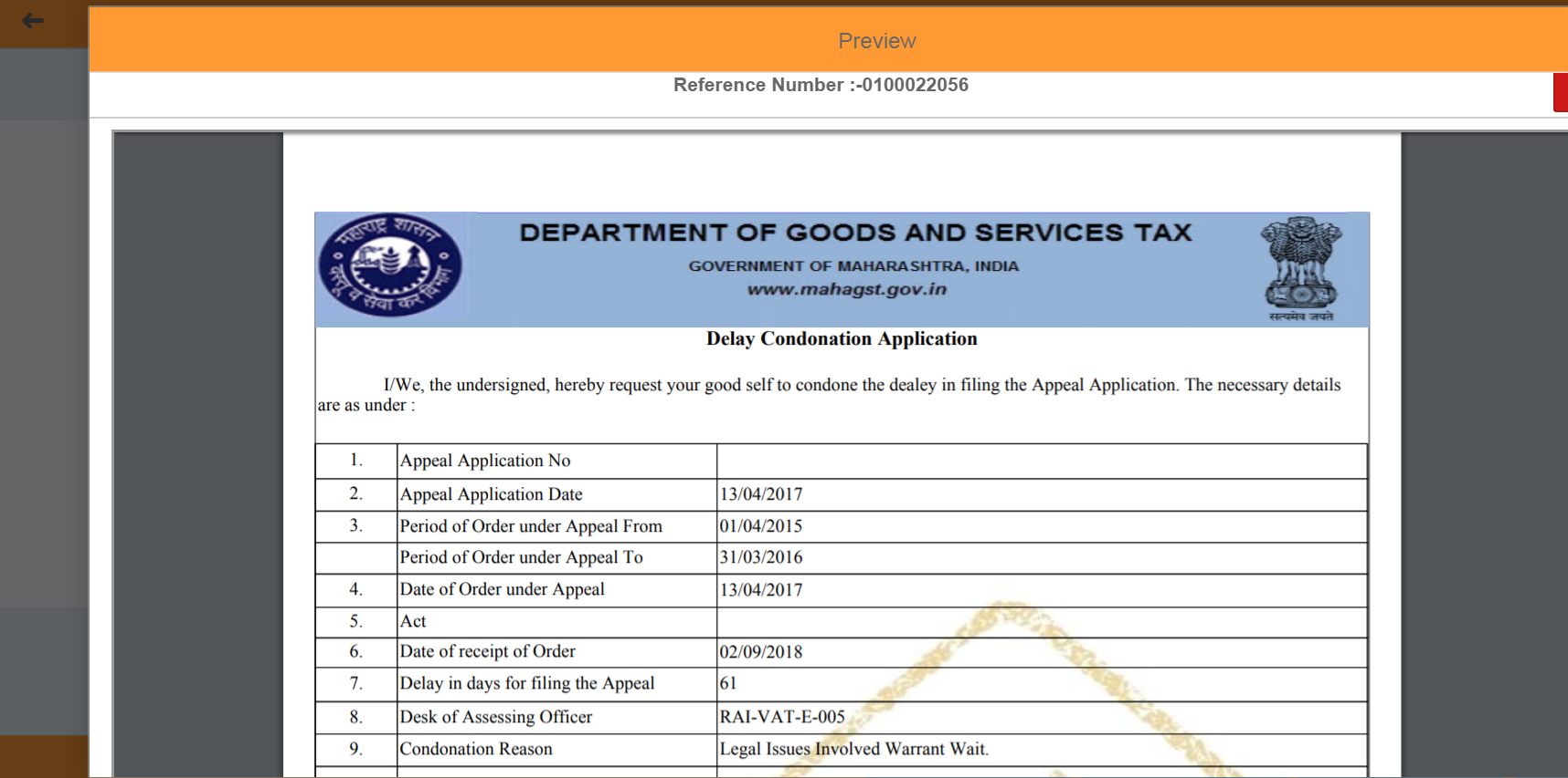

After filing of Appeal application along with Delay Condonation Application, the applicant can proceed for payment and submit the appeal application, the procedure of which is already explained in the above paragraphs.

B. FILING OF FORM 311 APPLICATION FOR STAY OF RECOVERY:

The Form 311 is application for stay of recovery. Form 311 is applicable where the condition of mandatory part payment is not applicable for filing of appeal. The tab of Form 311 is available at the bottom of the Appeal Application screen.

FORM 311 APPEAL APPLICATION
- Clicks on “FORM 311” button

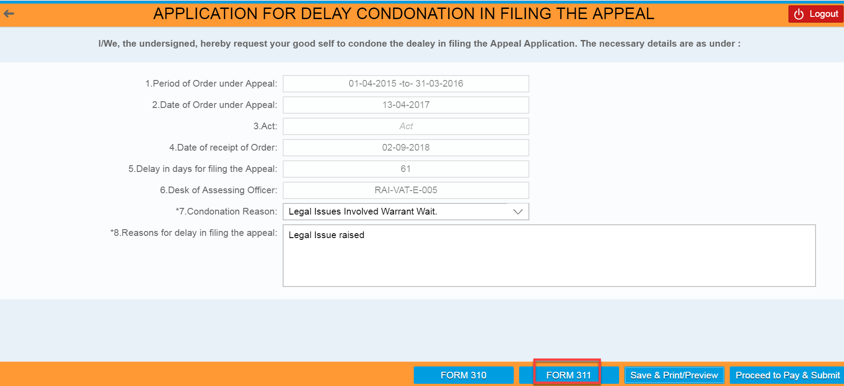

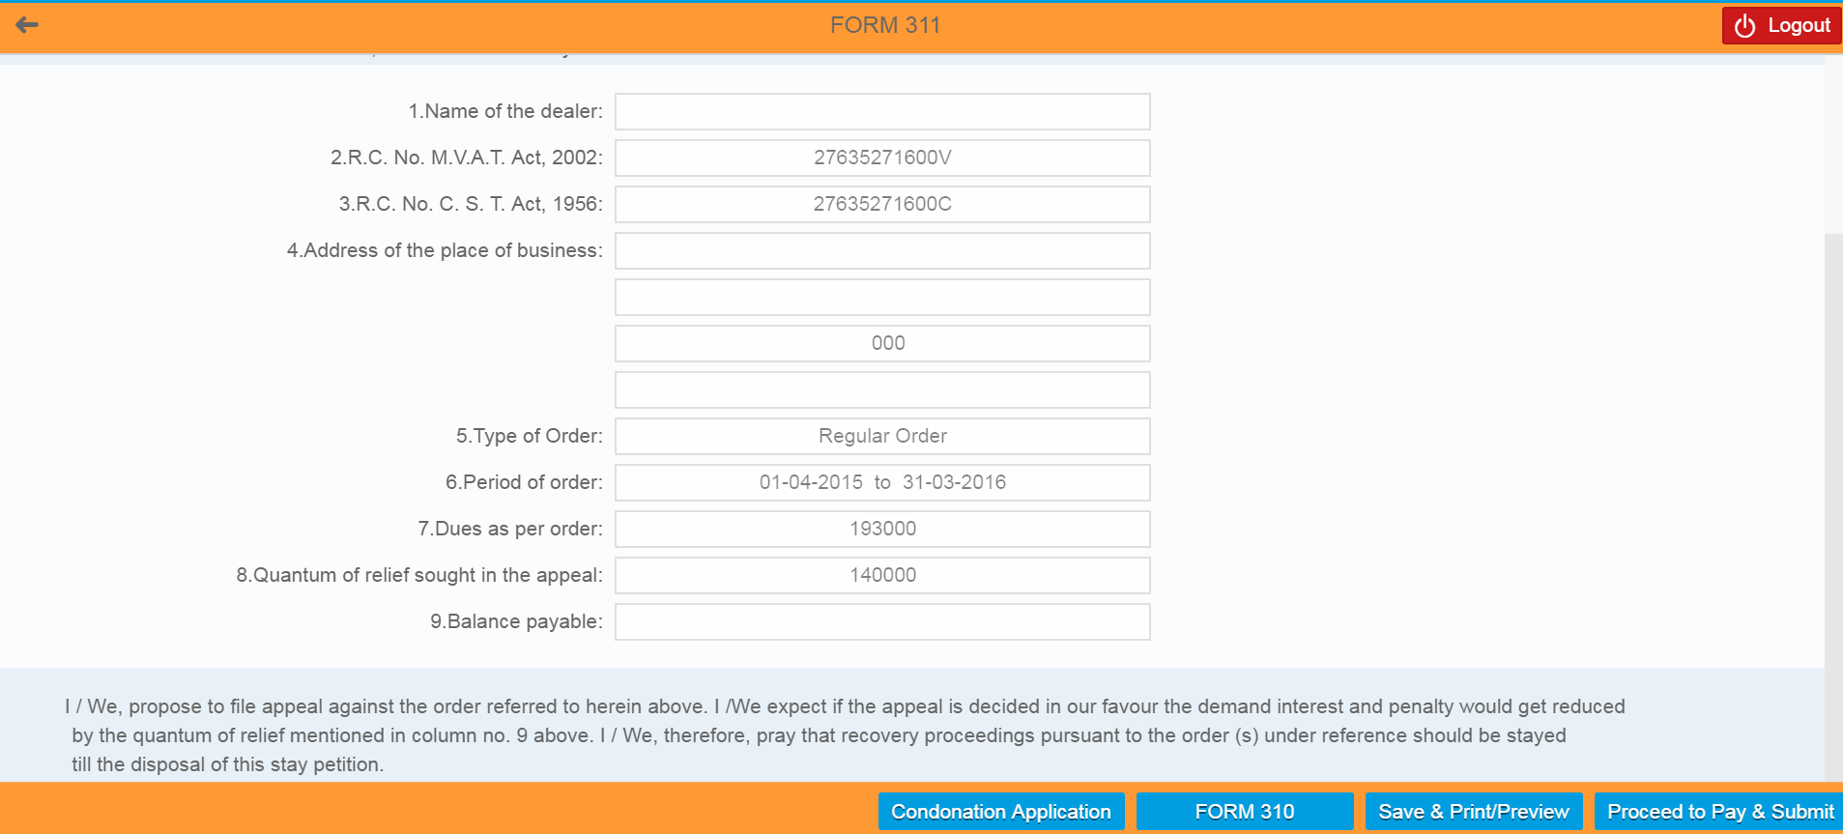

After filing of Appeal application along with Form 311 Application, the applicant can proceed for payment and submit the appeal application, the procedure of which is already explained in the above paragraphs.

FILING OF APPEAL WITHDRAWAL APPLICATION:

If the applicant has filed the Appeal Application online, in such cases, he is provided with the facility to file the online Appeal Withdrawal Application.

LOGIN SCREEN
- Login in to the Dealer Application with your Login credentials.
- User:
- Password:
- Click on ‘’Log On’’

XXXXXXXX

ASSEMENT ORDER ID SEARCH
- Click on ‘’Other-E Services’’ option from L.H.S menu (Left Hand Side)

- Click on ‘’Appeal’’ Tile under Activities section

- Click on “Appeal” tile again under CRM APPEAL // APPEAL TO TRIBUNAL HOME PAGE

- Enter the Appeal Case ID under “Search Document Number”
- Click on ‘Display’’ button

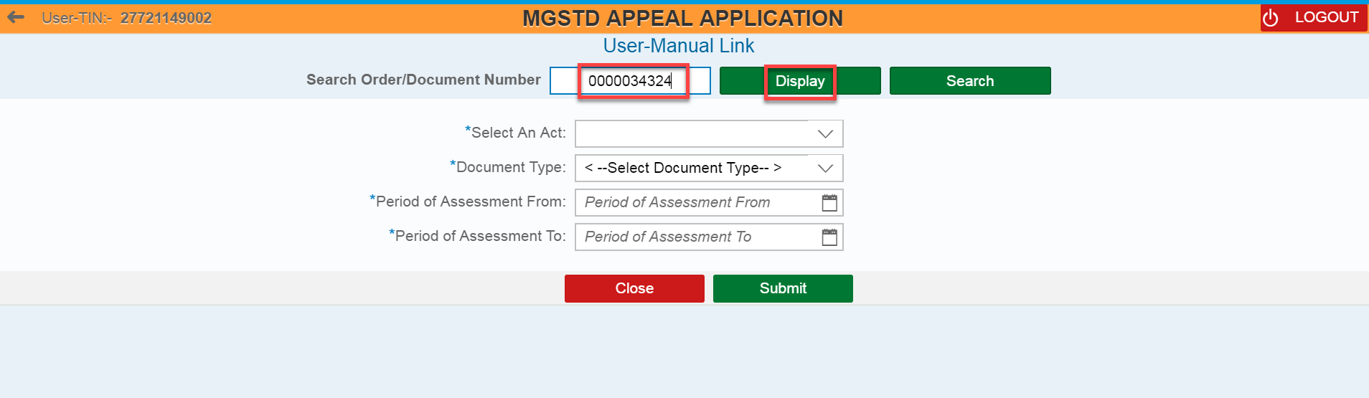

- Click on “Application For Withdrawal” button

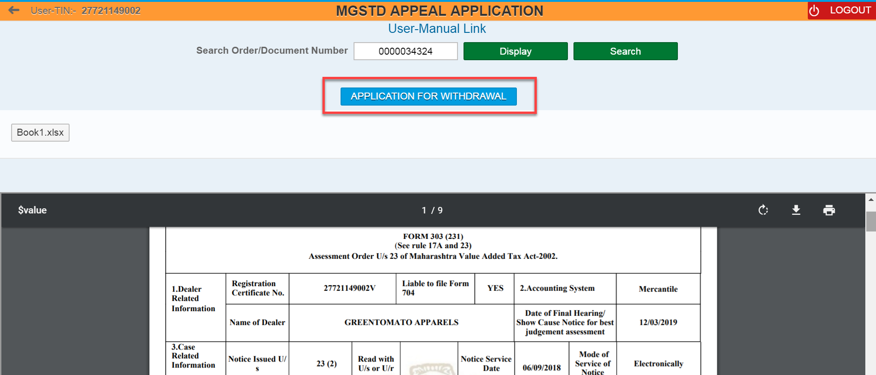

Dealer can also see the list of Orders through filling the following fields and clicks on “Submit” button– (Select an Act, Document Type, Period of Assessment from, and Period of Assessment to)
- Select an Act, and Document Type from drop down list
- Enter Period of Assessment From, and Period of Assessment To date
- Clicks on “Submit” button
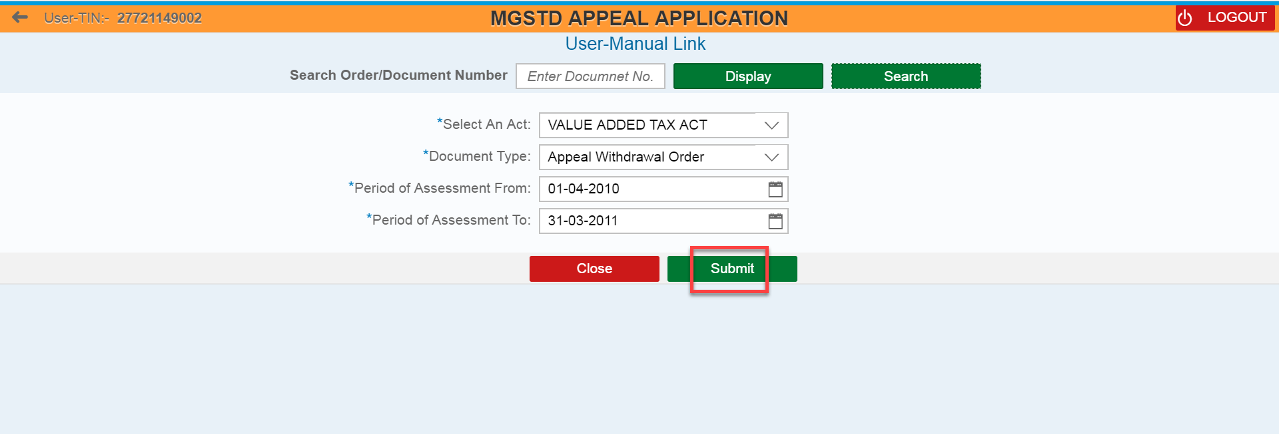

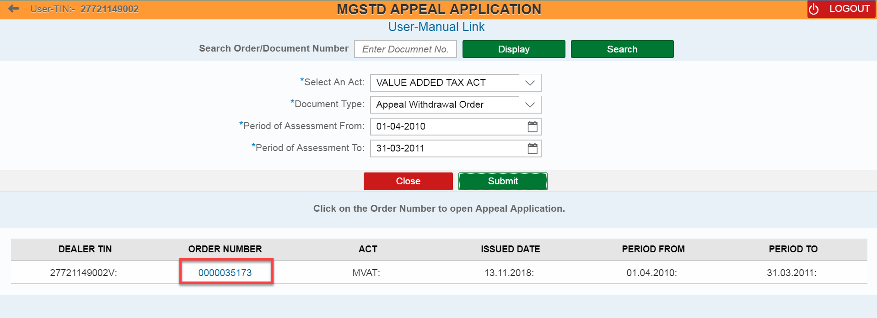

APPLICATION FOR WITHDRAWAL FORM
- Review all the field values which was auto populated in Application For Withdrawal page
- Enter the values under “Contention of Dealer” field

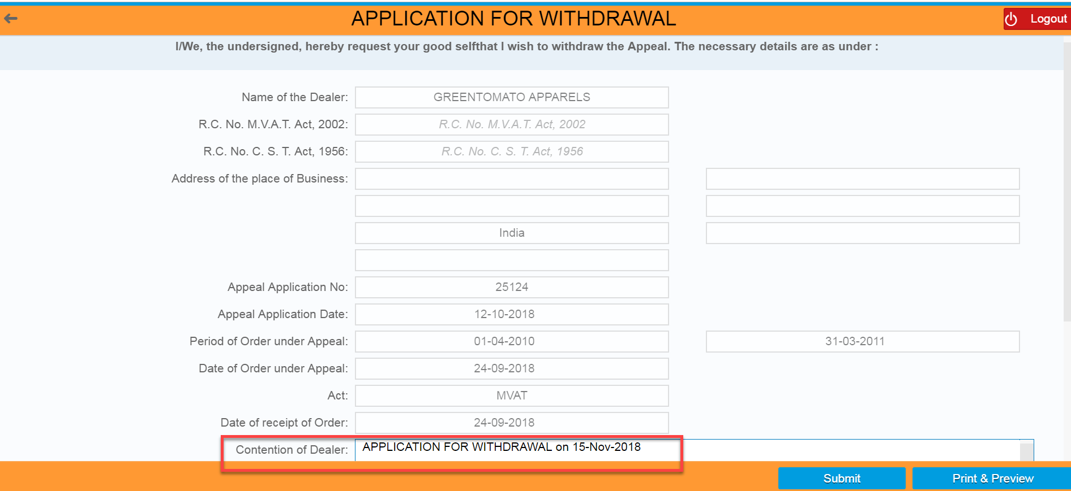

FILE UPLOAD
- Clicks on “Browse” button

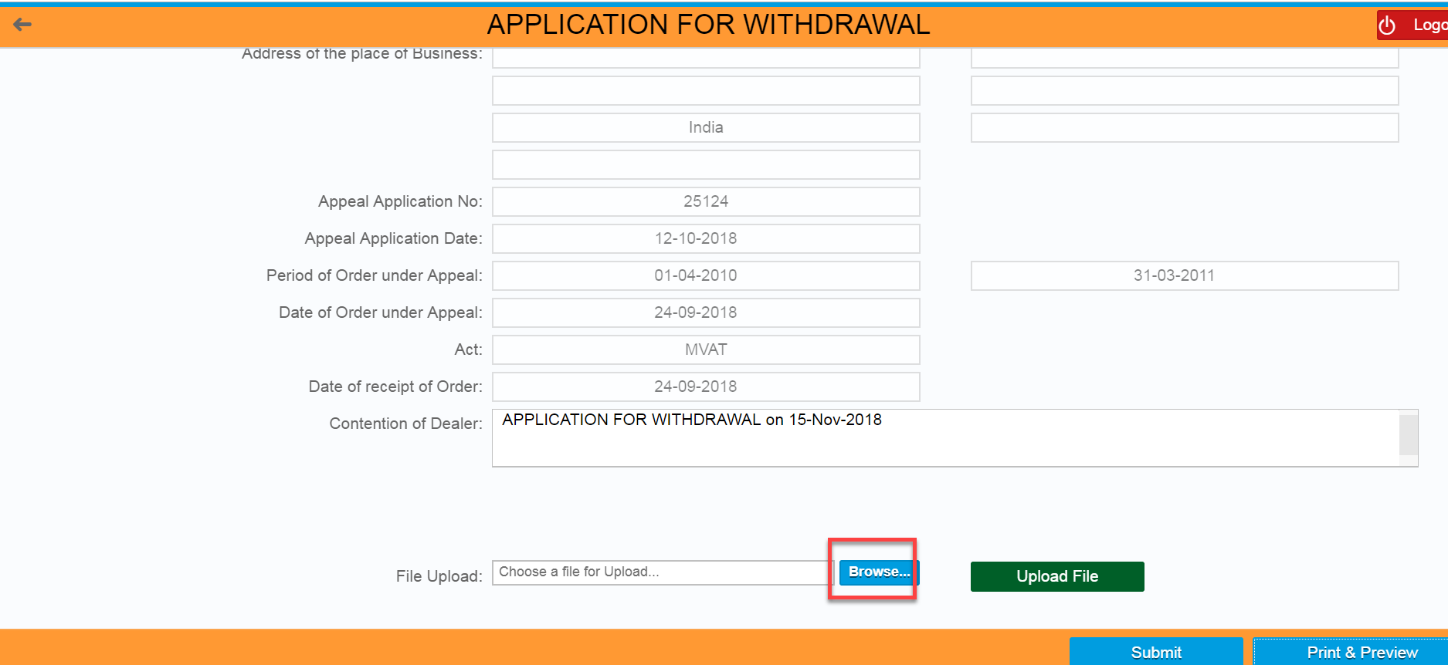

- Select the file from local machine and Clicks on “Open” button
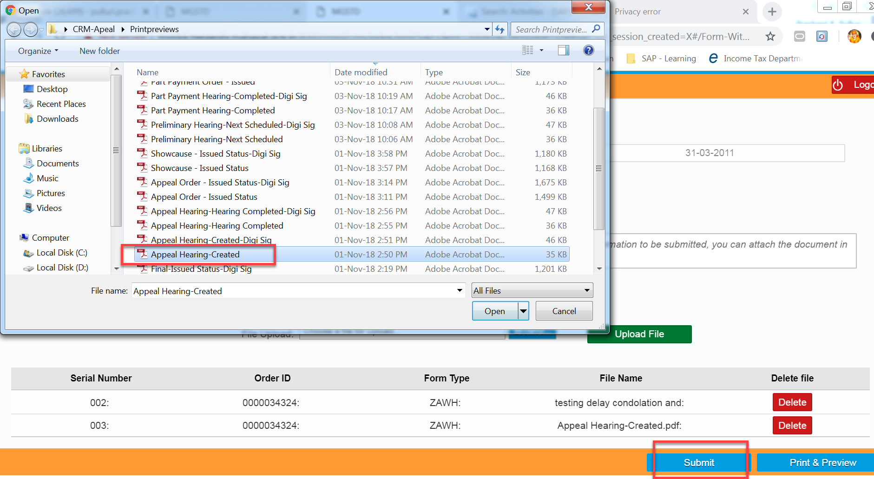

- Clicks on “OK” button

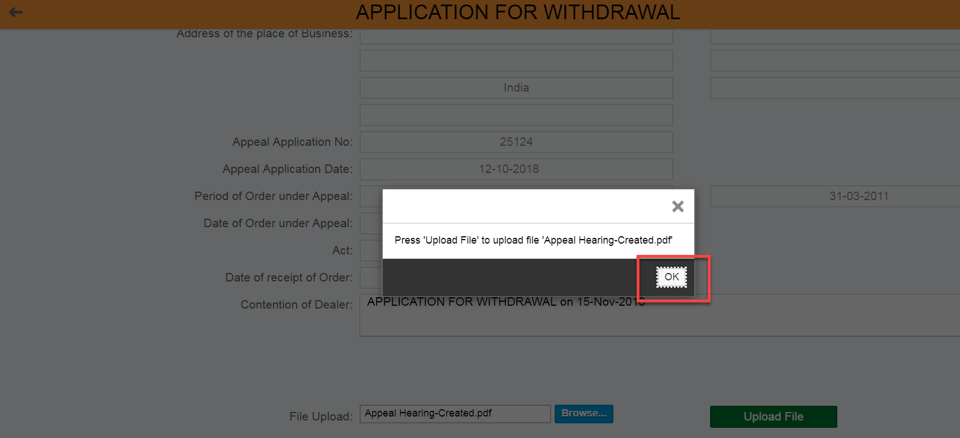

- Clicks on “Upload File” button

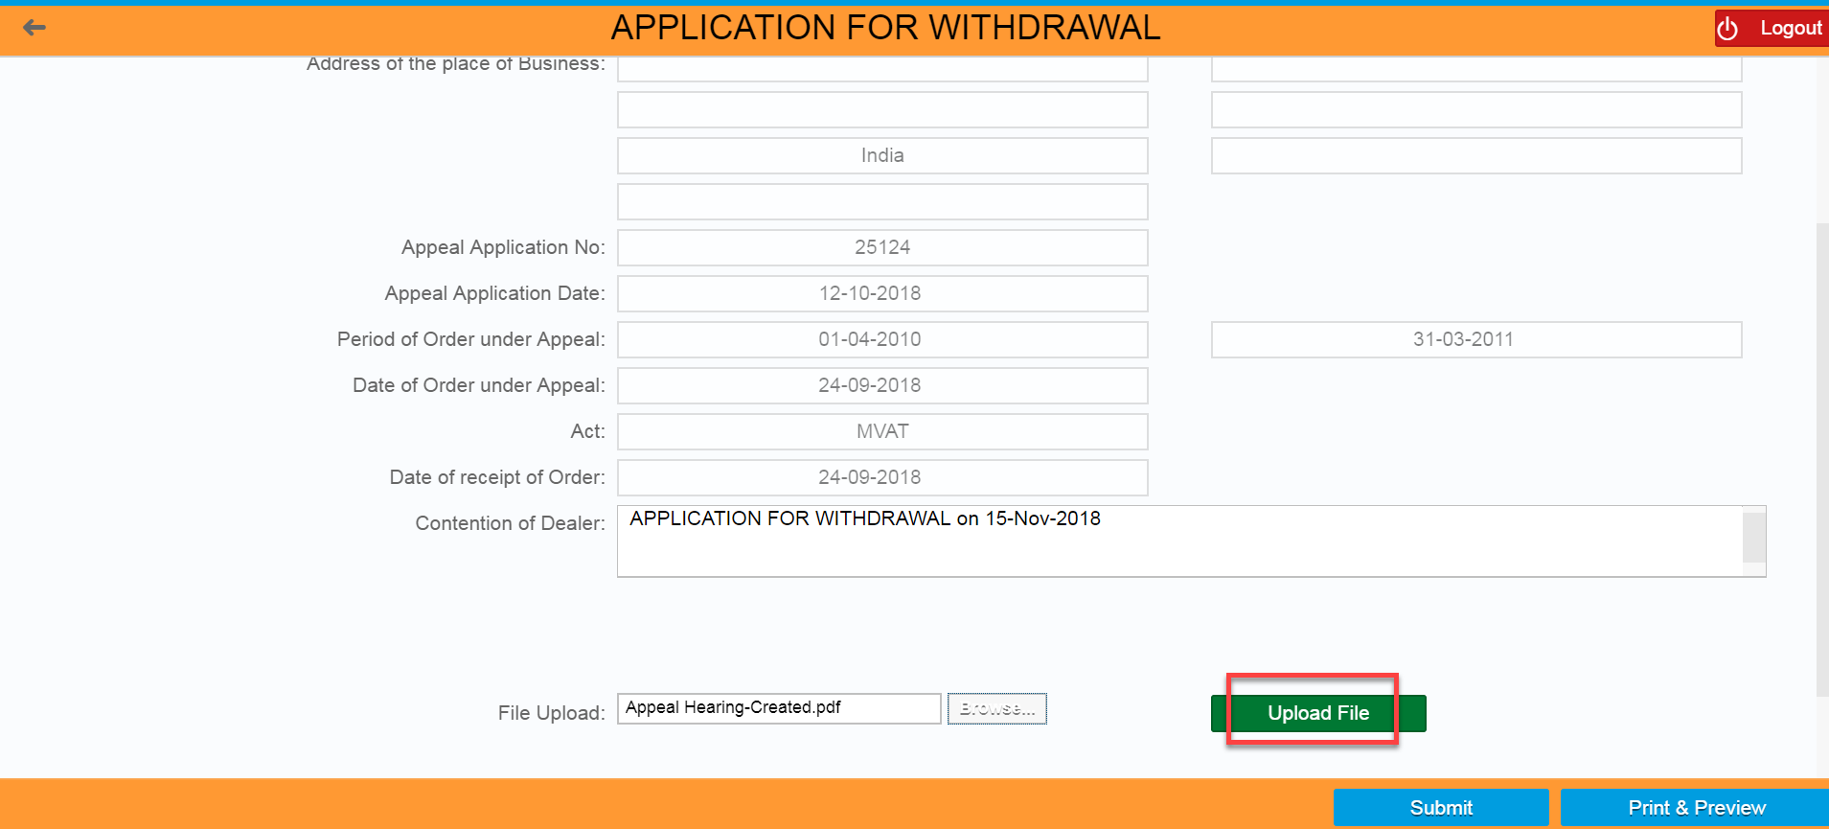

- Clicks on “Yes” button
- Verify the Uploaded file as one row created with uploaded file
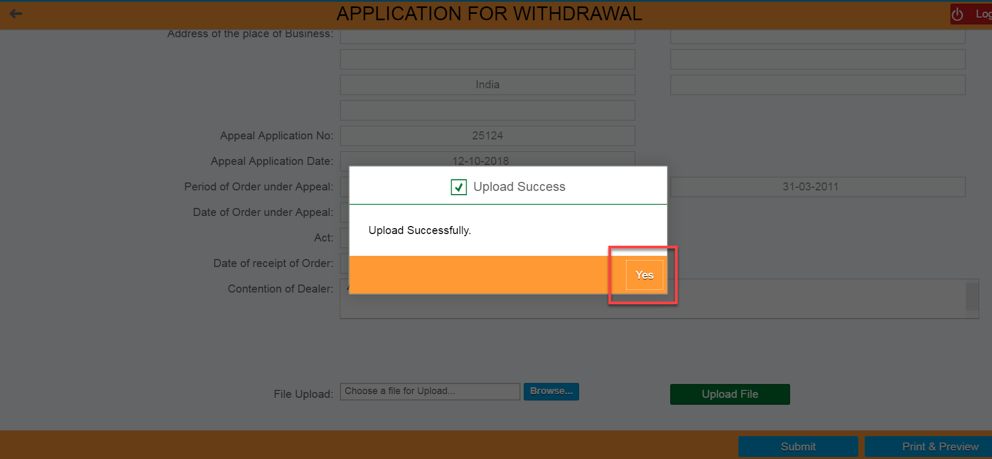

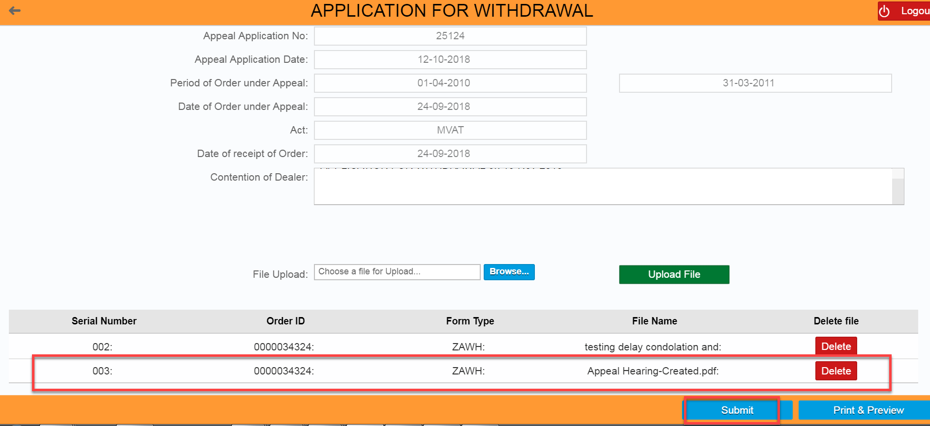

APPEAL WITHDRAWAL APPLICATION ID GENEARTION
- Clicks on “Submit” button
- Apple Withdrawal Application ID should be generated by system automatically

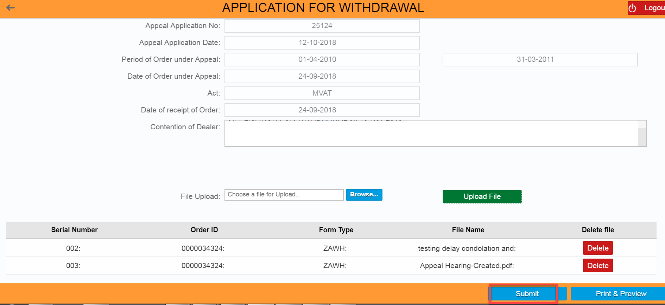

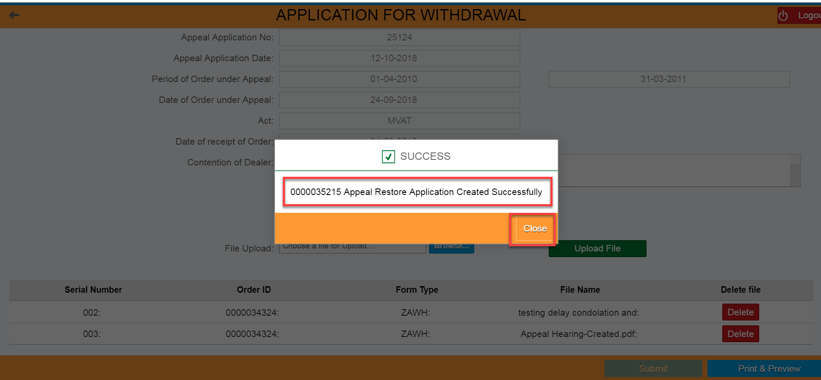
XXXXXXXX

FILING OF APPEAL RESTORATION AGAINST SUMMARILY REJECTION ORDER:

If the Appellate Authority has issued the Summary Rejection Order on the system, the dealer can view the said order on Dealer portal. The dealer subsequently can apply for Restoration of said Appeal by filing the Restoration Application online.

LOGIN SCREEN
- Login in to the Dealer Application with your Login credentials.
- User:
- Password:
- Click on ‘’Log On’’

XXXXXXXX

SUMMARILY REJECTION ORDER ID SEARCH
- Click on ‘’Other-E Services’’ option from L.H.S menu (Left Hand Side)

- Click on ‘’Appeal’’ Tile under Activities section

- Click on “Appeal” tile again under CRM APPEAL // APPEAL TO TRIBUNAL HOME PAGE

- Enter the Summary Rejection Order ID under “Search Document Number”
- Click on ‘Display’’ button

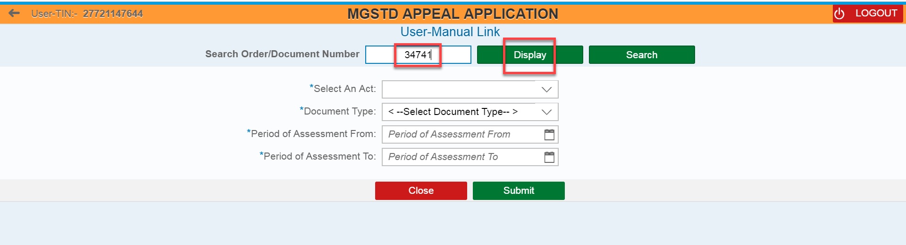

- Click on “Apple Restoration Against Summarily Rejection” button

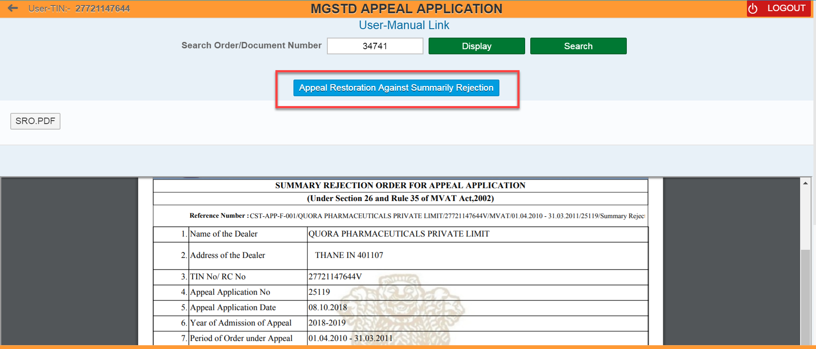

Dealer can also see the list of Orders through filling the following fields and clicks on “Submit” button– (Select an Act, Document Type, Period of Assessment from, and Period of Assessment to)
- Select an Act,
- Select Document Type as “Summarily Rejection Order” from the list of orders
- Enter Period of Assessment From, and Period of Assessment To date
- Clicks on “Submit” button
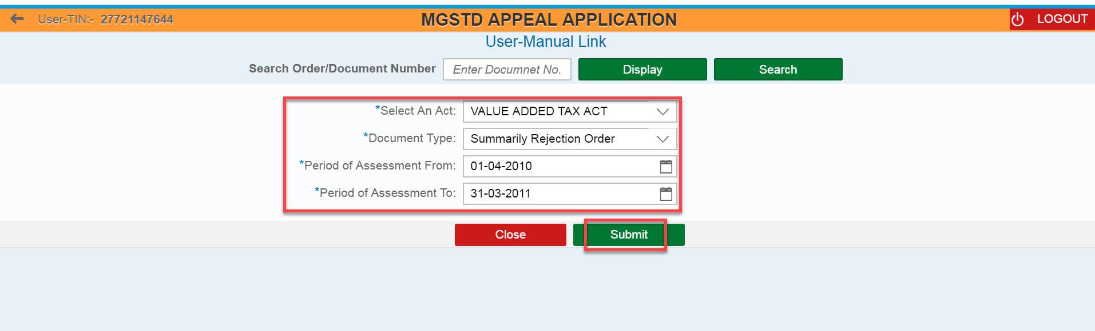

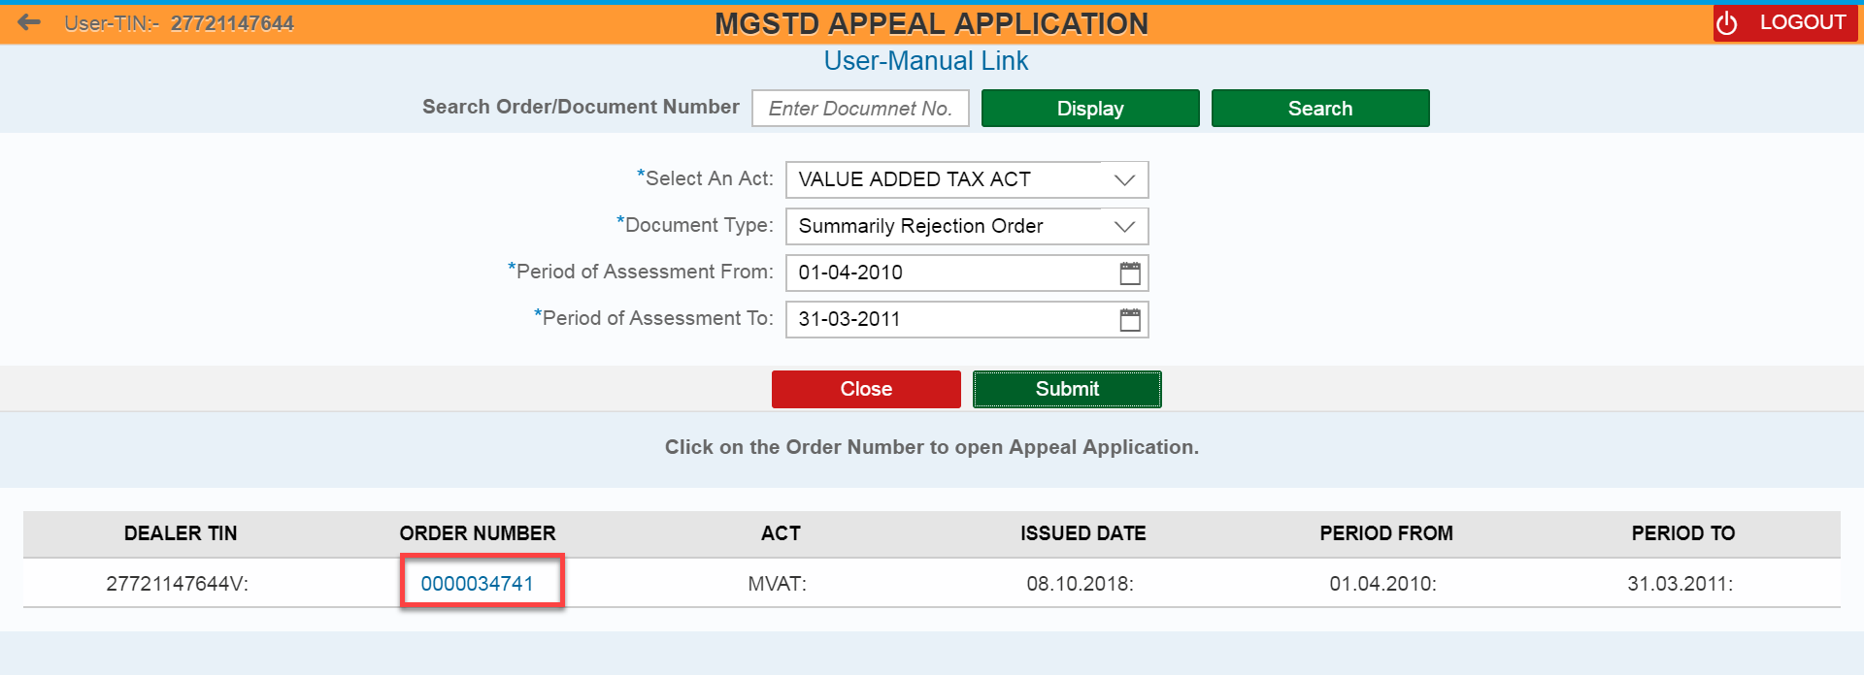

APPLICATION FOR RESTORATION OF APPEAL AGAINST SUMMARILY REJECTION
- Review all the field values which was auto populated in APPLICATION FOR RESTORATION OF APPEAL AGAINST SUMMARILY REJECTION page
- Enter the values/text under “Contention of Dealer” field

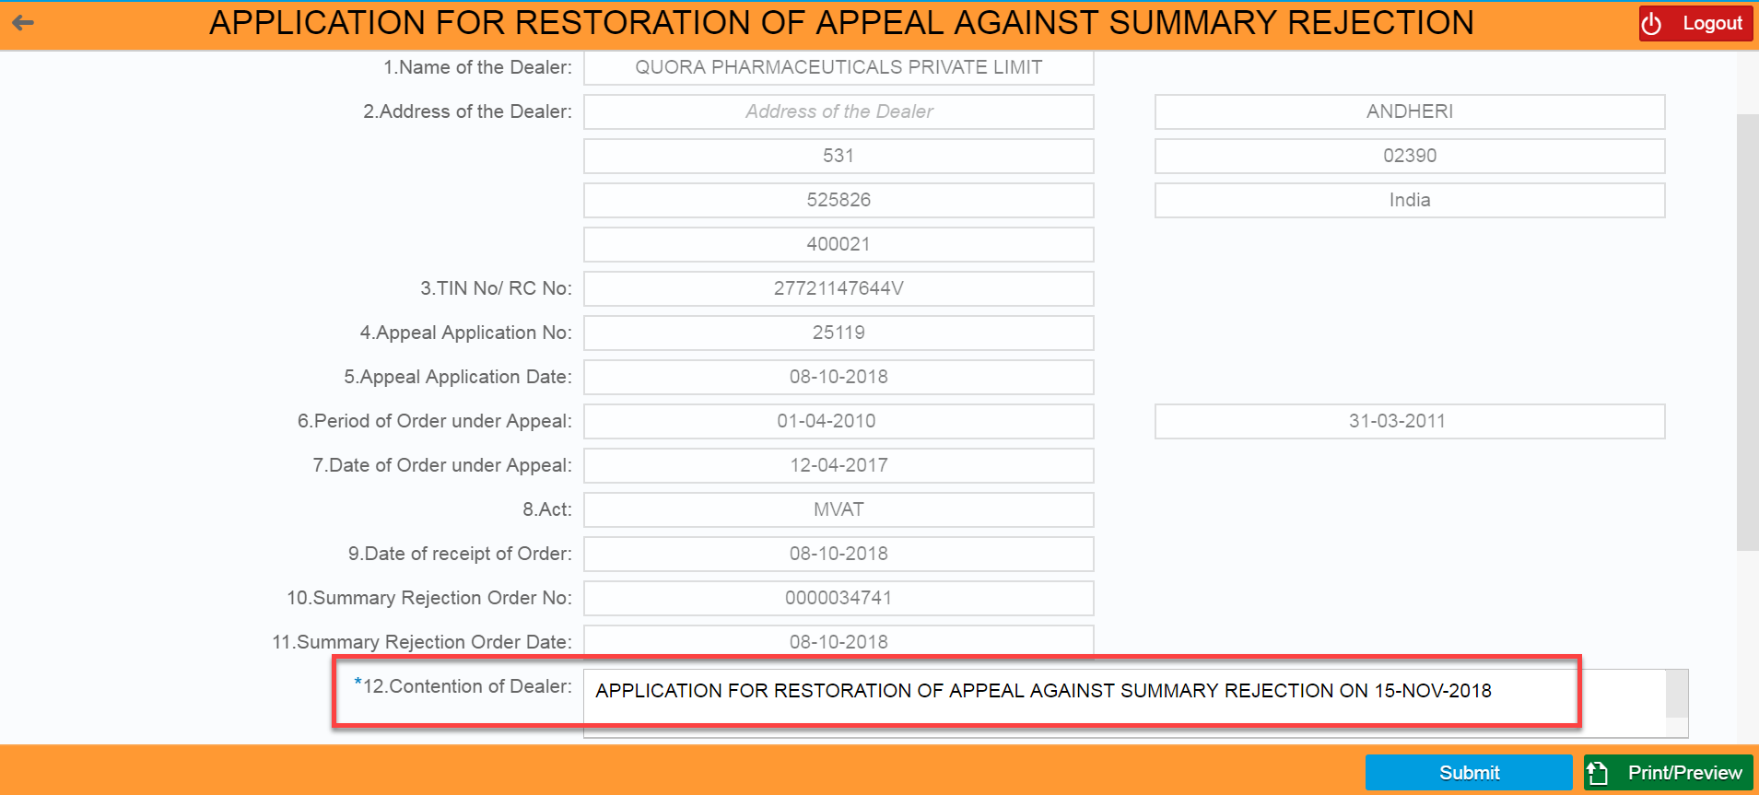

FILE UPLOAD
- Clicks on “Browse” button
- Select the file from local machine and Clicks on “Open” button

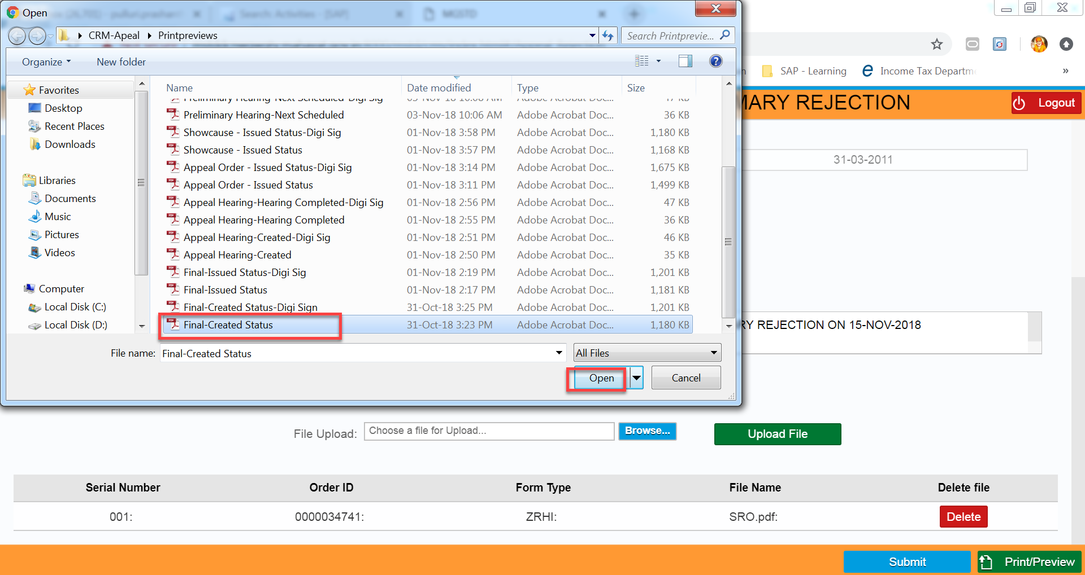

- Clicks on “OK” button

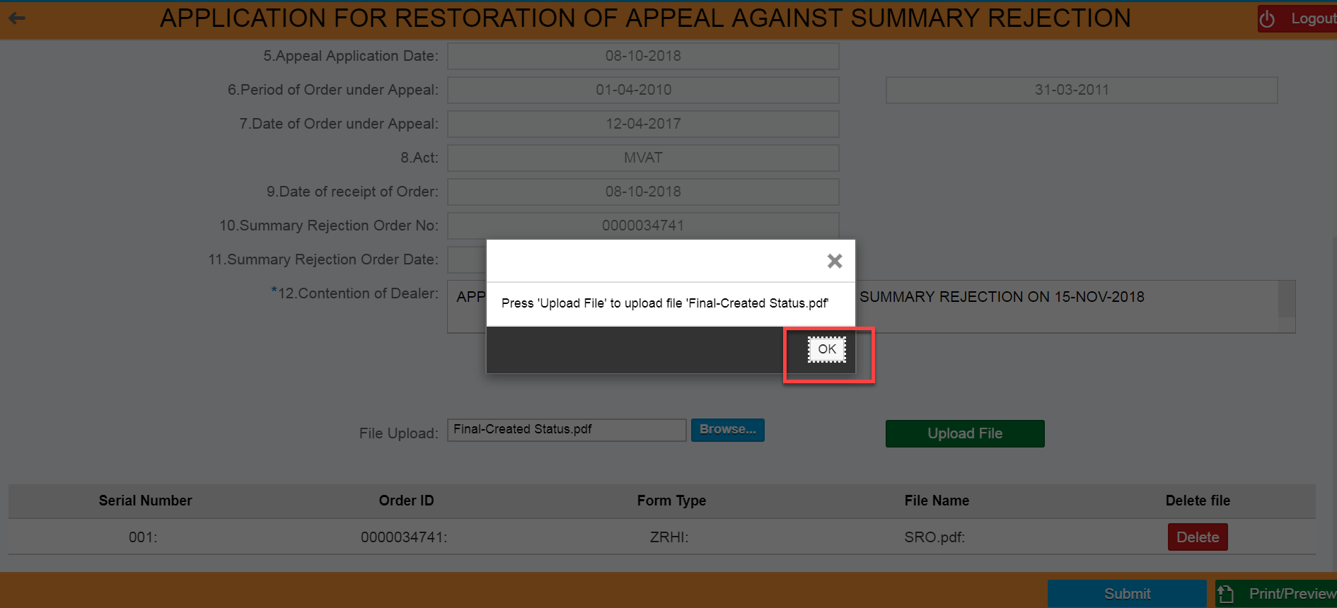

- Clicks on “Upload File” button
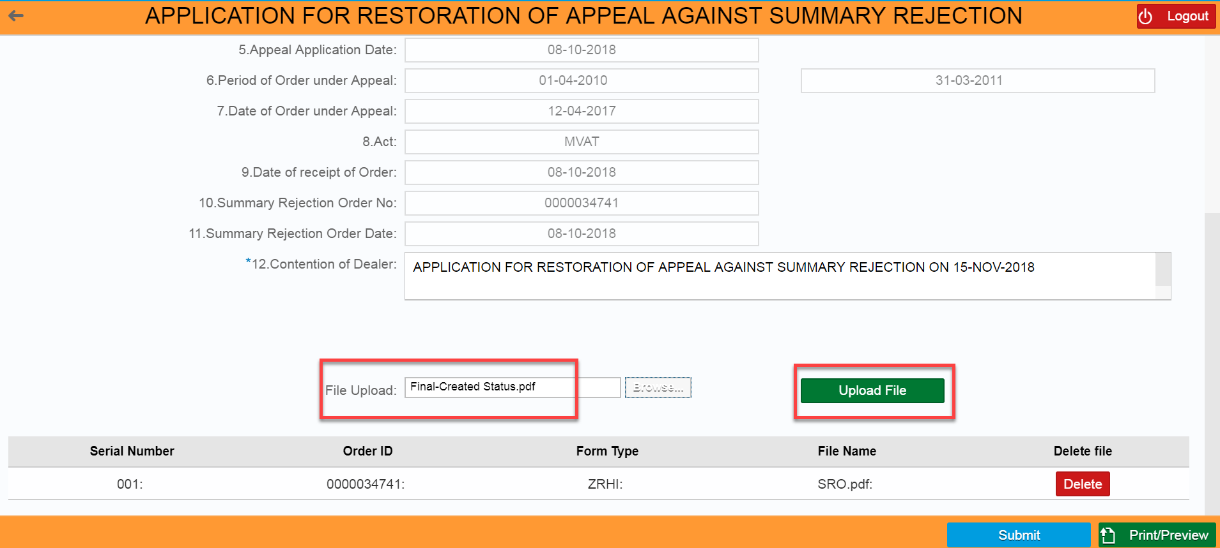

- Clicks on “Yes” button
- Verify the Uploaded file as one new row created with uploaded file
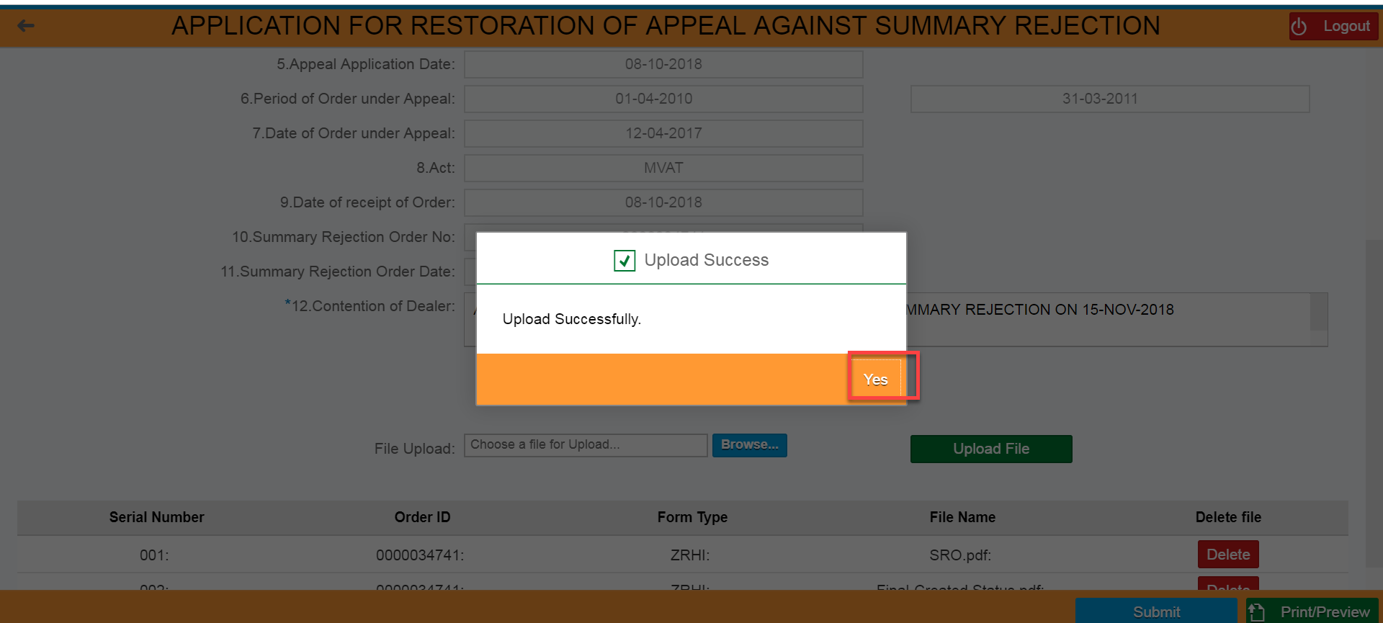

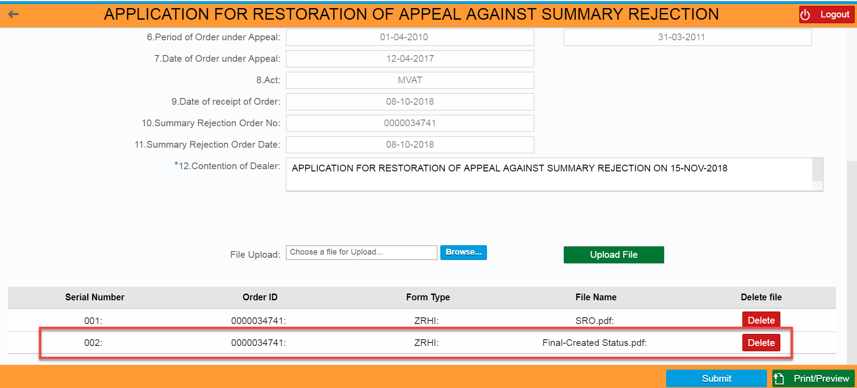

APPEAL RESTORATION APPLICATION ID GENERATION
- Clicks on “Submit” button

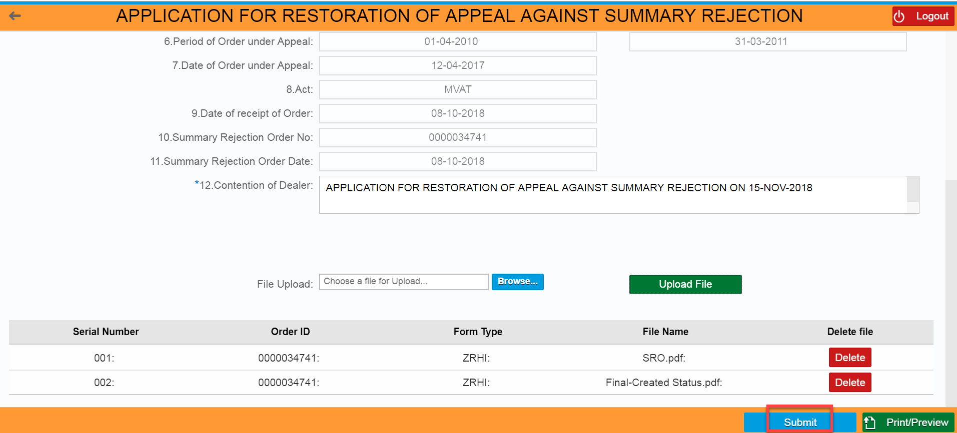

- Clicks on “Yes” button for “Are you sure you want to submit the Application?”
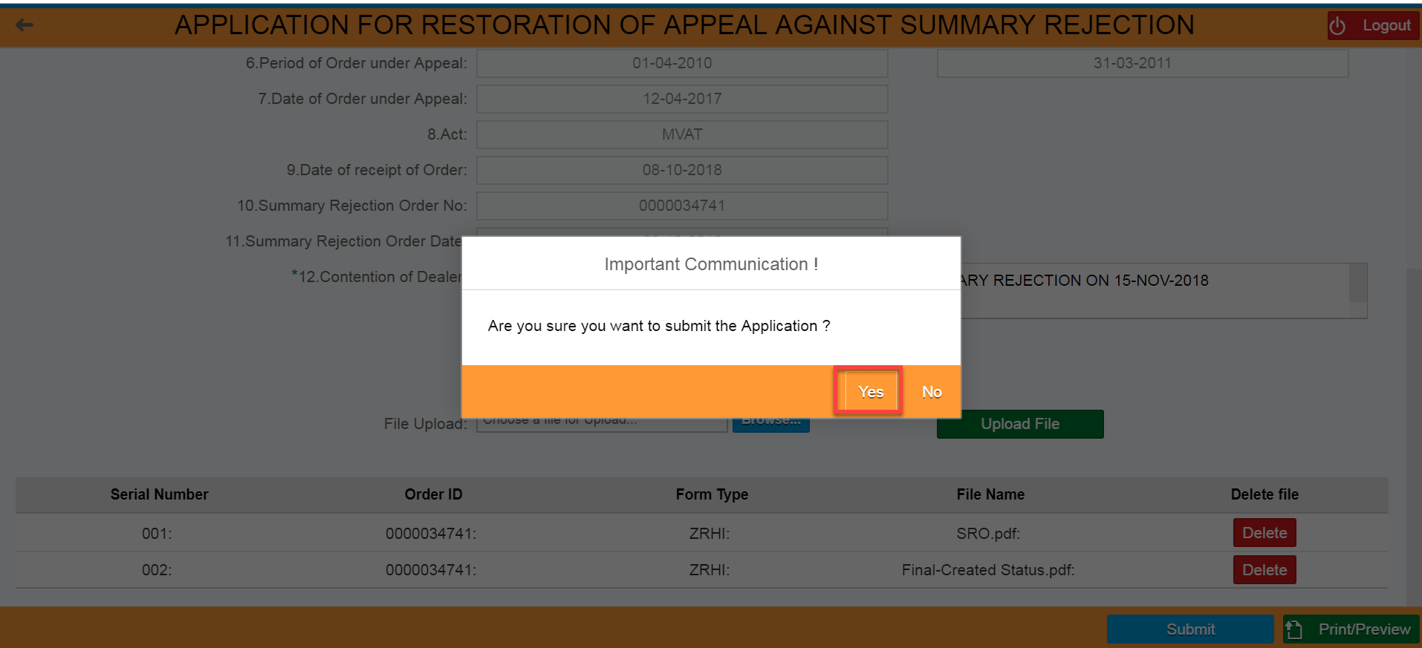

- Apple Restoration Application ID should be generated by system automatically
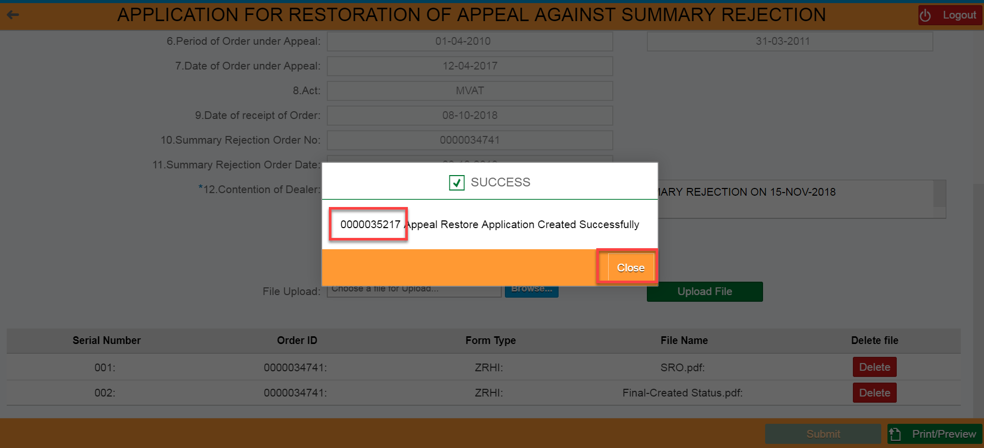

FILING OF APPEAL RESTORATION AGAINST APPEAL DISMISSAL ORDER:

If the Appellate Authority has issued the Appeal Dismissal Order on the system, the dealer can view the said order on Dealer portal. The dealer subsequently can apply for Restoration of said Appeal by filing the Restoration Application online.

LOGIN SCREEN
- Login in to the Dealer Application with your Login credentials.
- User:
- Password:
- Click on ‘’Log On’’

XXXXXXXX

APPEAL DISMISSAL ORDER ID SEARCH
- Click on ‘’Other-E Services’’ option from L.H.S menu (Left Hand Side)

- Click on ‘’Appeal’’ Tile under Activities section

- Click on “Appeal” tile again under CRM APPEAL // APPEAL TO TRIBUNAL HOME PAGE

- Enter the Appeal Dismissal Order ID under “Search Document Number”
- Click on ‘Display’’ button

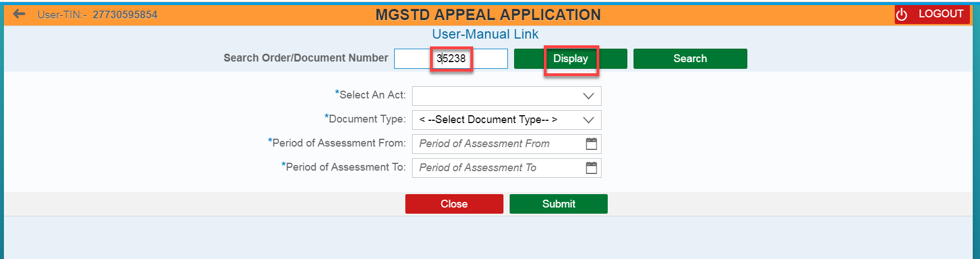

- Click on “Apple Restoration Against Appeal Dismissal Order” button

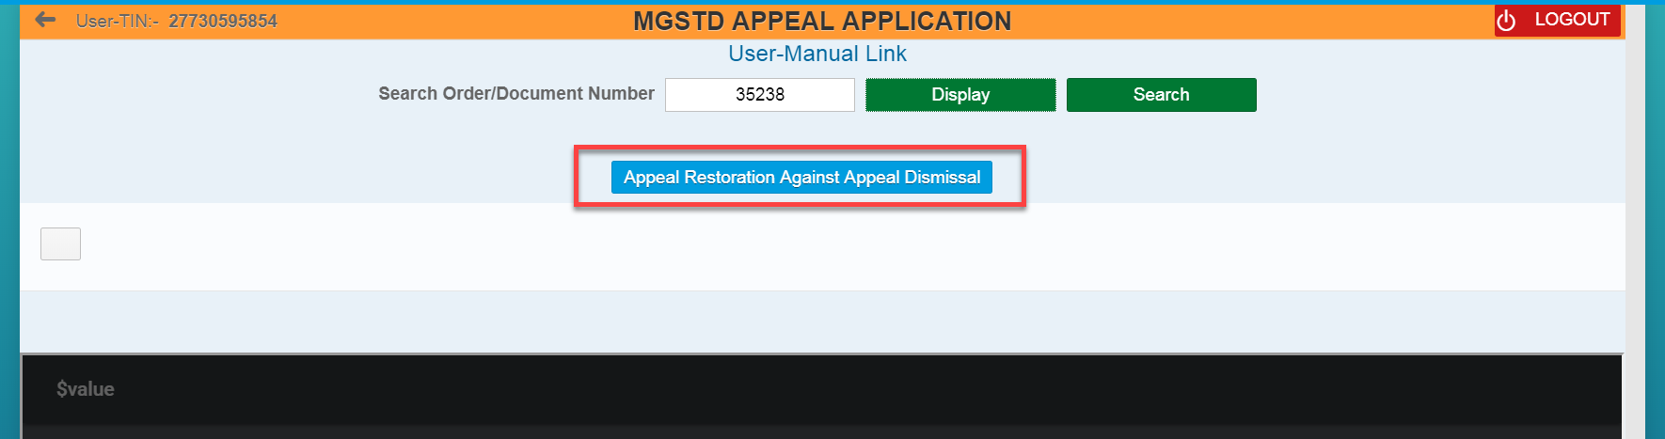

Dealer can also see the list of Orders through filling the following fields and clicks on “Submit” button– (Select an Act, Document Type, Period of Assessment from, and Period of Assessment to)
- Select an Act,
- Select Document Type as “Appeal Dismissal Order” from the list of orders
- Enter Period of Assessment From, and Period of Assessment To date
- Clicks on “Submit” button

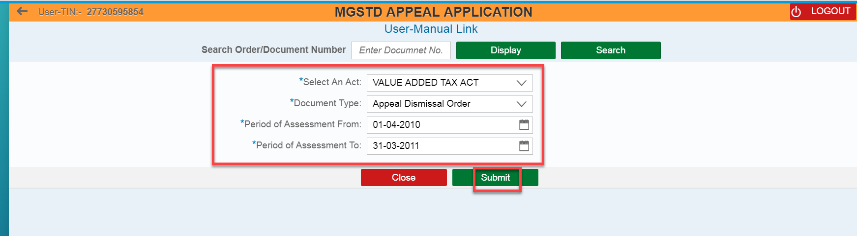

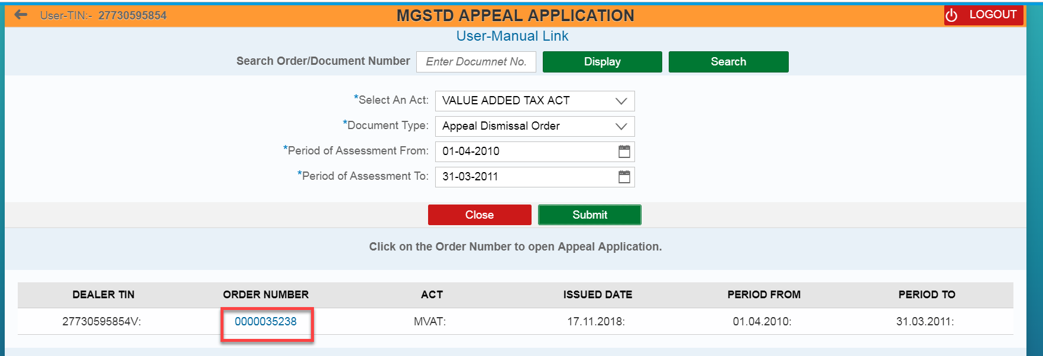

APPLICATION FOR RESTORATION OF APPEAL AGAINST APPEAL DISMISSAL
- Review all the field values which was auto populated in APPLICATION FOR RESTORATION OF APPEAL AGAINST APPEAL DISMISSAL page
- Enter the values/text under “Contention of Dealer” field

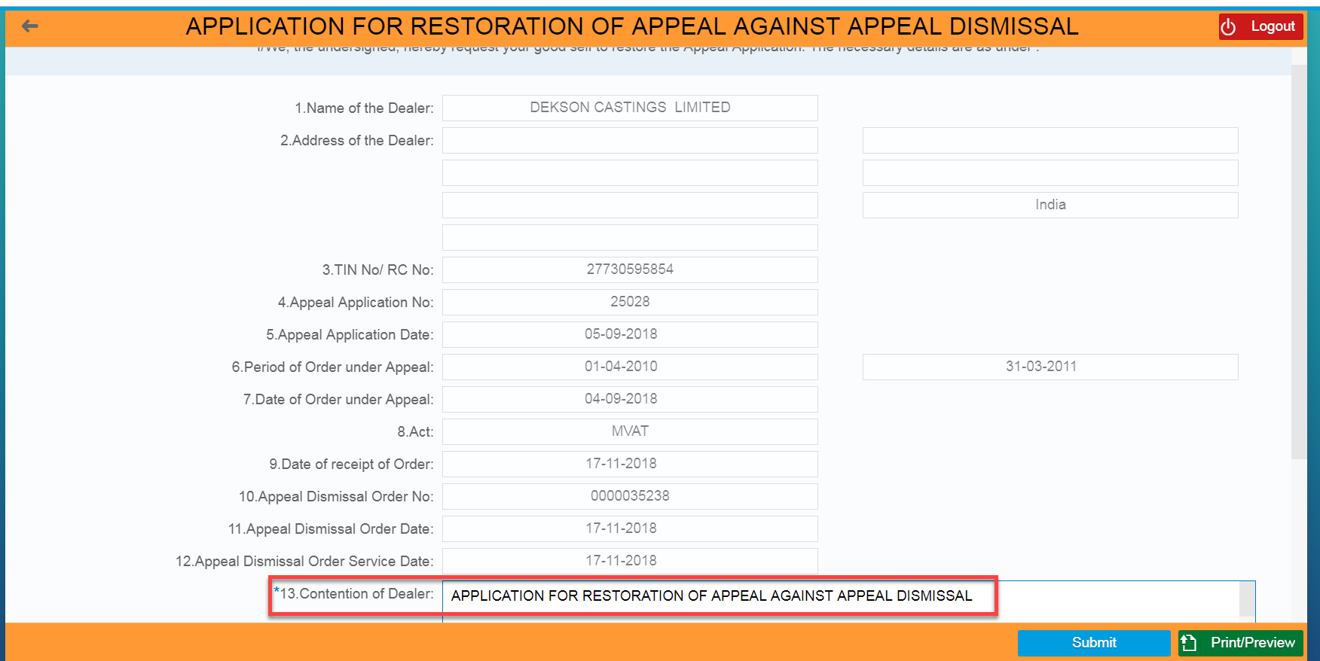

FILE UPLOAD
- Clicks on “Browse” button
- Select the file from local machine and Clicks on “Open” button

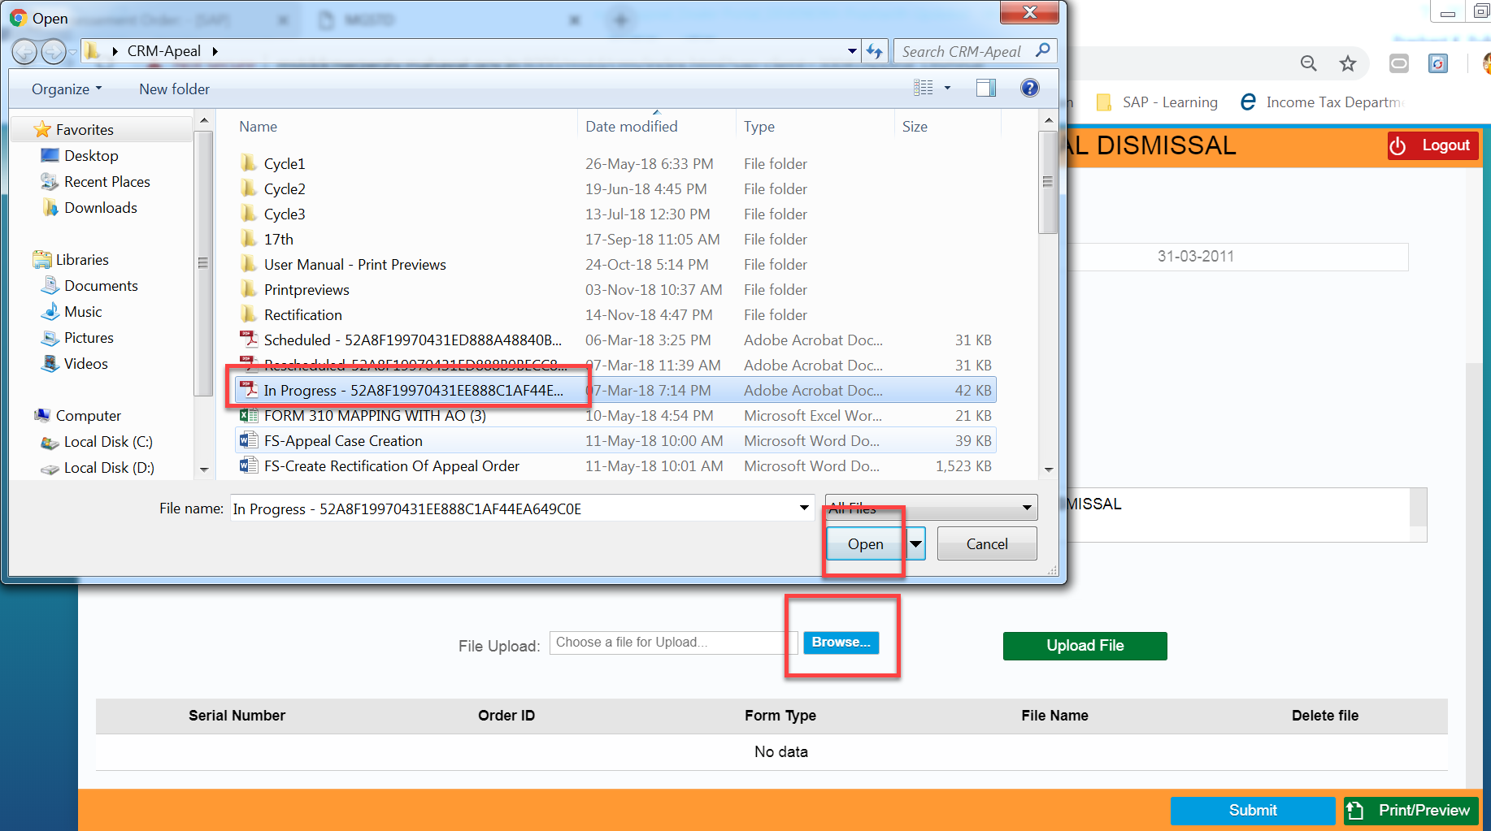

- Clicks on “OK” button

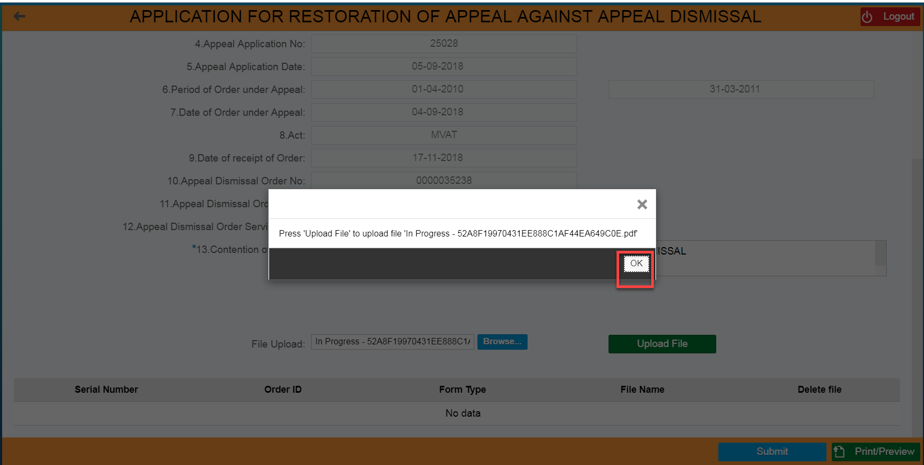

- Clicks on “Upload File” button
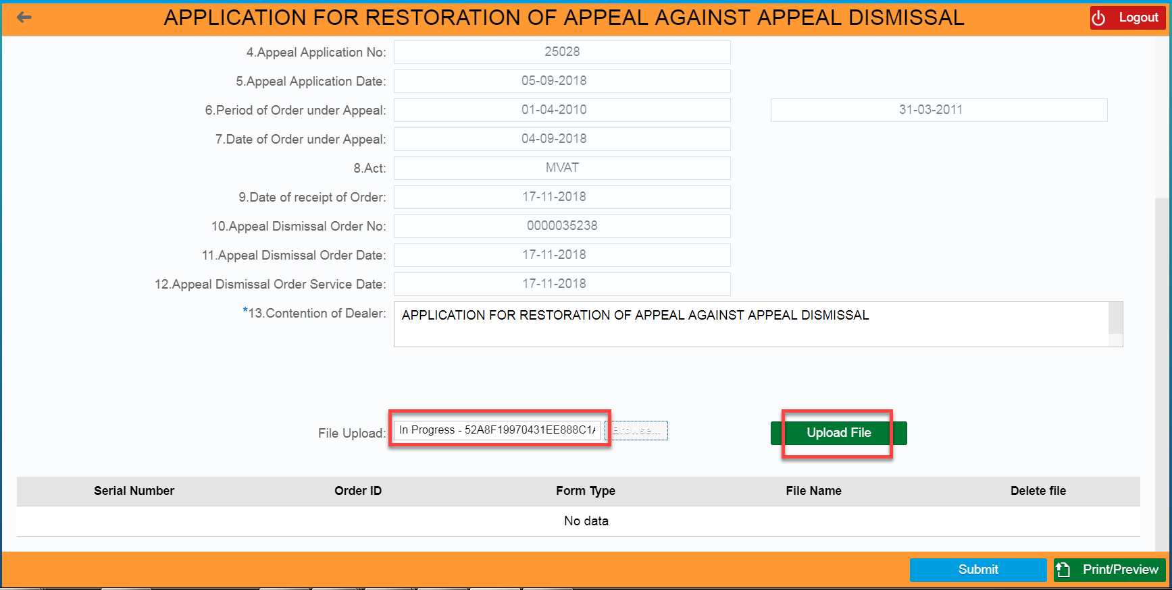

- Clicks on “Yes” button
- Verify the Uploaded file as one new row created with uploaded file
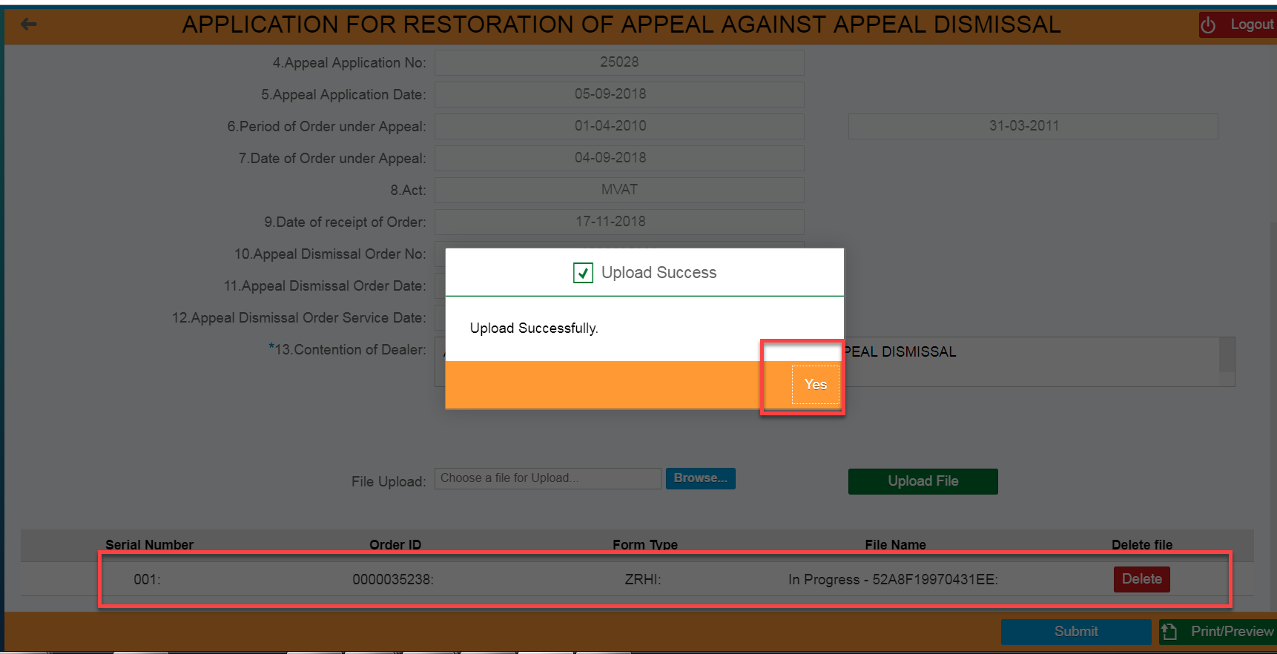

- Clicks on “Print/Preview” button
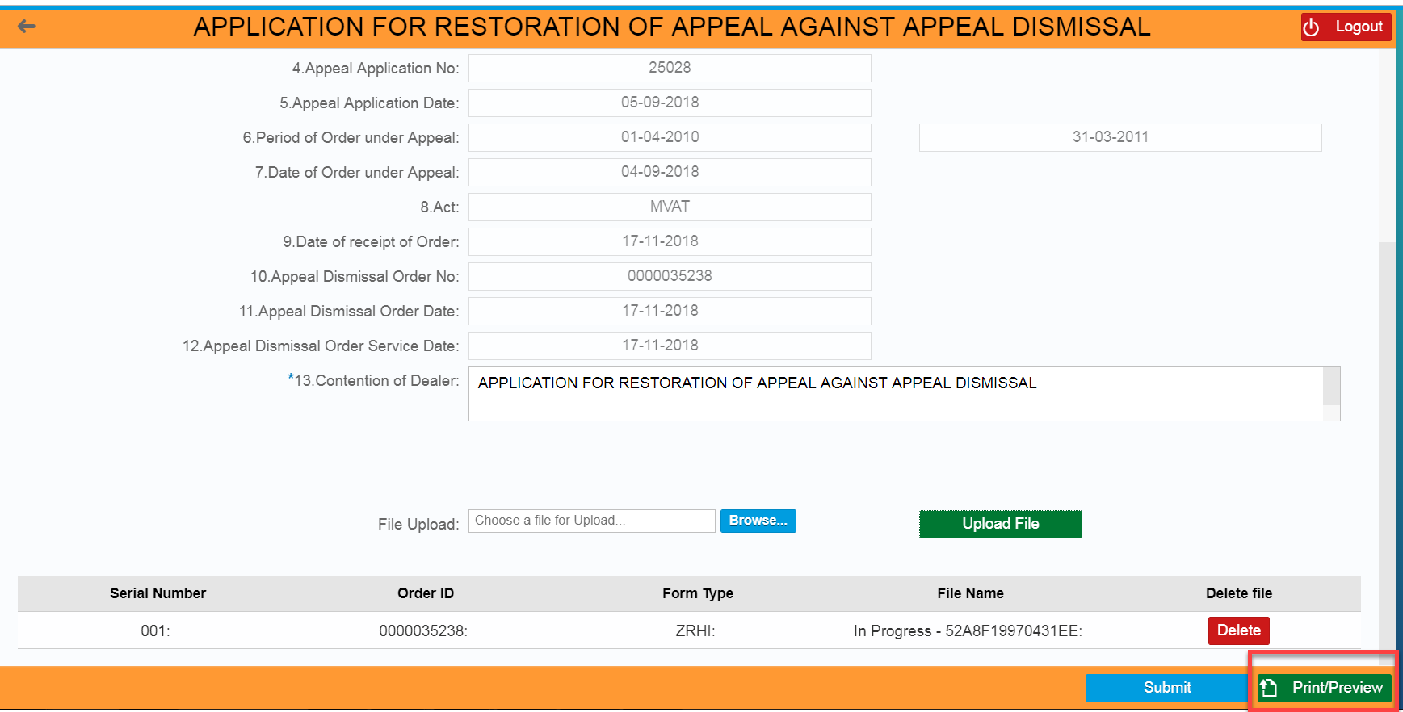

- Review the application details
- Clicks on “Download” icon and download it into the local machine

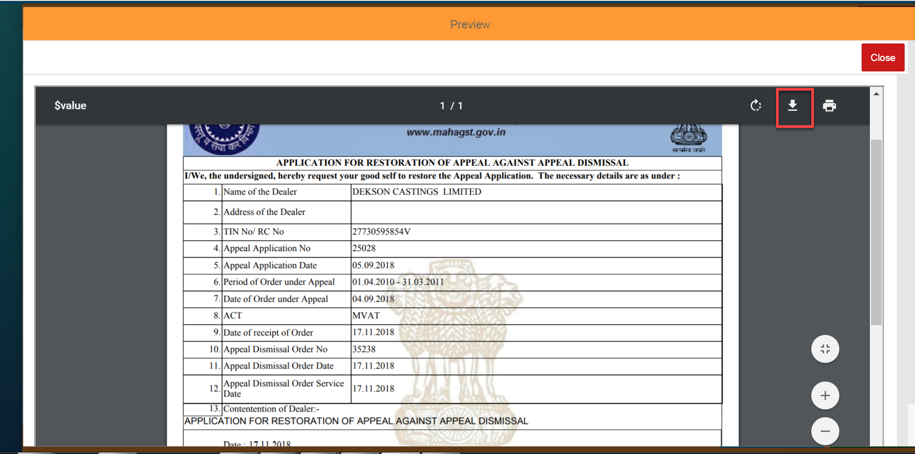

APPEAL RESTORATION APPLICATION ID GENERATION
- Clicks on “Submit” button

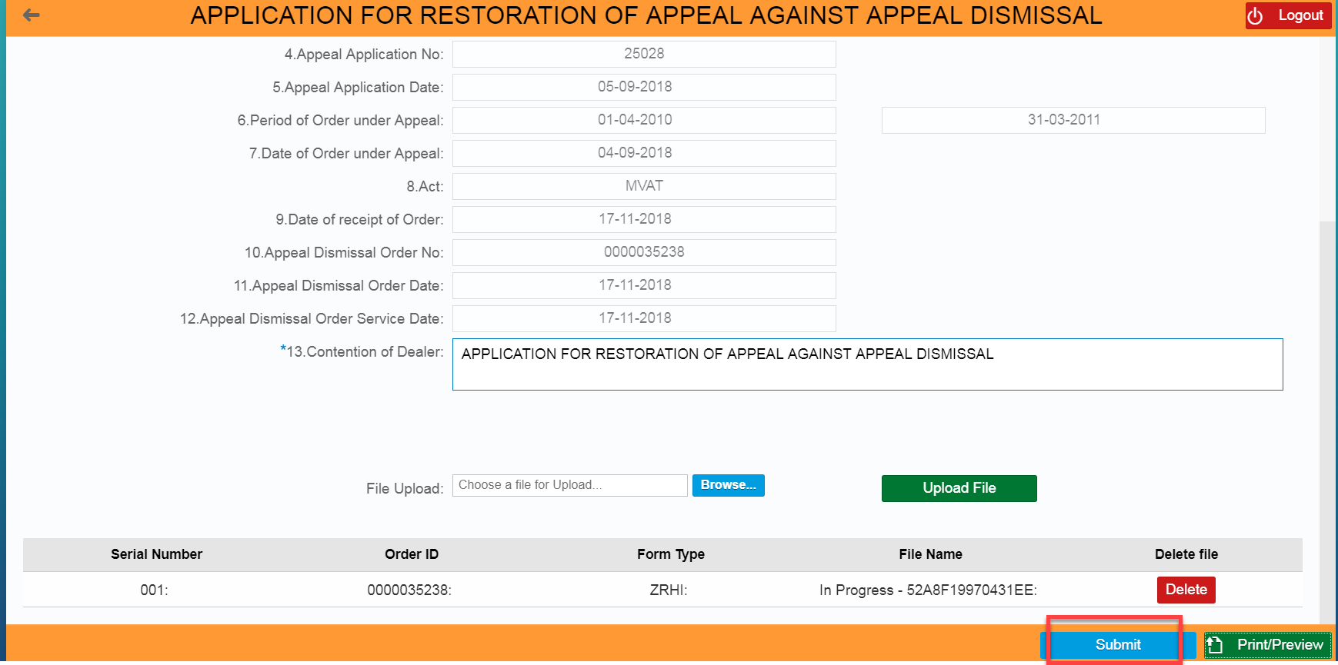

- Clicks on “Yes” button for “Are you sure you want to submit the Application?”
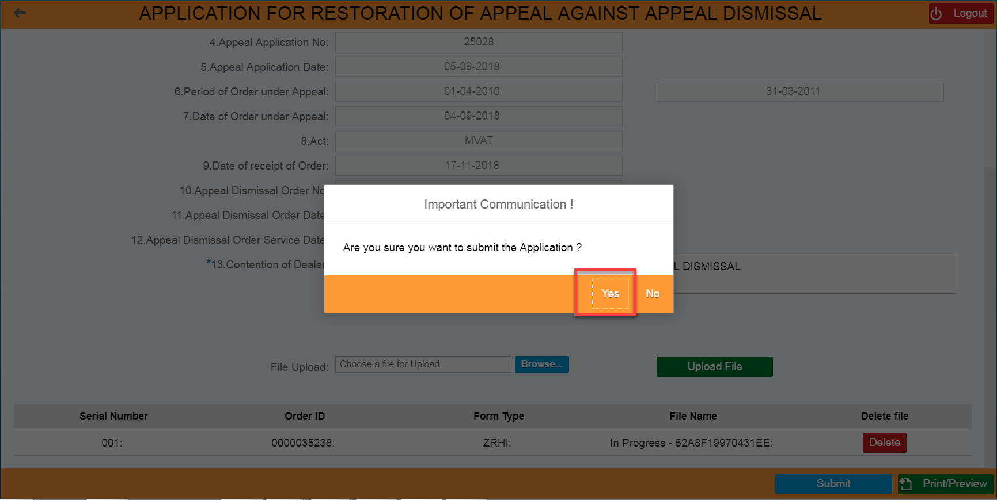

- Apple Restoration Application ID should be generated by system automatically

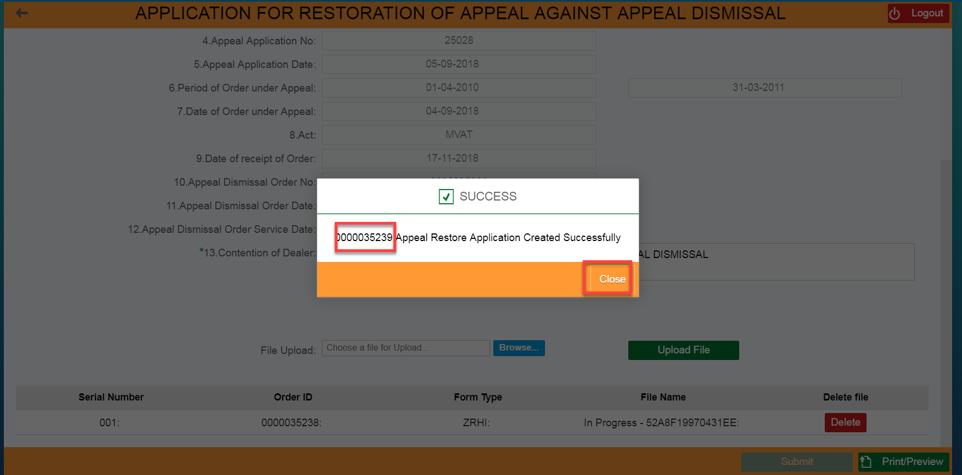

PAYMENT AGAINST PART PAYMENT OR ADDITIONAL PART PAYMENT ORDER:

If the Appellate Authority has issued the Part payment or Additional Part Payment Order on the system, the said Order is also available on the Dealer Portal to view and comply online. The dealer shall pay this amount only against the part payment or additional part payment order. This should be done to automatically adjust the payment against the said order and with the disputed dues. The dealer when makes the payment against such Part Payment or Additional Part Payment Order by following the steps given in the manual, the amount paid is automatically adjusted against such Part Payment or Additional Part Payment Order.

LOGIN SCREEN
- Login in to the Dealer Application with your Login credentials.
- User:
- Password:
- Click on ‘’Log On’’

XXXXXXXX

PART PAYMENT/ ADDITIONAL PART PAYMENT ORDER SEARCH
- Enter the Part Payment/Additional Part Payment Order ID under “Search Document Number”
- Click on ‘Display’’ button

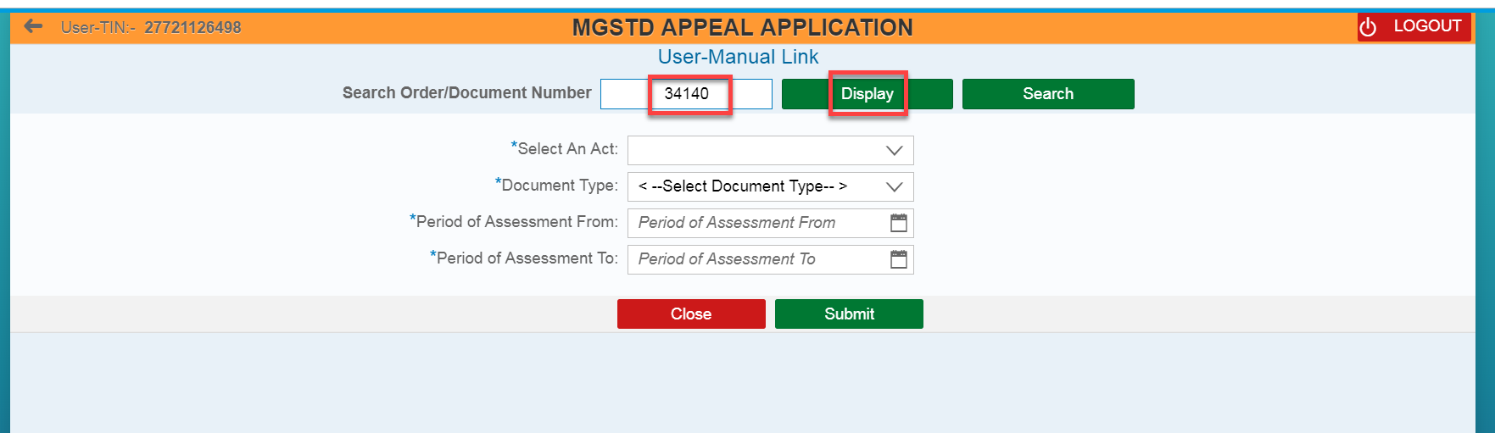

- Click on “Proceed For Payment” button

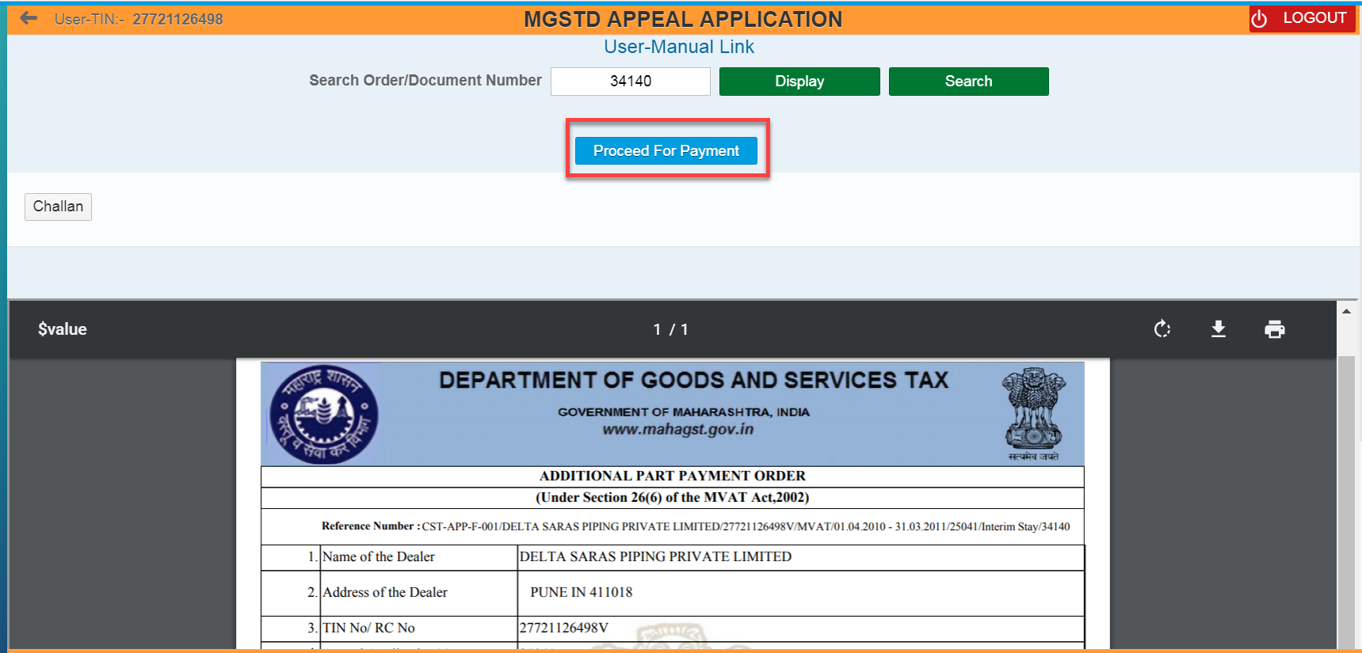

Dealer can also see the list of Orders through filling the following fields and clicks on “Submit” button– (Select an Act, Document Type, Period of Assessment from, and Period of Assessment to)
- Select an Act,
- Select Document Type as “Part payment/ Additional Part Payment Order” from the list of orders as the case may be.
- Enter Period of Assessment From, and Period of Assessment To date
- Clicks on “Submit” button
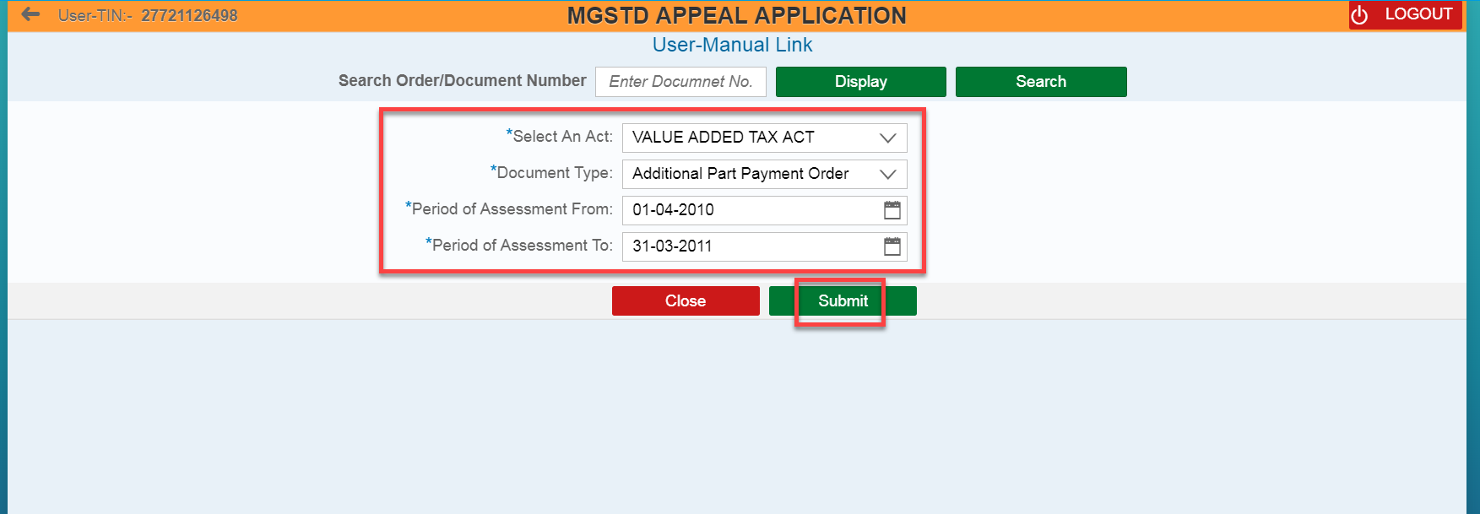

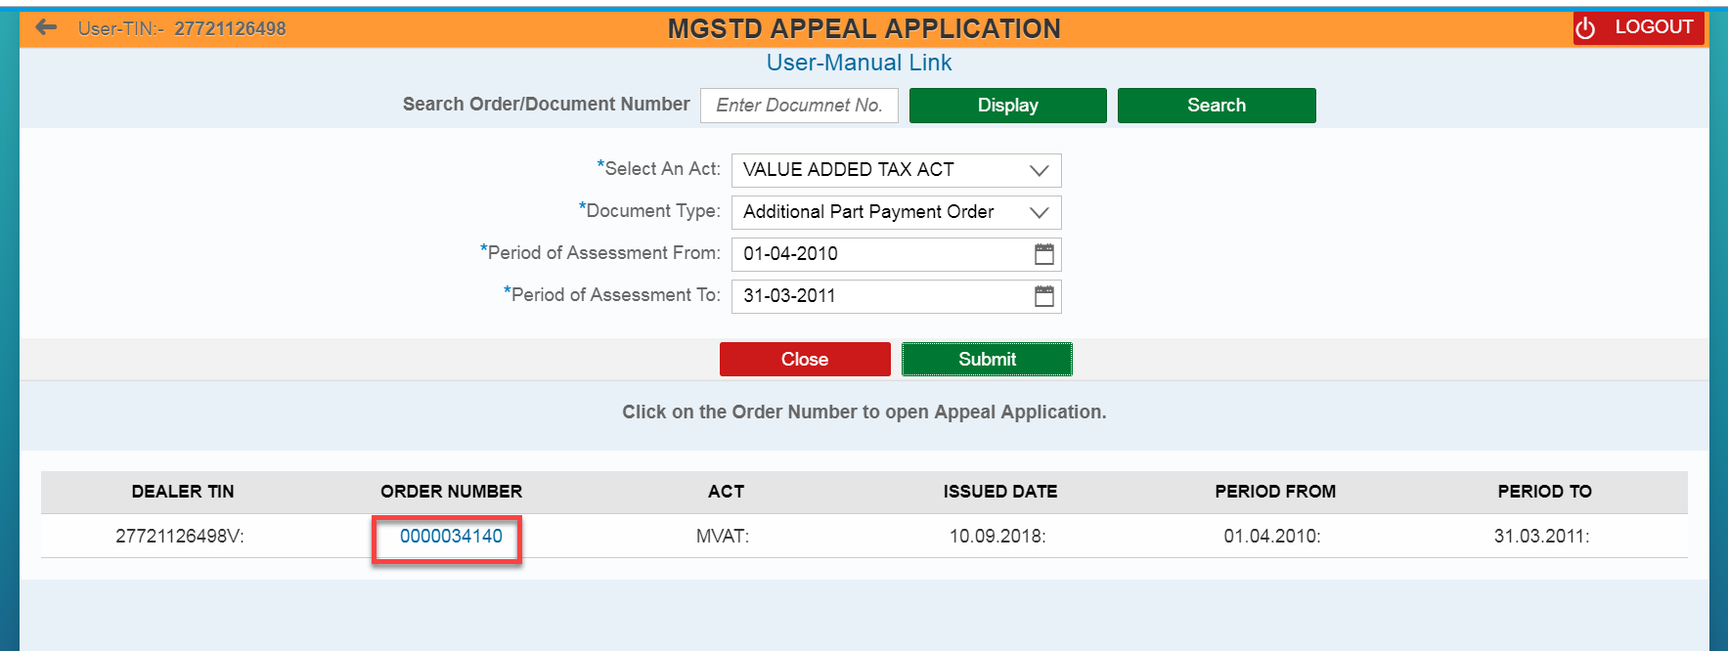

PART PAYMENT
- Review all the field values which was auto populated for “Original Part Payment Amount” and “Current o/s Part Payment Amount” rows
- Enter the values under “Amount to be Paid” row for Tax, Interest and Penalty
- Clicks on “Pay” button

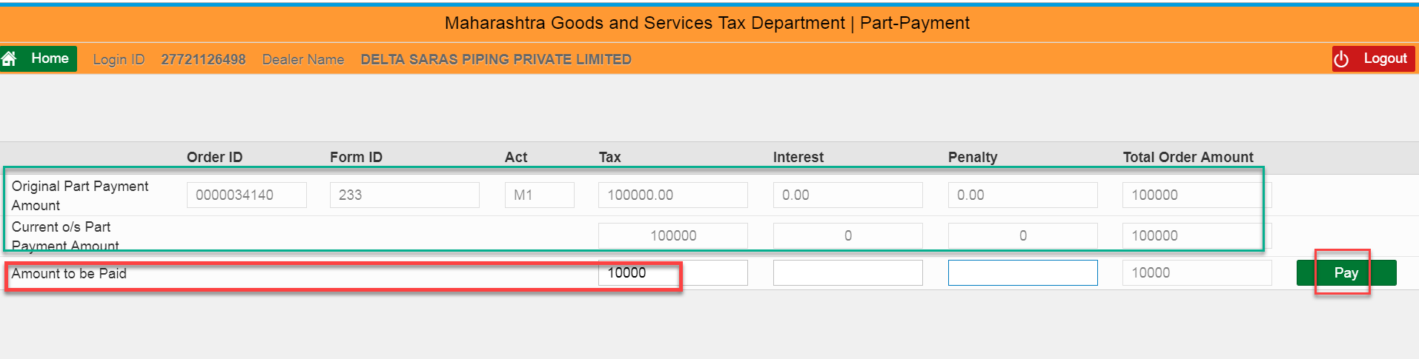
- Select the “Agree” radio button
- Select the either of one Payment Gateway (1. “GRAS” – Banks Supported By GRAS; 2. “SBI ePay” - Banks Supported By SBIEPAY)
For e.g.… Here I selected “SBI ePay” radio button
- Select the proper “Location” and enter the valid “Mobile Number” with 10 digits
- Clicks on “Proceed” button

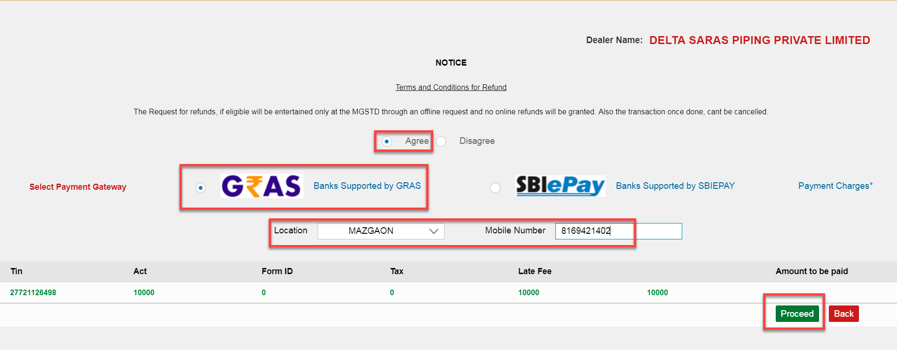

- Review the details and then Clicks on “Make Payment” button

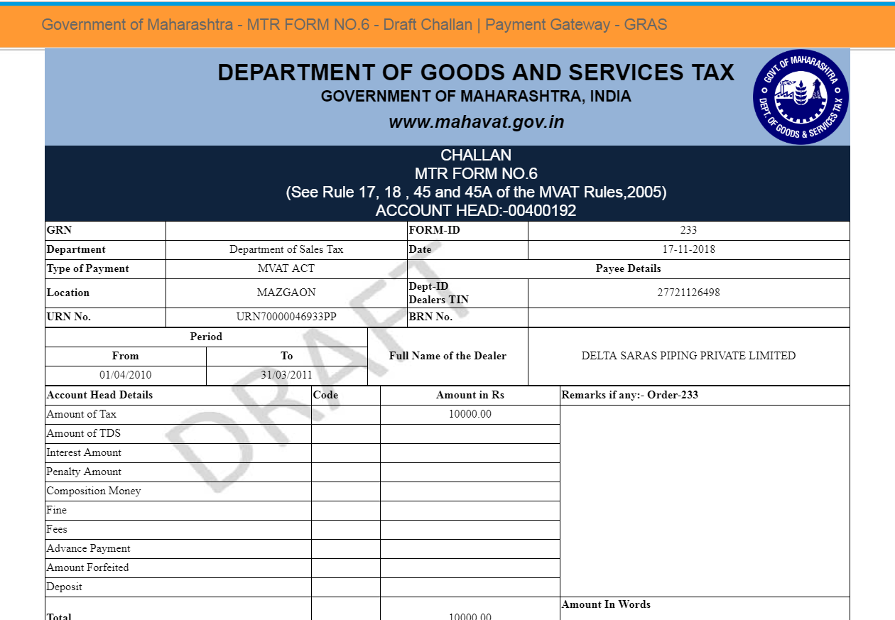

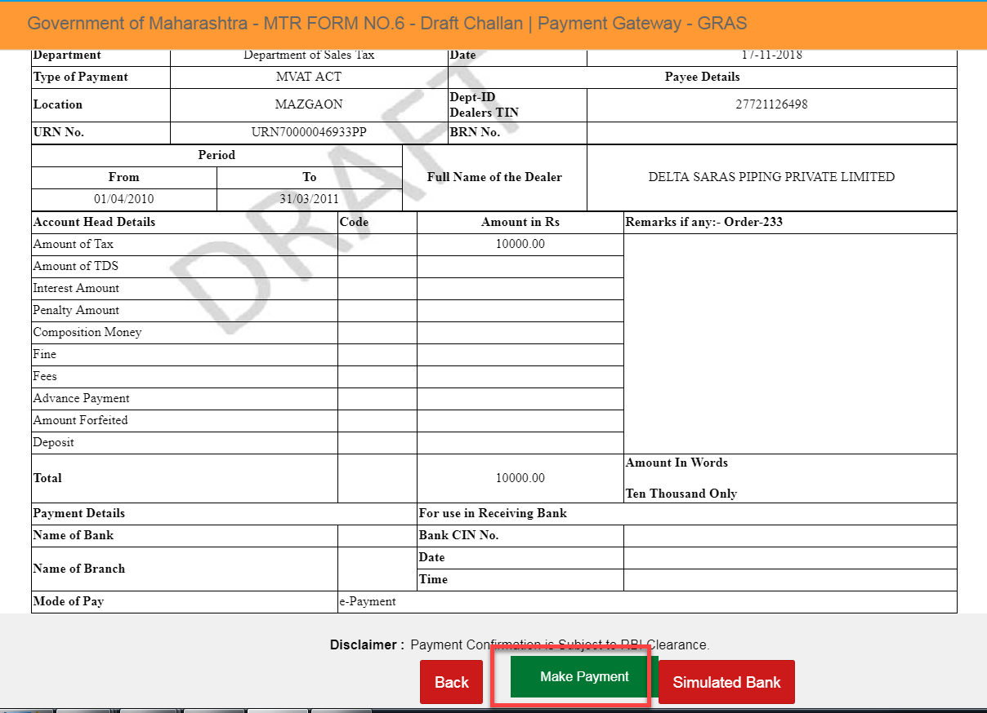

- Select either of one option (“Debit/Credit Card” OR “Internet Banking” OR “PayPal”),
For e.g... Here I have selected “Internet Banking” option
- Select the proper Bank from the list of Banks under “All Banks” section
- Clicks on “Pay Now” button

- Clicks on “Successful” button – Payment Acknowledgement should get displayed

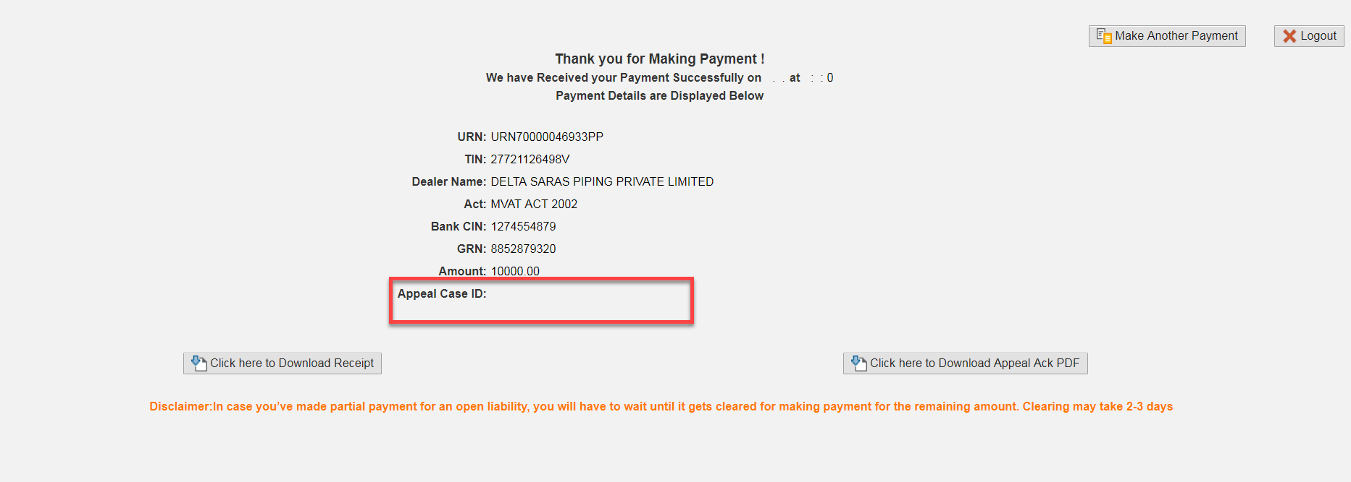
XXXXXXXX
Sending the payment link and downloading of Appeal Acknowledgement instructions as explained in “FILING OF APPEAL APPLICATION AGAINST ASSESSMENT ORDER PASSED ON SAP SYSTEM UNDER MVAT ACT “remains the same for this Applications also.

CHALLAN ACKNOWLEDGEMENT FORM
- Clicks on “Click here to Download Receipt PDF” button

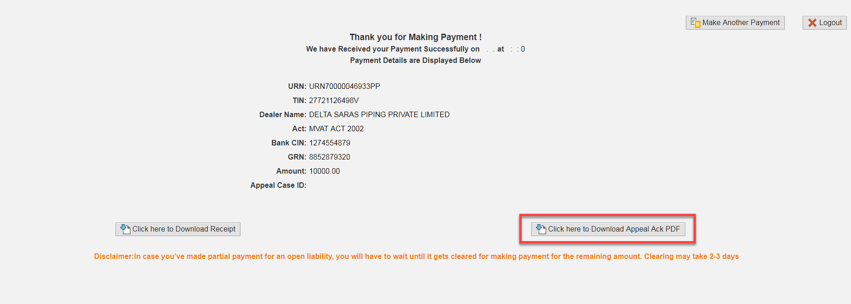
XXXXXXXX

